SOCIALIST REPUBLIC OF VIETNAM
Independence - Freedom – Happiness
------------------

CONTEST REGULATIONS, TASKS AND PLANS
CONTEST OF PLANNING AND ARCHITECTURAL PLANS FOR MUSEUM OF CHAM SCULPTURE - BRANCH NO. 2 (AT PHONG LE) - PHASE 1

***DANANG, 2023 ***
SOCIALIST REPUBLIC OF VIETNAM
Independence - Freedom – Happiness
---------***--------
Danang, date month 2023

CONTEST REGULATIONS, TASKS AND PLANS
CONTEST OF PLANNING AND ARCHITECTURAL PLANS FOR MUSEUM OF CHAM SCULPTURE - BRANCH NO. 2 (AT PHONG LE) - PHASE 1

Contest name: Contest of planning and architectural plans for Museum of Cham Sculpture - branch no. 2 (at Phong Le) - phase 1
Investment policy decision agency: Da Nang City People's Council
Investment decision-making agency: Da Nang City People’s Committee
Organizer: The Management Board of Construction Investment Projects of Civil and Industrial Works in Da Nang City
Consultant: Danang Consultant Technical Construction Centre

Consultant  Danang Consultant Technical Construction Centre | Organizer  The Management Board of Construction Investment Projects of Civil and Industrial Works in Da Nang City

PART I – GENERAL INFORMATION
- General information about the Contest
- Contest name: Contest of planning and architectural plans for Museum of Cham Sculpture - branch no. 2 (at Phong Le) - phase 1.
- Construction location: Hoa Tho Dong Ward, Cam Le District, Da Nang City.
- Contest format: widespread organization.
- Contest period: From December 2023 to April 2024.
- Investment decision-making agency: Da Nang City People’s Committee.
- Organizer: The Management Board of Construction Investment Projects of Civil and Industrial Works in Da Nang City.
+ Address: 2nd Floor, Working building of Project Management Boards and affiliated public service units, no. 48, Vo An Ninh Street, Hoa Xuan Ward, Cam Le District, Da Nang City.
+ Tel.: 0236. 3.817.118
- Consultant: Danang Consultant Technical Construction Centre.
+ Address: No. 107, Le Sat Street, Hoa Cuong Nam Ward, Hai Chau District, Da Nang City.
+ Tel.: 0236.3.796.322
+ Website: http://tuvanxaydungdn.vn/thituyen/
- Contest Council: Established by the competent authority.
- Technical Team: Established by the Management Board of Construction Investment Projects of Civil and Industrial Works in Da Nang City.
- Funding source: State budget.
- Currency: Vietnamese dong (VND).
- Language: Vietnamese is the main language.
- Legal bases:
- Urban Planning Law No. 30/2009/QH12 dated 17 June 2009; Consolidated Document No. 16/VBHN-VPQH dated 15 July 2020;
- Construction Law No. 50/2014/QH13 dated 18 June 2014; Law amending and supplementing a number of articles of the Construction Law No. 62/2020/QH14 dated 17 June 2020;
- Law on Architecture No. 40/2019/QH14 dated 13 June 2019;
- Law on Cultural Heritage dated 23 July 2013 according to Consolidated Document no. 10/VBHN-VPQH 2013;
- Decree No. 37/2010/ND-CP dated 07 April 2010 of the Government on establishment, appraisal, approval and management of urban planning; Decree No. 72/2019/ND-CP dated 30 August 2019 amending Decree No. 37/2010/ND-CP dated 07 April 2010;
- Decree No. 85/2020/ND-CP dated 17 July 2020 of the Government detailing a number of articles of the Law on Architecture;
- Decision No. 6314/QD-UBND dated 12 September 2013 of the People's Committee of Da Nang city on approving the boundary diagram for protecting Phong Le archaeological site;
- Decision No. 8950/QD-UBND dated 26 December 2016 of the People's Committee of Da Nang city on approving the land use planning boundary diagram, Expanding conservation-oriented planning and promoting the Cham-Phong Le relic site;
- Decision No. 1545/QD-UBND dated 27 March 2017 of the People's Committee of Da Nang city on approving the central subdivision planning;
- Decision No. 359/QD-TTg dated 15 March 2021 of the Prime Minister on approving the general planning of Da Nang city until 2030, vision 2050;
- Decision No. 153/QD-UBND dated 19 January 2023 of the People's Committee of Da Nang city on approving adjustments to the Project on archeology and promoting the value of Cham Phong Le relic site;
- Decision No. 4568/QD-UBND dated 27 November 2020 of the People's Committee of Da Nang city on the ranking of Cham Phong Le archaeological site (city-level relic site);
- Resolution No. 02/NQ-HDND dated 24 March 2023 of the People's Council of Da Nang City on Decision on investment policy of Museum of Cham Sculpture Project (at Phong Le) - Phase 1.
- Investment necessity:
The Cham - Phong Le archaeological site began archeology from 2011 - 2012 and recently the 2018 archeology period. The vestiges revealed through archaeological excavations confirm that the Cham - Phong Le relic site is very valuable and plays a very important role in the system of Cham cultural works in Vietnam and in the region. Currently, the preservation of this relic site still has many shortcomings; the architectural structures of the relics have been revealed without any overall protection and preservation measures; other architectural structures are directly affected by erosion due to environmental factors and the need for measures to preserve and promote the value of the Cham - Phong Le relic site has become even more urgent.
The Museum of Cham Sculpture is a specialty of Da Nang, this is the place to store and display the richest and most typical collection of religious sculpture art of the Champa Kingdom, although it has been invested in upgrading and expanding many times, the current display area is still quite modest compared to the archive of documents and artifacts that the Museum has collected and stored during its operation for more than 100 years. The construction of the Museum of Cham Sculpture - Branch no. 2 is necessary, but there needs to be a plan to exploit, arrange artifacts and information so that the two display areas do not compete or overlap information. Creating a space to reduce the load for the Cham Museum and create a separate, specialized space for the antiquities excavated at the Cham - Phong Le relic site right in the archaeological site, it not only optimizes the space of the covered area, but also helps visitors and researchers have information right at the scene.
In addition to the temple and tower system, there are existing religious and belief structures of the Cham people that are still being invested and preserved by the state; other types of buildings such as traditional houses of the Cham ethnic group... are not receiving proper attention. Modern life as well as the development of cheap, durable and diverse materials in quantity and type, modern construction technology that is both simpler and more effective has eroded traditional construction materials and technology. That general situation has been increasingly losing the core cultural foundation and undervaluing traditional values to come to new creativity in the new era. True creativity is only based on the core - the foundation filtered from the cultural quintessence of our ancestors. Cham Museum - branch no. 2 at Phong Le relic site has the opportunity to preserve these core values, including preserving and promoting the tangible values of buildings and intangible values of traditional material and spiritual activities of the Cham people.
This preservation and promotion project of the value of Cham Phong Le relic site has a convenient location directly connecting the river tourist route to the world cultural heritage site of My Son, with many historical and archaeological relic sites containing many great values. Therefore, if planned and invested in, this place has enough potential to become an attractive cultural tourism destination. According to document no. 390/BC-SDL dated 05 December 2018 of the Da Nang Department of Tourism "Report on results of tourism activities in 2018 and directions and tasks in 2019"; In 2018, Da Nang welcomed 7,660,000 tourists, an increase of 15% compared to 2017. When the Cham Phong Le Project is completed, it will create an attractive and unique destination along with traditional tourist attractions... for tourists to explore.
The project will concretize the Party and State's policies on promoting national cultural values; honoring the value of labor and cultural quintessence of ancestors in the land of Vietnam.
The project will complete the architecture - landscape of the area, contributing to improving the regional space according to the planning of Da Nang City in general and Cam Le district in particular; create motivation for local socio-cultural development. With the inherent value of the relic site in terms of culture, history, and spirituality, festivals are a factor that gives future generations a better understanding of the culture of their homeland and country.
PART II – CONTEST RULES
- Contest purposes and requirements
- Contest purposes:
The contest organization aims to find and select the optimal planning and architectural plans with high feasibility and meet the requirements of planning, architecture, culture, socio-economic efficiency, national defense and security and environmental protection, preserve all Cham relics revealed by archeology to ensure long-term sustainability and aesthetics, ensure proper use of technical requirements, synchronous connection of technical infrastructure, landscape architecture in harmony with surrounding space, create highlights and bring unique characteristics of Cham cultural architecture to the region and city, serve the needs of people and tourists, and serve as a basis for implementing investment design and construction projects.
- Contest requirements
- The planning and architectural design plan must fully demonstrate the content of the Contest Tasks, comply with the Contest Regulations of Planning and Architectural Plans for Museum of Cham Sculpture - Branch no. 2 (at Phong Le) - phase 1.
- Comply with current Vietnamese construction design regulations and standards and international standards approved by Vietnamese competent authorities.
- Analyze and evaluate the design plans of contestants, and on that basis, propose and select the best option as a basis for implementing the next steps of the project;
- Ensure fairness, objectivity, transparency, compliance with Vietnamese state regulations and relevant international laws.
- Organizations and individuals participating in the design contest must have full capacity and civil conduct conditions in accordance with current Vietnamese law.
- Units participating in the contest must bear all costs related to the contest process.
- For foreign organizations and individuals participating in the contest, a separate interpreter is required.
- Contest format:
- Contest format:
Widespread organization, it does not restrict domestic or foreign organizations and individuals from participating.
- Selection format: Selection through 02 rounds.
- Pre-qualification round: Publicly announce the contest content, it will be posted publicly on the contest website. At the same time, directly invite a number of reputable and experienced domestic design consultant units to participate in the contest. Invited design consultant units as well as design consultant units wishing to participate in the contest need to submit application for contest.
After finishing registration process, the admission process in the pre-qualification round will be based on the capacity profile of the contestants. From there, at least 03 design consultant units with appropriate qualifications, capacity, and experience will be selected to invite to participate in the qualification round. The organizer will notify the results to organizations and individuals participating in the next round (qualification round) to deploy the contest plan.
- Qualification round: Organizations and individuals that have passed pre-qualification round carry out the plan and submit the plan within the prescribed time. The Contest Council evaluates and selects the plans according to the Design Tasks, Contest Regulations and Council's Regulations and transmit the contest's results to the organizer and report to the City People's Committee to approve the results and award prizes.
- Documents provided to contestants
- Text Documents:
- Contest plan;
- Design tasks;
- Contest regulations;
- Application for contest;
- Other related documents.
- Technical Documents
- All official contest documents will be provided by the organizer via the contest information website.
- Other related documents and information (if any).
- Contest rules
- Subjects and conditions:
a) Subjects:
All domestic and foreign design consultant organizations, individuals or partnerships that have adequate conditions, professional capacity and practice in accordance with current laws of Vietnam can register to participate in the contest.
b) Conditions:
- Independent organizations, independent individuals or partnerships participating in the contest must fully meet the following conditions:
+ Have legal status, operate in accordance with the law of Vietnam; have full capacity for civil acts as prescribed by law; be allowed to operate in the field of construction design consultancy, planning design consultancy,
+ Have a certificate of competency for construction activities in compliance with current regulations.
+ The individual in charge of planning and architectural design must be an architect and has a planning or construction design practising certificate according to the provisions of Article 69 of Decree no. 15/2021/ND-CP dated 03 March 2021.
+ The consultant units participating in the contest must ensure the capacity conditions in accordance with current regulations, have the eligibility certificate in the field of planning design consultancy or minimum architectural design according to the provisions of Article 92 Decree no. 15/2021/ND-CP dated 03 March 2021.
+ Prioritize and encourage organizations and individuals participating in the Contest to have a relic restoration practice certificate, have experience in Champa cultural works, and have won high prizes at domestic and foreign architectural design contests.
- Contestants will have their capacity assessed by the organizer according to the criteria of this Contest Regulations. Official contestants will be notified by the organizer and will receive an invitation to participate in the contest.
- Criteria for selection and invitation to participate in the contest must meet the criteria set out by the contest, it must be an organization or individual who is knowledgeable in the field of architecture, planning, and has enough operational capacity; reputable and have relevant practical experience according to current legal regulations.
c) Subjects are not allowed to take the contest:
- Member of the Contest Council;
- Member of the Technical Team;
- Individuals involved in establishing the contest tasks and regulations;
- Organizations and individuals who are related to members of the Contest Council and do not have the appropriate qualifications, experience, and practising certificates according to regulations.
d) Regulations on partnership, membership status:
- Organizations and individuals participating in the contest may enter into a partnership with other organizations and individuals to ensure that they meet the conditions set forth above. In this case, there should be a firm to take the main responsibility;
- Each organization or individual can only participate in one partnership relationship;
- The design consultancy partnership must have a written agreement between members participating in the partnership relationship. The written partnership agreement must be sent to the Organizer together with the application for contest (pre-qualification round);
- All issues of rights and obligations between the parties in the partnership are agreed upon by the parties themselves, the Organizer shall not be responsible;
- Contestants can collaborate with an expert or a group of experts with prestige, experience and capacity to ensure work results (Experts cannot be members of the Contest Council, Technical Team). In this case, the consultant units are not required to send a written agreement to the Organizer. The names and Science Profiles of these experts must be stated by the Contestants in the list of personnel involved in preparing the contest plan.
- Procedures for registration and submission for the Pre-qualification round
a) Registration:
Contestants can register their participation information as follows: Submit online via e-mail to pre-register, after confirmation check, submit the application in person or by post at the consultant.
Contestants must submit the following documents to the organizer:

No. | Description | Online | In person (original) | Form
1 | Registration form and Partnership Agreement (if any) | 01 scanned file in PDF format (signed and sealed) and 01 word file with the same content | Signed and sealed document | Appendix 01, 02
2 | Proof of practicing capacity and legal status of the individual or consultant unit according to the provisions of Vietnamese law. | 01 scanned file in PDF format | Notarized documents within 6 months
3 | Capacity profile of consultant units.  Certificate of winning prizes in previous contests (if any). | 01 scanned file in PDF format | Signed and sealed document (for units submitting capacity profiles)
4 | List of experts and members (if they are individuals) participating in the partnership | 01 scanned file in PDF format and 01 word file with the same content | Signed and sealed document
Notes:
- Contestants do not have to pay a fee to participate in the contest;
- The organizer may request the consultant unit to clarify and supplement documents proving eligibility, capacity, and experience if necessary;
- The organizer does not pay any costs for the participation of units registering for the contest except for prizes and contest participation support costs for up to 05 units with a suitable contest plans and highest rated by the Contest Council (excluding units winning first, second and third prizes).
b) Receipt of applications in the pre-qualification round:
Application for contest registration (including the lists specified in Clause 1, Article 7) must be submitted in person (during office hours) or sent by post to the consultant (excluding postmark), no later than 05:00 p.m. on the last day to receive the Applications according to the contest plan.

DANANG CONSULTANT TECHNICAL CONSTRUCTION CENTRE
Address: No. 107, Le Sat Street, Hoa Cuong Nam Ward, Hai Chau District, Da Nang City
Email: TTTVthituyen@gmail.com
Tel.: 0236.3.796.322

c) Receipt of submission of contest products in the qualification round:
- Contestants who are selected for the qualification round must submit the entries within 45 days.
- Contestants submit their design products in person (during office hours) to the organizer no later than 05:00 p.m. on the day of receiving entries according to the contest plan. If sent by post, it is based on the postmark but no more than 03 days compared to the prescribed period:

DANANG CONSULTANT TECHNICAL CONSTRUCTION CENTRE
Address: No. 107, Le Sat Street, Hoa Cuong Nam Ward, Hai Chau District, Da Nang City
Email: TTTVthituyen@gmail.com
Tel.: 0236.3.796.322

- The Technical Team will make a handover report of submission of entries (in person or by post), clearly stating: Time of submission, quantity, content, product status. The Technical Team and representatives of the party submitting the entry will sign the report; The handover report is made in 02 copies, each party keeps 01 copy;
- Contestants should pay attention to the safe preservation of the entries and respect the regulations on application when sending the entries to the Organizer;
- Contestants are not allowed to change the entries after the submission time. During the evaluation of the entries, the Organizer may request the Contestants to clarify the content of the entries in the form of indirect or direct exchange, but must ensure that the basic content of the entries is not changed. The request for clarification of the Organizer, the answers of the Contestants must be expressed in writing and kept by the Organizer in accordance with the Contest Regulations.
- Contest time and location:
a) Contest time:
Contest time is carried out according to the Contest Plan approved by the organizer.
- Contest registration time: From the date of announcement on the contest website and mass media.
- Submission time of contest application: According to the approved plan.
- Time to report the results of the pre-qualification round: No later than 5 days after the closing date of receiving pre-qualification application, the organizer shall sign the Meeting Report on assessment of Capacity Profile and issue Decision on results of selection of suitable design consultant units selected for the qualification round.
- Design consultant units selected for the qualification round will be notified to each unit.
- Time to deliver documents for the qualification round to selected contestants: Within 03 days from the date of notification to selected contestants.
- Time for field surveys: Organizations and individuals participating in the contest organize their own field surveys and field visits if deemed necessary.
- During the contest, if there is a change in time, the organizer will send a notice to contestants at least 3 days before the entry submission deadline.
b) Location:
The location reports the contest plan to the Contest Council, the organizer will send a Notice or Invitation to the contestants 05 days before the judging session.
- Requirements for applications and entries:
a) General regulations:
- There is no limit to illustrative content for the entries.
- Language to be used in all entries and explanations is: Vietnamese or bilingual English-Vietnamese (if the contestant is a foreign subject), other languages may not be used in the presentation of any drawings and explanations.
- Unit of Measurement used in the entries: Measure the length in the metric system (m); dimensions for the master plan drawing are meters (m), square meters (m2) or hectares (ha); dimensions for architectural drawings are millimeters (mm).
- Expression form: Symbols and colors according to the conventions of the drawing symbol system in architectural projects and construction planning in Vietnam.
- Each contestant must have no more than 02 contest plans.
- Currency: Vietnamese Dong.
b) Regulations for applications and entries:
- All applications and entries are presented on the principle of anonymity. Use anonymous numeric notation on submitted entries (page-by-page drawings and presentations). This anonymous code chosen by the contestants consists of 02 letters and 02 digits (eg AB12), printed letters of 01cm high on the upper right of each drawing and entry. This code is also written on the cover of the explanation and on a corner of the model (if any). Contestants who write their company name or research group’s name in the name box of any of the drawings will be disqualified.
- Each entry must be contained in a sealed package, the contest name is written on the outside, the contestant code and a list of documents are contained inside (following the principle of anonymity).
- On the drawings and explanations, there must not be any information in words or pictures (logo, symbol, sign...) that can identify the contestant.
- Full information about the contestant is shown in a sealed envelope (including the contestant name, address, phone, fax, e-mail...). On the outside of the envelope, there is only the code of the contestant;
- Anonymity rule is implemented on all documents, entries as well as USB ports.
- Document will be kept confidential until it is handed over to the Contest Council and this profile can only be used when the Council is grading (publicly) or the contestant will present in front of the Council.
c) Content of design plan:
- Explanation: Explanation of the contest plan is presented on A3 paper size, A3 paper size drawing, it is printed horizontally, bound into volumes with hardcovers, must show the following contents:
+ Introduce and describe the natural characteristics, cultural and historical values of the Cham - Phong Le relic site;
+ Orient prospects and potential for tourism development, cultural and economic development;
+ Clearly explain solutions to preserve, restore and promote the value of relics excavated in area I, research solutions to apply new technology in simulating and promoting relics to serve visitors;
+ Assess the current state of the area, traffic organization, technical infrastructure, landscape architecture of the study area and construction land fund;
+ Design ideas of the contest plan (including shape and functionality);
+ Analyze the compatibility with the design, planning, and landscape architecture tasks of the construction area;
+ Analyze the compatibility of historical, socio-cultural characteristics of the locality;
+ Provide estimates of technical solutions inside and outside the project; solutions for construction materials and construction equipment (if any);
+ Influence and impact of the plan on regulations on environmental protection, floods and fire and explosion prevention;
+ Feasibility of the plan;
+ Estimate the total investment according to the contest plan and proposal to ensure compliance with the scale and investment rate according to current regulations (including design costs, site clearance (if any) and other related costs).
- Drawing:
+ Location map and relationship with surrounding areas of Hoa Tho Dong ward;
+ Diagrams and drawings assessing the current status include revealed relics, land use, transportation, technical infrastructure, landscape architecture of the study area and construction land fund;
+ The overall diagram clearly shows the items in the conservation and protection area of relic site and area for promotion the value of relic site, etc.
+ Master plan drawing with appropriate scale: Clearly shows the relationship between the project and the neighboring traffic network and surrounding landscape and architectural space;
+ Drawings of architectural design plans with appropriate scale: Plans, elevations, main cross-sections, typical cross-sections;
+ Overall perspective drawings of the project, including at least 01 night perspective drawing showing the project's lighting ideas;
+ Perspective of architectural space miniatures to describe the features, functions, highlights, and check-in points of the bridge project;
+ Other contents are selected by the contestants to illustrate the project's design solutions;
- Other contents:
In addition to explanations and drawings, contestants can make presentation films and models of the contest plan (encouraged, not required). Note that in the video report, only the anonymous code is mentioned, the contestant's name is not allowed.
- Number of applications:
+ Documentation explaining the plan and condensed color drawings presented on A3 paper size: Quantity: 18 sets;
+ Drawings displayed on A1-sized hardboard (numbered sequentially) for exhibition display and reporting to the Contest Council: Quantity: 01 set;
+ PDF or Power Point file reports all explanations, drawings, and illustration photos;
+ 01 USB to record all data of the contest plan.
- Illustrative video for plan (recommended).
- Report video presents the plan to the Contest Council, note that it only mentions the anonymous code, not mention the unit's name in the report video.
d) Invalid documents and entries:
The Organizer will remove, not accept and not present in front of the Contest Council for consideration and evaluation of the entries that do not meet the basic requirements of the Contest Regulations, including the following cases:
- Violate the principle of anonymity as prescribed so that the Contest Council can identify the contestant during the process of evaluating plans.
- Lack quantity and components of documents, not submit them on time and at the prescribed location.
- Evaluation and classification of contest plans and announcment of results
- Contest Council:
a) Council’s members.
- The Contest Council of planning and architectural plans (referred to as the Council) evaluates and ranks the contest plans, helps the Organizer choose the optimal plan that meets the requirements of planning, architecture, culture, socio-economic efficiency, national defense, security and environmental protection to implement the next steps of the project.
- The Contest Council is established by decision of the competent authority.
- The Council's members comply with the provisions in Article 13 of Decree No. 37/2020/ND-CP dated 07 April 2010.
+ The Council is expected to consist of 11 members, representatives of state management agencies, relevant social and professional organizations, planning architecture council and experienced experts in the field of planning and architecture, they are objective and fair-minded people.
+ The Council's Chairman must be an experienced expert who has designed many architectural projects and has a professional reputation in the specialized field. The Council's Chairman is elected by the Contest Council or invited by the Employer.

b) Working principles of the Contest Council.
- The Council operates independently, complies with the Council's operating regulations. The Council's members ensure independence, objectivity, honesty and the highest responsibility to fulfill the common tasks of the Council;
- The Council's regulations must specifically express the principles and methods of evaluation and classification of contest plans, and the responsibilities of the Council;
- Regulations must be agreed upon by members. The Council's Chairman approves the Regulations and is responsible for the implementation of the Regulations on behalf of the Council;
- The Council will only evaluate and rank the contest plans when at least 3/4 of the members are present;
- The Council's Chairman, members and secretaries are not allowed to publish or provide organizations or individuals other than the Council with information about the content of discussions and conclusions of the Council during the evaluation and classification period of contest plans;
- The contest results report must be signed and certified by all the Council's members.
c) Responsibilities of the Contest Council.
- The Council's members are responsible for ensuring confidentiality, objectivity, honesty and no negative behavior affecting the evaluation and classification results.
- The Council works according to the Regulations prescribed by the Council (hereinafter referred to as Council Regulations). The Council Regulations express the principles, evaluation methods, and classification criteria for contest plans; working policies and tasks, powers and responsibilities of the Council. Council regulations must be agreed upon by members. The Council's Chairman approves the Council Regulations on behalf of the Council.
- The Council's Chairman must be present and chair the Council during the Council's working time.
- Summarize and report the results of evaluation and classification of the contest plans to the Organizer.
- The Contest Council's comments on the plans will be compiled so that the Organizer requests the winner to complete the plan design.
- Technical Team:
- The technical team is established by the organizer.
- The technical team has responsible for:
+ Guiding organizations and individuals to register for the contest; receiving contest registration procedures, receiving and checking contest products; reviewing the validity of each contest plan and reporting to the Council (if necessary);
+ Supporting and evaluating capacity profiles of consultant units participating in the contest;
+ Receiving and explaining contest regulations to organizations and individuals registering for the contest; Providing relevant information and documents to organizations and individuals;
+ Preparing a comprehensive report on planning criteria, technical specifications and validity of each plan to send to the Contest Council;
+ Supporting and advising the Contest Council throughout the process of organizing, evaluating and ranking the plans.
- Plan report and selection (Qualification round):
a) Plan defense before the Contest Council:
After submitting the entries, eligible contestants will be informed of the time and place to officially defend their plans before the Contest Council. The defense form will be as announced by the organizer.
- Direct report form:
Each unit appoints a representative to report and defend the plan in the form of presentation and explanation. The contestant prepares the file and shows it at the time of reporting. In case of reporting in another form, the contestant must equip itself with the necessary means.
Maximum report period for each unit is 20 minutes (25 minutes if there is video), foreign units are 25 minutes (30 minutes if there is video).
- Report form via video:
Each unit recorded a video presents its plan for the Contest Council to view and discuss with the Council via online connection.
b) Plan selection process (Qualification round):
b.1. Selection process:
- 1st round (Classification of entries): The organizer classifies entries that meet the criteria according to the approved contest regulations and tasks to enter the 2nd round to defend the plan before the Contest Council.
- 2nd round (report, judge entries): After studying the contest plans and listening to the presentations (live or via video), the Contest Council analyzes, evaluates, and selects 03 plans with the highest score to enter the 3rd round and be ranked last according to the award structure.
- 3rd round (Awards ranking): The Contest Council discusses and evaluates the final rankings through secret voting.
Note: The selection process may change according to the actual situation as decided by the Contest Council.
b.2. Evaluation criteria:
No. | Evaluation criteria | Maximum score
1 | Design ideas (creative inheritance of traditional Champa architecture) | 20
2 | Planning solutions (spatial organization of project complexes, functional subdivisions) | 20
3 | Architectural solutions (usability, project’s symbolism) | 30
4 | Technical solutions (solutions to protect and preserve the relic site) | 20
5 | Economic solutions | 5
6 | Plan explaination and defense and quality of documents | 5
 | Total score | 100
The Contest Council can adjust the score scale accordingly according to the evaluation criteria.
The evaluation and classification results report must be signed and confirmed by all members of the Contest Council.
Consultant units participating in the Contest do not have the right to request explanations regarding the scoring and ranking of contest plans.
- Announcement of contest results
- After the People's Committee of Da Nang City agrees on the contest's results, the organizer announces and publicizes the results and sends results to the winners and contestants will receive support costs, and awards prizes after the end of the contest.
- The People's Committee of Da Nang City decides on the form of organization of displays and exhibitions, and consults with the community on contest plans (if any).
- Report the contest results to the City Party Committee, People's Council and People's Committee of Da Nang city.
- In case there is no plan to meet the objectives and requirements specified in the Contest Regulations, the contest will be re-organized or stopped by the decision of the People's Committee of Da Nang City.
- Prize structure and funding
- Contest fees:
- Contest organization costs include costs for the Council; Technical Team; award levels, support cost for contest plans and other costs.
- The Organizer is responsible for the contest organization costs.
- Contest costs: Based on the estimated cost of organizing the contest approved by competent authorities.
- Prize structure and value:
a) Prize structure:
- The total value of the prize and support costs is: VND 500,000,000, of which:
+ 01 First prize : VND 250,000,000.
+ 01 Second prize : VND 100,000,000.
+ 01 Giải ba : VND 50,000,000.
+ Support costs for plans entering the qualification round (Top 05 plans with high scores are taken from top to bottom, except for 03 plans in the 3rd round): VND 100,000,000 (VND 20,000,000/each plan).
- If the contest does not have one of the above prizes and there are plans that win the same prize, the prize value is the average of such prize with the remaining unsatisfactory prizes divided equally among the plans that have the same prize.
- In case the contest does not have any plan to enter the 3rd round and is agreed upon by the Contest Council, an additional consolation prize will be awarded to the top 03 high-scoring plans from top to bottom, it values VND 50,000,000/plan, it is taken from the prize cost, then the support cost for plans to enter the Qualification round is VND 20,000,000/plan for the top 05 teams with the next highest scores from top to bottom.
- The above prize value includes taxes that the prize recipient must pay according to regulations.
- The above prize value includes taxes that the prize recipient must pay according to regulations, and is sent to the units after the organizer approves the contest results and the contestants complete the necessary financial procedures.
b) Support funds.
The contestants are selected and evaluated through the pre-qualification round and are assessed by the Council as fully complying with the Contest Regulations, having a serious investment plan, fully meeting the criteria of the contest and having a minimum score of 70 points or more (based on a scale of 100) but if they do not win the award, they will receive a support budget of VND 20,000,000 (Twenty million Vietnamese dong) for each unit. Support up to 05 units that do not win awards according to scoring results from top to bottom.
c) Payment method for prize money and support funds.
- Bonuses and support funds are transferred by the organizer in Vietnamese currency (VND) to award-winning units and supported units;
- Prizes will be sent to the contestants after the approval decision of the City People's Committee and the contestants complete the necessary financial procedures.
- Contest organization costs:
The Contest organization cost is about VND 1,191,898,192 (In words: One billion one hundred ninety-one million eight hundred ninety-eight thousand one hundred ninety-two Vietnamese dong) including expenses:
- Contest organization costs: 325.828.044
- Consulting costs for contest organization: 359.312.000
- Prize cost: 500.000.000
- Basis for calculating project design fees:
Basis for calculating project design fees: According to current regulations on project construction investment cost management.
- Regulations on copyright and ownership, rights and responsibilities of contestants
- Confidentiality, copyright, ownership:
- The Entries of consultant units participating in the contest are preserved and secured by the Technical Team throughout the judging period.
- The plans for participating in the cotest are guaranteed copyright according to the law on intellectual property.
- The contest decision-making agency is the owner of the contest's design products and is allowed to announce the contest's design products.
- Contest design products (maps, drawings, reports, explanations, models, films...) submitted by the contestants will become the property of the contest decision-making agency and will not be returned to the contestants.
- The organizer will agree with the winning design consultant unit to use and supplement ideas from the contest plans to complete the design according to the opinion of the Contest Council.
- The contestants commit:
+ The winning plan from this contest shall not be used in any other contests or projects. Contestants must refund prize funds in case of violation;
+ All dossiers, documents and entries must not infringe the copyright or intellectual property rights of any other individuals or third parties. Consultant units participating in the Contest must be responsible for the copyright and intellectual property rights of their entries, including ideas, contents, explanations, drawings, software used... with third parties in case of complaints. If the infringement of copyright and intellectual property rights causes damage to the contest decision-making agency and the Organizer, the design consultant units who causes damage must pay compensation including prize money and support funds received.
- Before announcing the contest's results, the consultant units are not allowed to use, provide or display the entries for other purposes without the permission of the Organizer.
- Contestants may use the contest plan to introduce their consulting capabilities after the contest ends.
- Rights and Responsibilities of units:
a) Rights and responsibilities of design units participating in the contest:
- The organizer provides financial support for up to 05 units whose scores are evaluated from high to low by the Contest Council (excluding units winning first, second and third prizes) after the results are announced.
- The plans for participating in the contest are guaranteed copyright according to Vietnam's intellectual property laws.
- Organizations and individuals whose plans win the highest prize will be given priority in implementing the next steps of the project when they meet the conditions according to the provisions of construction law and bidding law.
- Organizations and individuals that have the plan to win the highest prize are selected to carry out the next steps of the project (consulting on preparing a feasibility study report, construction design) if they do not meet the capacity conditions to implement the next steps, they can partner with consulting organizations that have the capacity to carry out.
- Within 30 days from the date of notification of the Organizer or the unit assigned to implement the project, in case the organization or individual with the selected plan does not proceed, refuses to proceed with the next steps, or the parties cannot negotiate mutually, the next ranked plan will be selected for negotiation and contract signing (after receiving comments on finalizing the plan).
Consulting costs for the selected implementation plan apply according to Vietnam's current regulations.
- Design consultant units participating in the contest do not have the right to request the organizer, Technical Team, Contest Council and organizations/agencies related to this contest to explain the results of pre-qualification and qualification rounds.
- By participating in the Contest of Planning and Architectural Plans for Museum of Cham Sculpture - Branch no. 2 (at Phong Le) - phase 1, the consultant unit is considered to have learned about, acknowledged and voluntarily complied with with the approved and promulgated Contest Regulations.
- Comply with the Contest Regulations and Design Tasks.
- Be responsible to the law for the copyright and the author’s right of the entries, even if there are related disputes.
- Ensure independent financial accounting and not being in the process of dissolution, not being concluded to be in bankruptcy or insolvent debt as prescribed by law.
- Finalize the plan based on comments from the Contest Council, experts, Investors, Project Management Unit in case of being selected as the unit to implement the next steps.
- Coordinate with the organizer to report the winning plan to the City Party Committee, People's Council and City People's Committee (if required).
- Contestants are notified of the time and location to officially defend their plans before the Contest Council. The notification time must be at least 05 days before the defense date (if required).
- Bear all costs related to registering for the contest and participating in the contest.
b) Rights and responsibilities of the Contest Council and the organizer:
- Comply with the approved Contest Regulations.
- Do not use its influence to falsify the contest results.
- Organize a public and transparent contest. All requirements must be clearly communicated to the contestants.
- Protect the information of the contestants.
- Own all products participating in the contest.
- Pay the prize-money to the contestants according to regulations.
- Select a unit that ensures the capacity according to regulations and is most suitable to proceed with the next steps based on the idea and research result of many plans in this contest but must guarantee the copyright in use.
- Select the most suitable plan to proceed with the next steps.
- Other regulations of the contest:
- The Organizer may amend the Contest Regulations based on the proposal of the Contest Council and the Contest's Consultant, is responsible for notifying relevant parties about the amended contents.
- In case there is no plan that meets the objectives and requirements as prescribed in the Design Tasks and the Contest Regulations, the contest will be held again or stopped under the decision of the People’s Committee of Da Nang City.
- Any disputes related to the contest process (if any) will be resolved through amicable conciliation; if the mutual agreement cannot be reached, they will be resolved in accordance with current Vietnamese law.

PART III. CONTEST TASKS
- Investment goals
- Repair and preserve all items and structures of Cham relics revealed by archeology to ensure long-term sustainability and aesthetics. Use technological and technical measures to minimize the impact of natural environmental conditions such as groundwater, erosion, etc. to help the relic site to be sustainable in the long term. Build houses to cover the entire relic site that has been archaeologically revealed for long-term conservation and research. The project's form is highly symbolic, easy to maintain and energy efficient. At the same time, create more display and exhibition space to promote Cham cultural tangible heritage.
- Complete and renovate regional infrastructure associated with preservation and promotion of the value of relics, thereby create more amenities for tourism, create motivation for local socio-economic development. Build a synchronous technical infrastructure system and connect with the general technical infrastructure system of the region such as power supply, water supply, drainage, traffic and static traffic systems, etc.
- Link and connect with tourist routes to exploit relics effectively and sustainably, create unique and special tourism products for Da Nang Tourism in general.
- Propagate and orient the community in the relic area to participate in preserving and promoting the relic site; bring economic values through tourism and service activities... to contribute to improving the material and spiritual life of people in the region.
- Contest tasks

Applicable design regulations and standards:

- Current standard and regulation.
- QCXDVN 01:2021/BXD: Vietnam Construction Regulations on Construction Planning;
- QCXDVN 02:2022/BXD: National technical regulations on natural condition data used in construction.
- QCXDVN 03:2022/BXD: National technical regulations on construction classification for construction design.
- QCXDVN 05:2008/BXD: Regulations on Housing and Public Works - Life and Health Safety;
- QCVN 06:2022/BXD: National technical regulations on fire safety for houses and projects.
- QCVN 07:2016/BXD : Regulations on technical infrastructure works.
- QCVN 09:2017/BXD: Regulations on energy efficient buildings.
- QCVN 10:2014/BXD: Regulations on building construction to ensure access and use by disabled people.
- Current standards and regulations.
  - General introduction:

- Location - Scale:
+ Phong Le archaeological relic site is currently located about 300m east of National Highway no. 1 and about 500m north of Cau Do River (Cam Le River); coordinates 16000'13" North latitude and 108011'38" East longitude (according to Flash Earth); located in Hamlet no. 3, Hoa Tho Dong Ward, Cam Le District, Da Nang City.
+ Phong Le archaeological relic site is named after the ancient Phong Le village. Currently, Phong Le is no longer the name of an administrative unit, but is still the name of a village communal house and many people can still identify the territory of the ancient Phong Le village. The area of ancient Phong Le village is located on both sides of Cau Do River (Cam Le River).
* Planning location on googlemap:
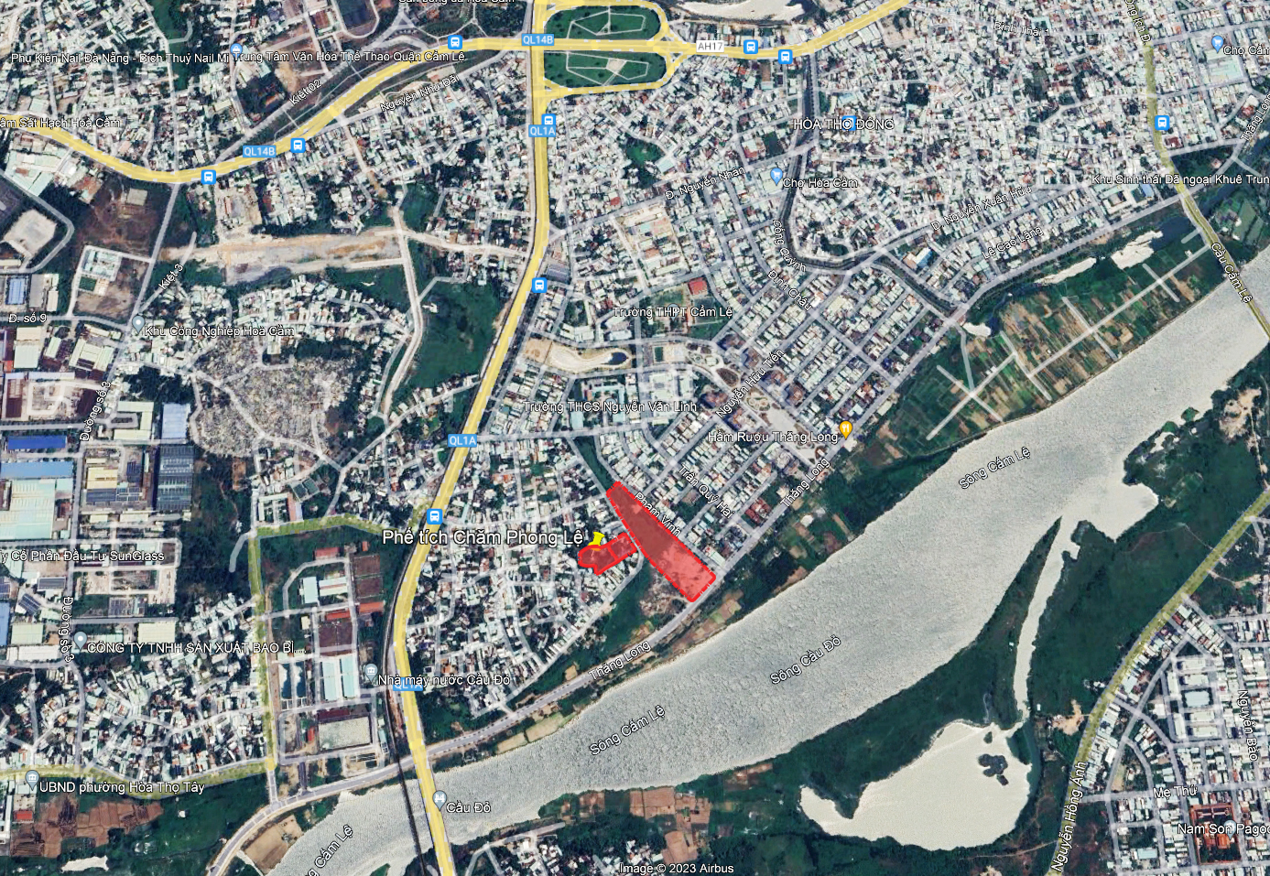

Planning Location

* Planning location in central zoning planning

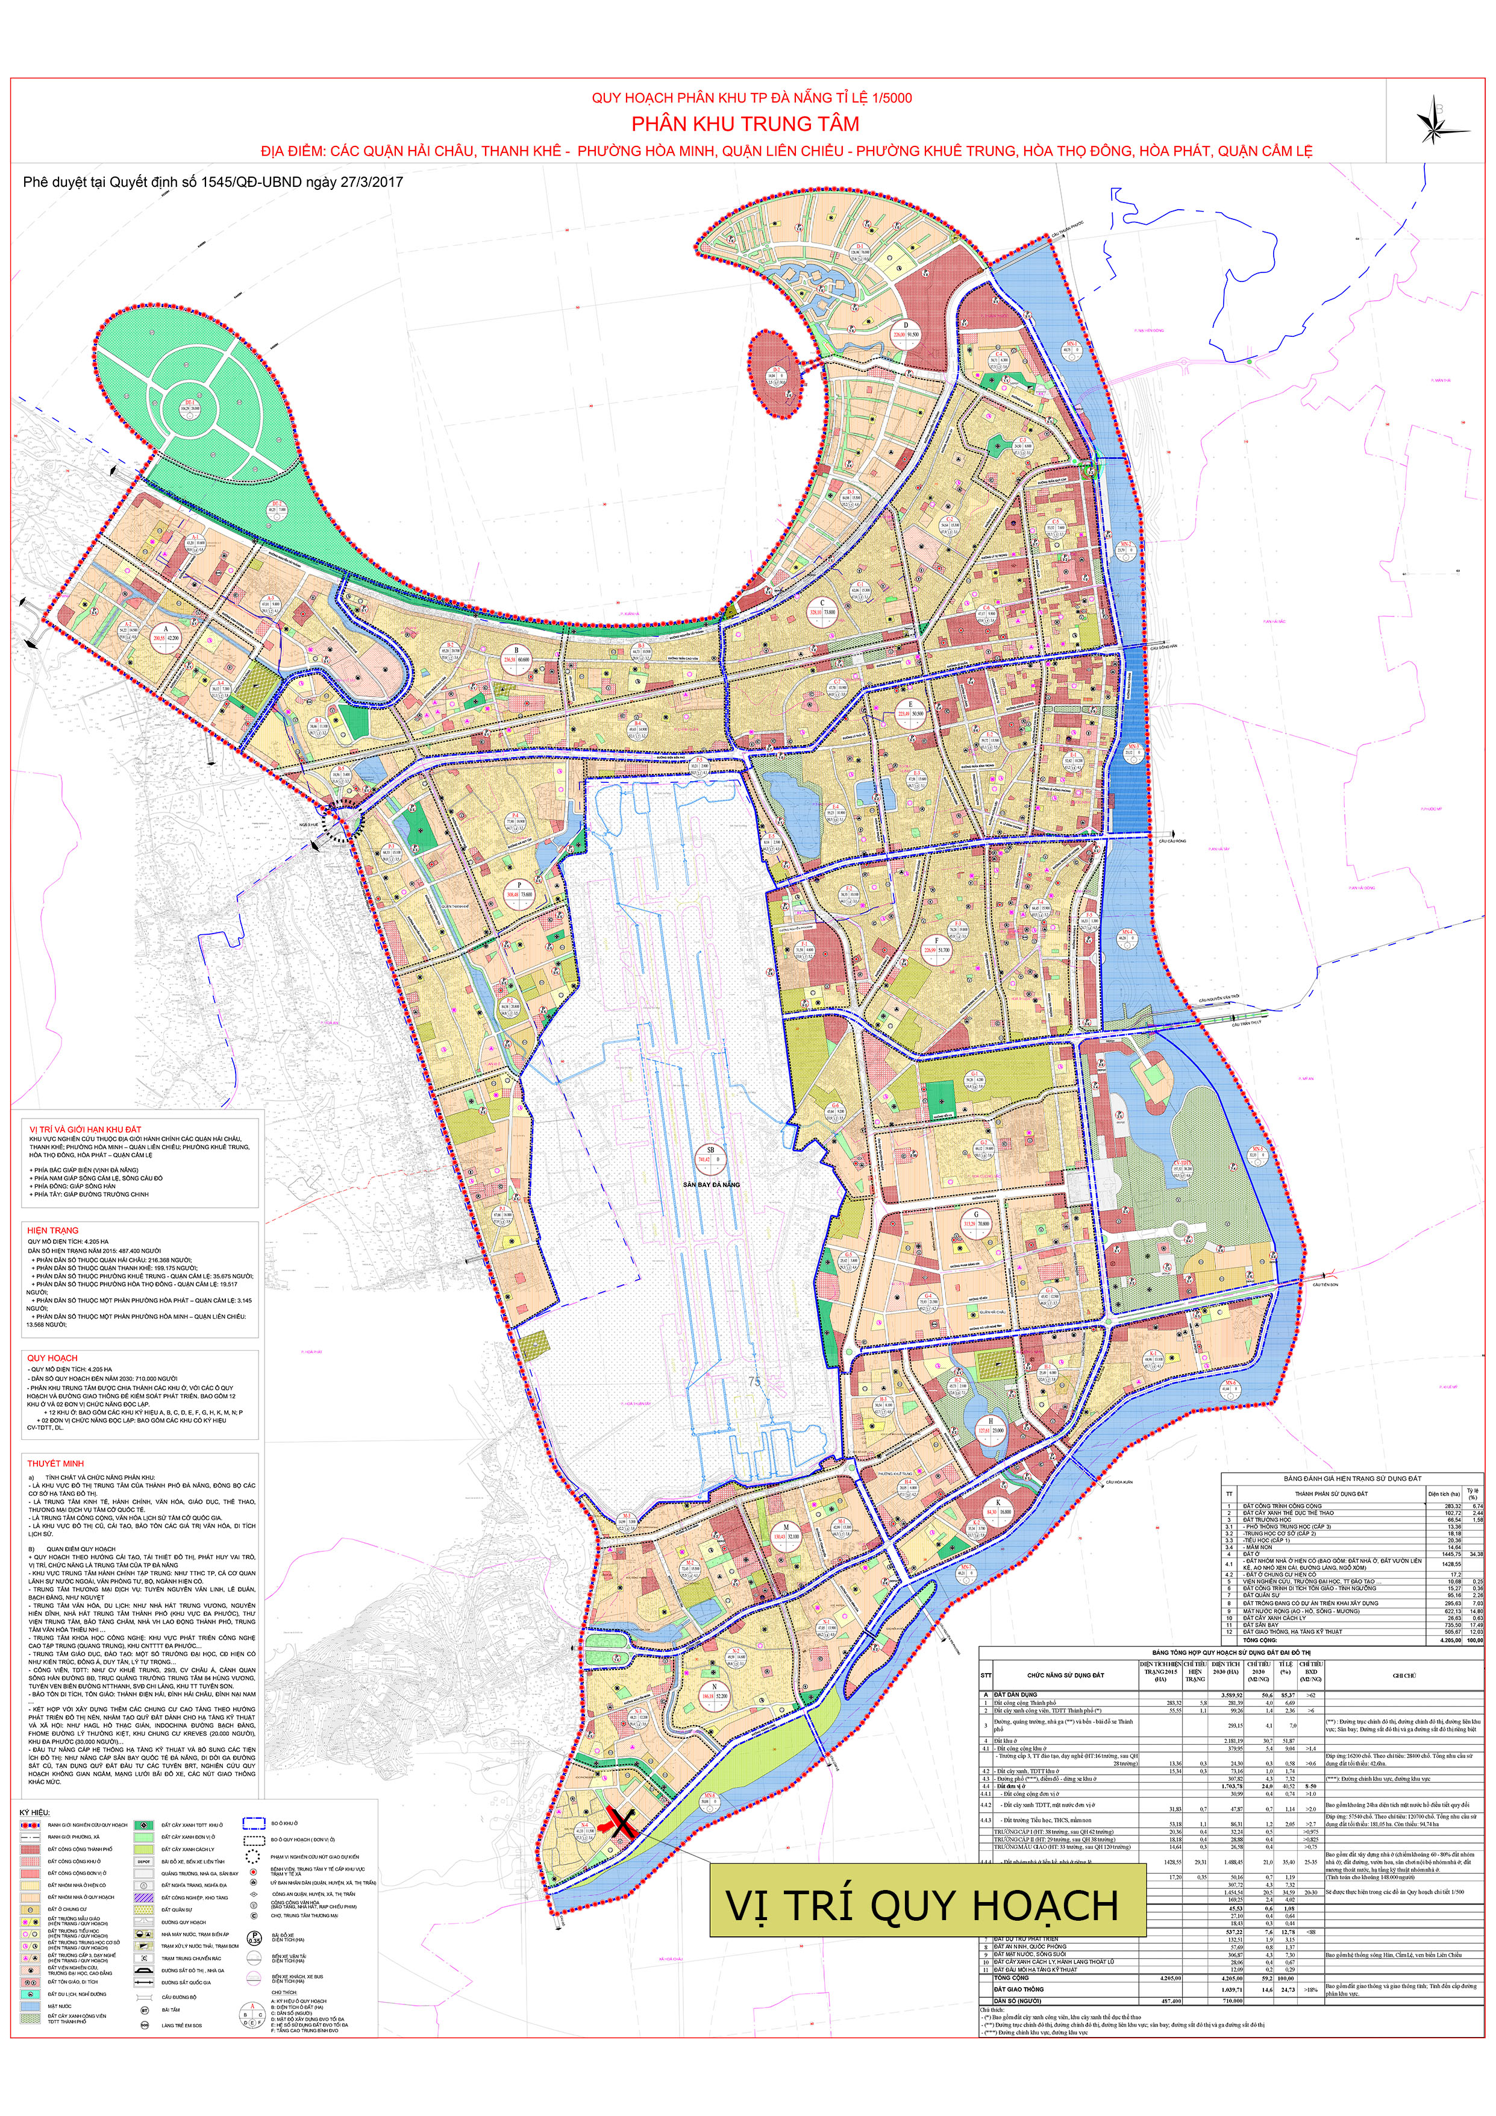

- Historical - cultural value:
+ It was built around the beginning of the 10th century, the Cham - Phong Le relic site has both long-standing historical value and architectural and artistic value. This is one of the rare ancient architectural and artistic relics in Da Nang city.
+ Currently, the Da Nang Museum of Cham Sculpture is preserving and displaying many artifacts transferred from Phong Le in the early 20th century, including round statues, reliefs and architectural decorations.
+ Archaeological campaigns in 2011, 2012 and 2018 all discovered very valuable sculptural artifacts and completely revealed the most important architectural structures constituting the Cham Phong Le complex; in particular, archaeological excavations have revealed "sacred holes", whose size is currently among the largest in Vietnam and the region.

- Scientific value:
+ With vestiges revealed through archaeological excavations, large-scale Champa architectural works once existed in Phong Le.
+ The excavation of the Phong Le relic site in 2011 opened 5 holes (symbolized as 11.PL.H1, 11.PL.H2, 11.PL.H3, 11.PL.H4, 11.PL.H5) with a total area of 206m2 and has revealed 2 large-scale architectural relics. In particular, it is possible that H1 is the relic of the Gate tower and H4 and H5 are the relics of the Central tower in a Hindu architectural complex of the ancient Champa kingdom. In addition, the excavation of the Phong Le relic site in 2011 also collected a lot of valuable documents to serve the Museum's display and scientific research. The second excavation of the Cham Phong Le relic site in 2012, although it did not excavate and explore the entire relic site, revealed quite clearly and accurately the entire scale and the foundation structure of a very large Cham tower. Especially for the first time, a "sacred hole" has been excavated with a completely different layout from known relics. The obtained artifacts, although they are egg-shaped granite pebbles, square bricks, white quartz, etc., they raise us many questions about religious beliefs, about the scale of the entire relic site, about the significance of the relic site in the material and spiritual life of the ancient Cham people.

- In general, the historical, cultural, scientific and aesthetic value of the relic site:
The newly excavated Cham - Phong Le relic site still retains many traditional cultural features as well as architecture typical of traditional architecture. In particular, the special structures of this relic site will be valuable research objects for the process of understanding intangible cultural heritage in the city.
  - Boundaries and scope of research:
- The total area of the research land is 19,740 m², including:
+ The scope of the relic conservation and protection area is 4,279 m² (Area I is 2,653 m²; Area II is 1,626 m²).)
+ Scope of area for promotion of relic value with an area of 15,461 m² (Area III).
- The four areas near the research area are as follows:
+ Area I is a Conservation Area with an area of 2,653m²: North, South, West: Border on the current residential area; East: Border on the Area II;
+ Area II is the Relic Protection Area with an area of 1,626m²): North and South: Border on the current residential area; East: Border on the planned road; West: Border on the Area I.
+ Area III is the Area for promotion the value of relic site with an area of 15,461m²: North: Border on the land planned for green park; South: Border on Thang Long street; East: Border on Pham Vinh street; West: Border on the planned road;
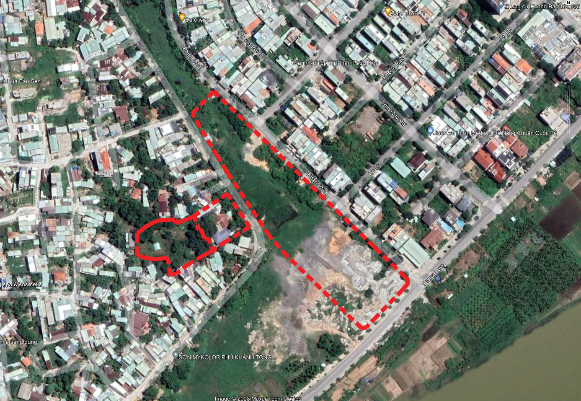
* Land boundaries on Google map:
AREA III
AREA: 15,461 M²
AREA II
AREA: 1,626 M²
AREA I
AREA: 2,653 M²
* Boundaries of the research land:

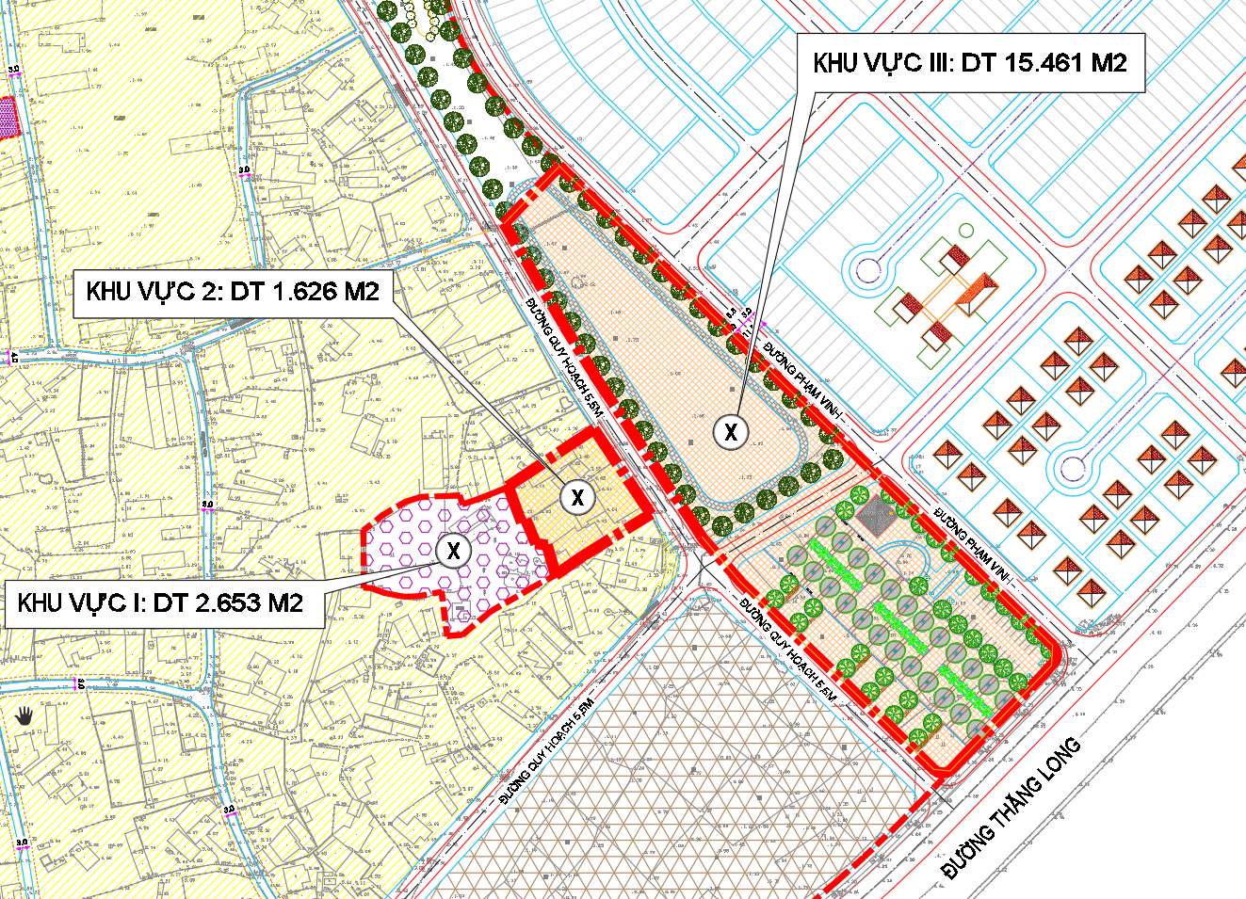

  - Area’s current status:
Current status of the research area includes: Relic conservation and protection area, area of 4,279m² (including 2,653m² of Area I and 1,626m² of Area II): Tower architecture, auxiliary structures and connection systems , Ba Temple, 02 ancient tombs, sacred holes, antiques, exhibition house.
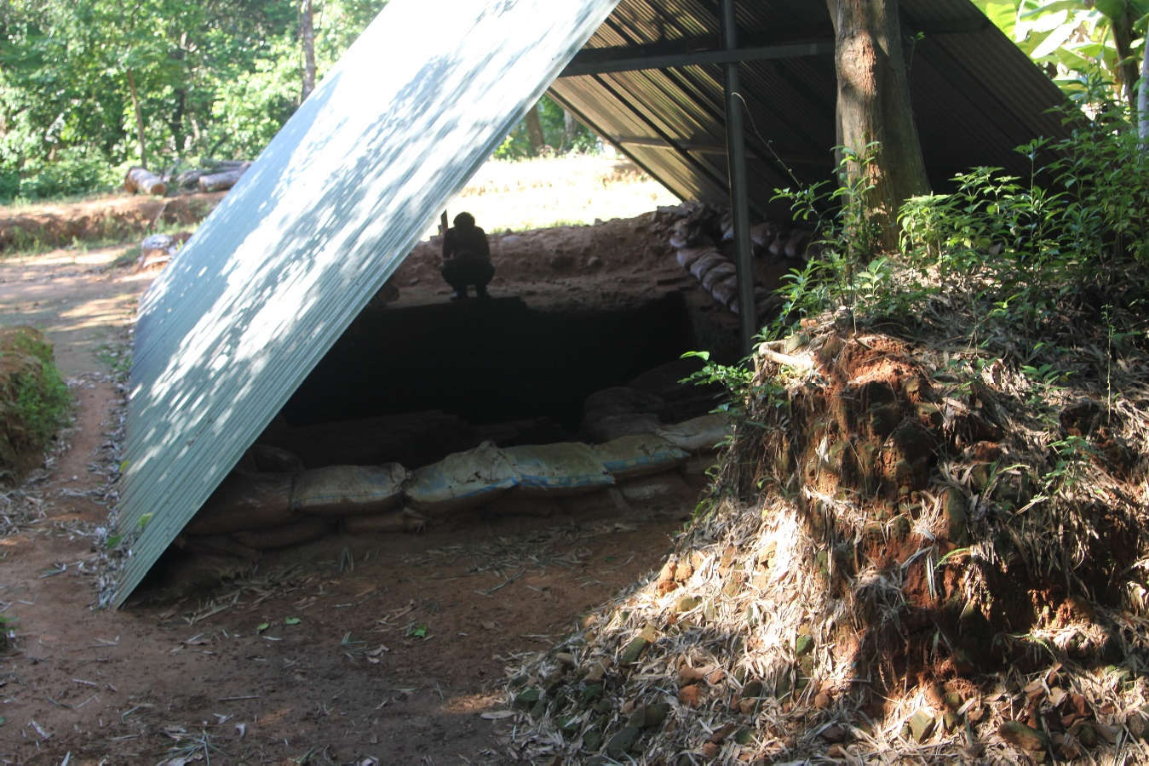

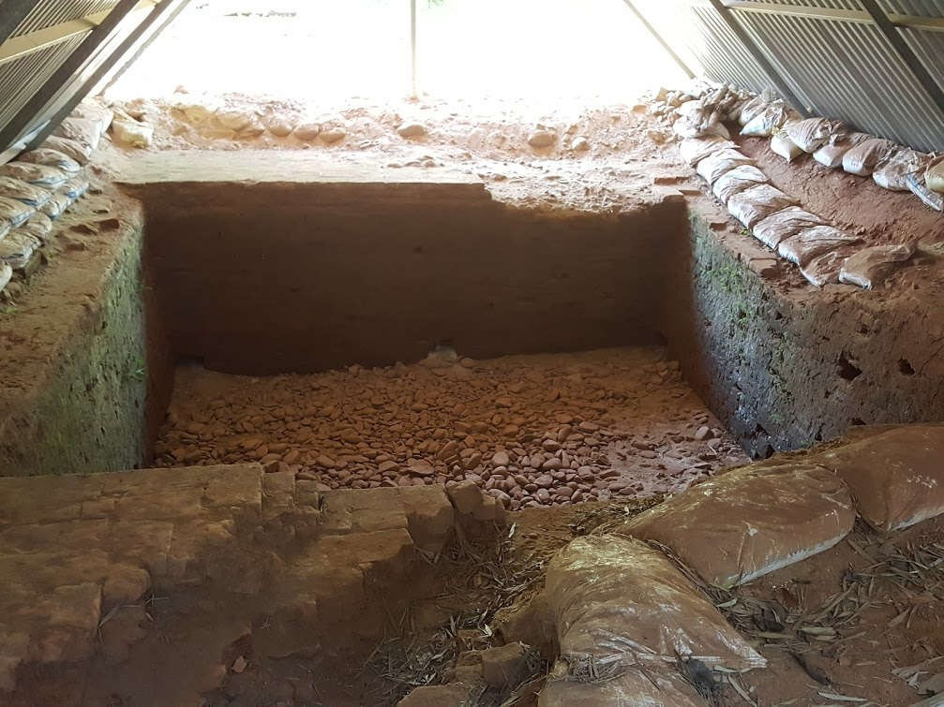
The sacred hole is temporarily covered
After excavating the sacred hole, there are no scientific conservation measures

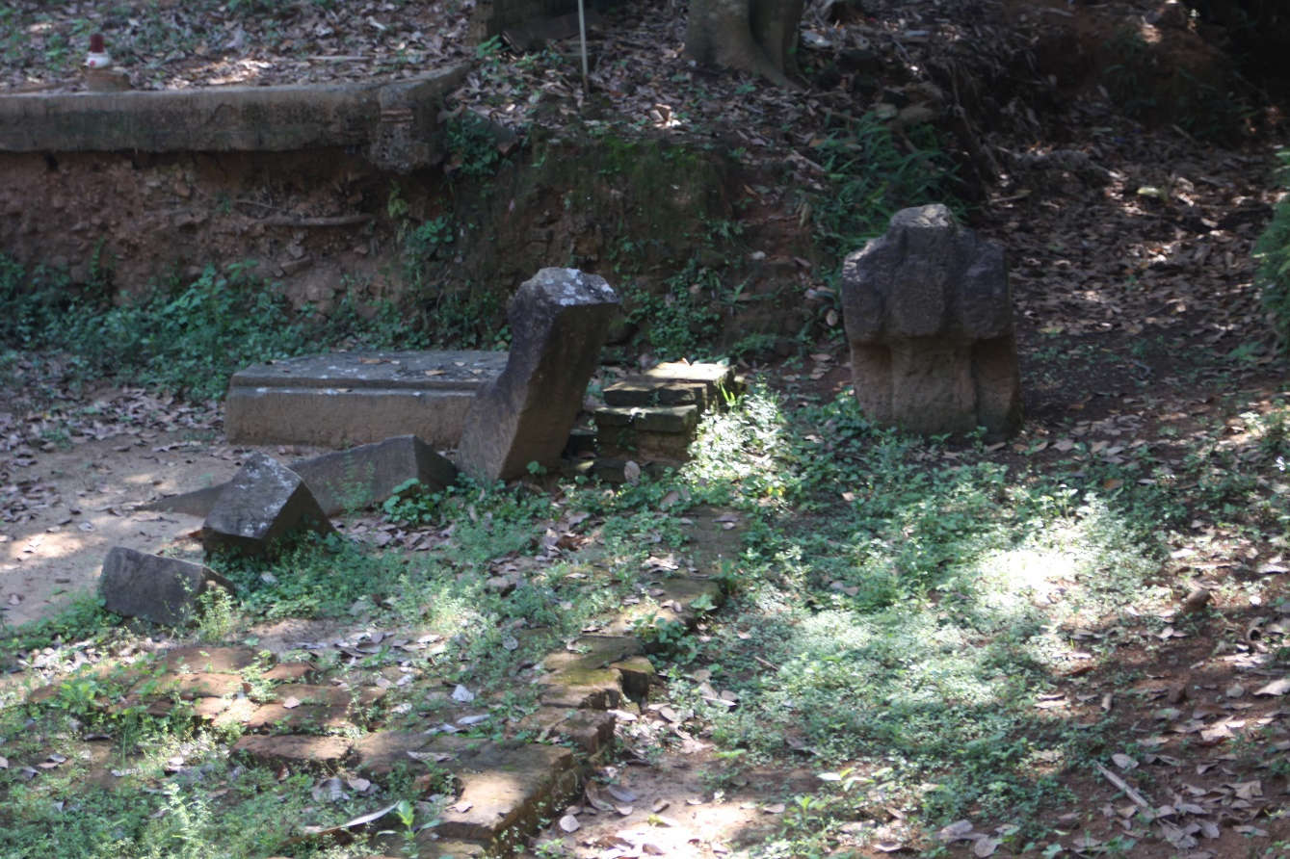

Antiquities after archeology have no protection measures
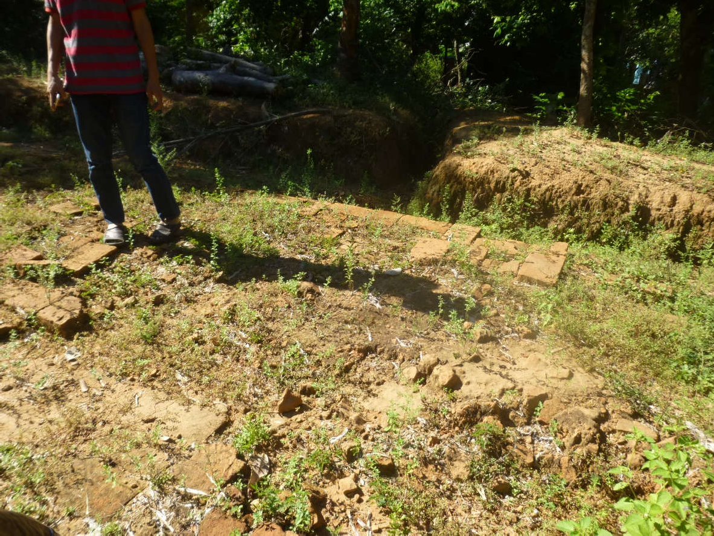
The archaeological area was invaded by trees after a period of time

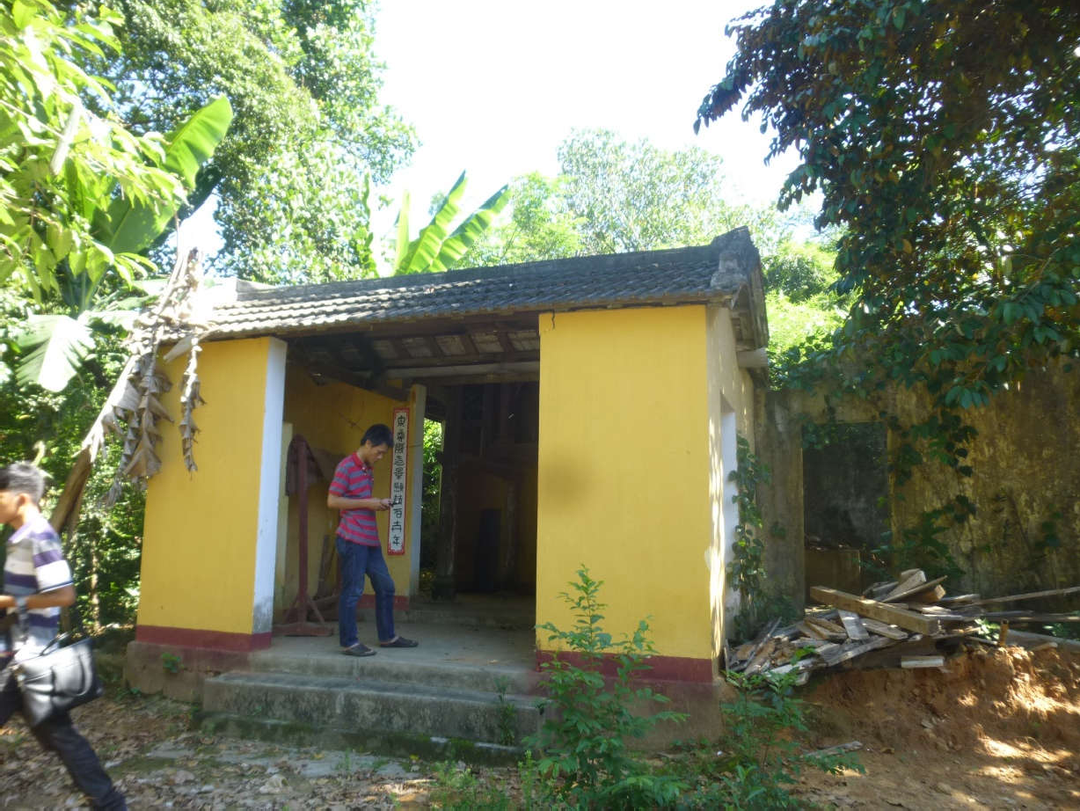

Ba Temple in the relic area
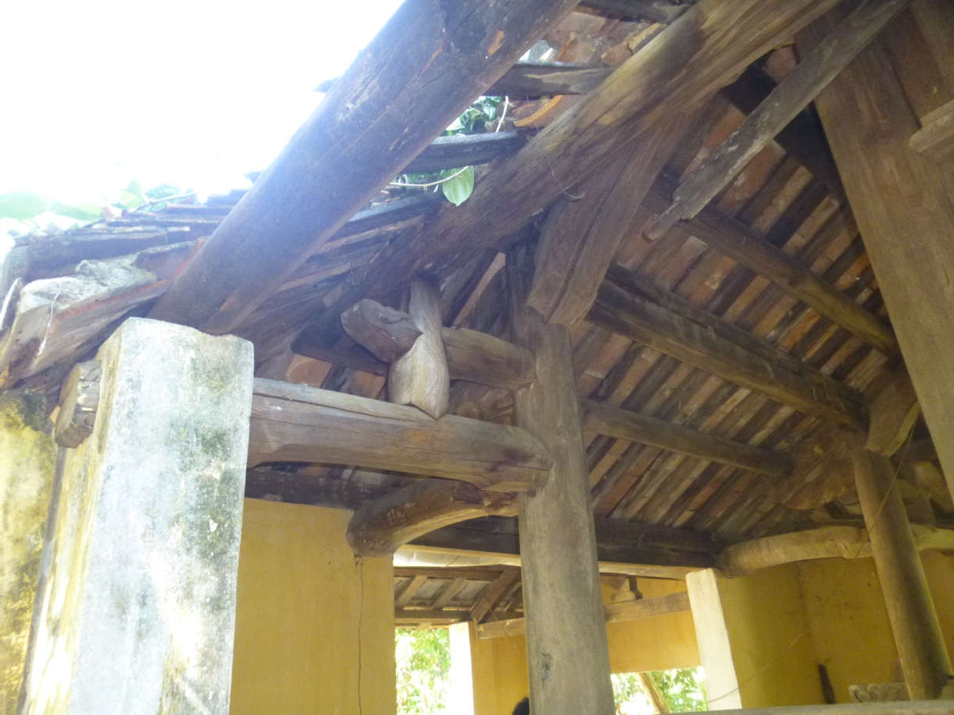

The degraded condition of Ba Temple

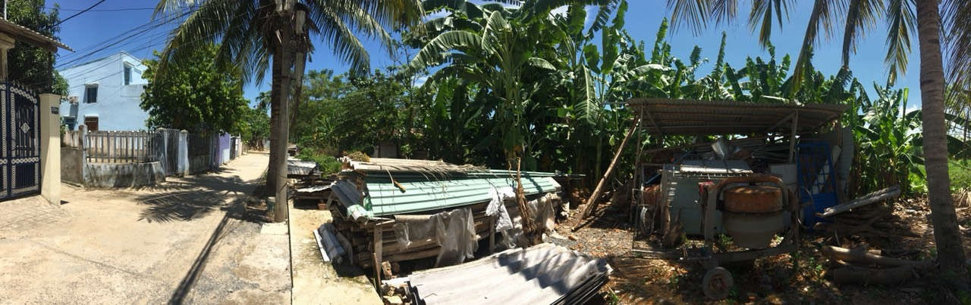
Current status of residential concrete road K29 Tran Ngoc Suong in southwest of the research area
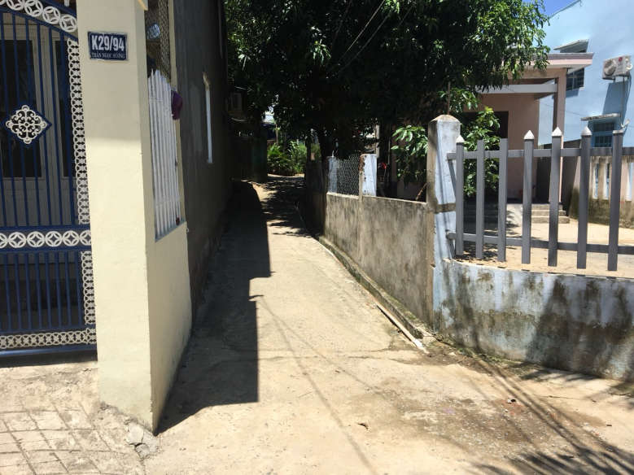

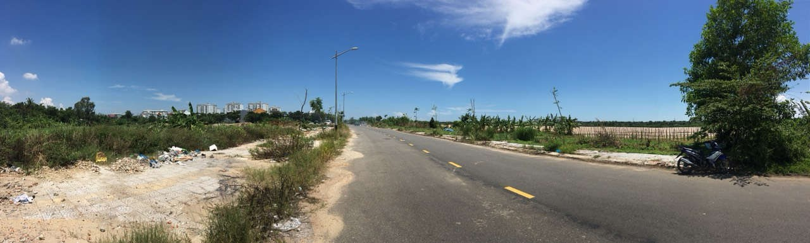
Entrance to the Cham Phong archaeological area
Current land use status between residential street K29 Tran Ngoc Suong and Pham Vinh street

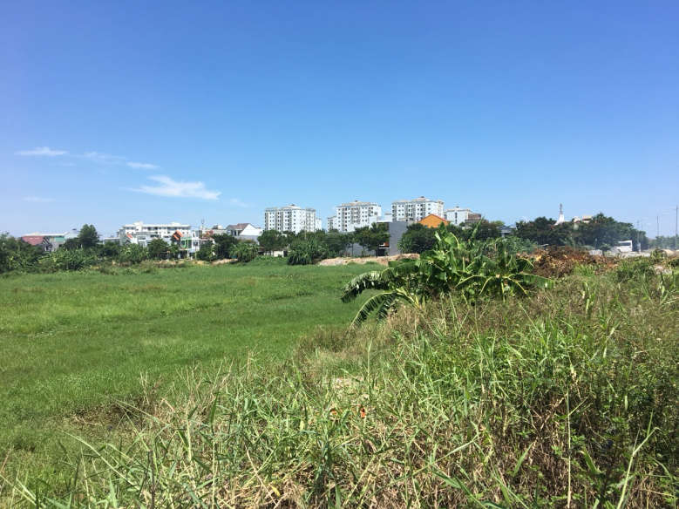
Current status of the Thang Long road section in front of the research area and the Cam Le riverbank area
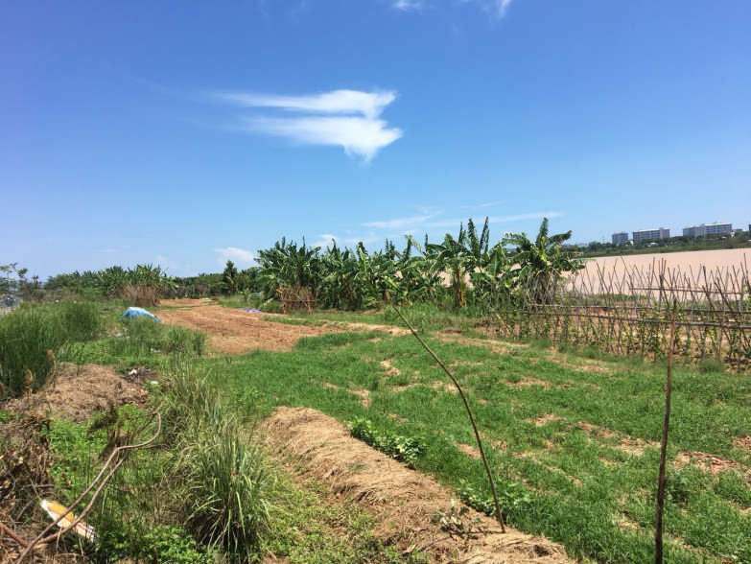
Current land use status of Cam Le riverbank area

  - Design requirements:
a) General requirements:
- Survey the current status and analyze and evaluate the project's general current conditions.
- Comply with the orientation of the Project on archeology and promoting the value of Cham Phong Le relic site approved by the People's Committee of Da Nang City in Decision No. 6236/QD-UBND dated 01 November 2017 and Decision No. 153/QD-UBND dated 19 January 2023 on approving adjustments to the Project on archeology and promoting the value of Cham Phong Le relic site and Resolution No. 02/NQ-HDND dated 24 March 2023 of the City People's Council on deciding the investment policy of the Museum of Cham Sculpture project, branch no. 2 (at Phong Le).
- Planning and architectural criteria: Propose criteria on land use, technical and economic criteria, and socio-economic criteria in accordance with current regulations and standards.
- Ensure usability, including providing technical solutions to preserve, restore and promote all revealed Cham archaeological relics, while ensure utilities, information and services to serve for the sightseeing needs of residents and tourists.
- Solutions for functional zoning, organization and arrangement of functions to ensure proper use and operation.
- Solutions for architectural design, space organization, and interior of the project are suitable for the nature of the project, with the shape, location and size of the planned land, in harmony with the surrounding landscape space, create highlight and have its own characteristics consistent with Cham cultural architecture.
- Height space solutions: Propose design solutions in terms of height, project shape and organization of landscape space around the area, consistent with the landscape of the Cam Le riverbank area and neighboring works.
- Specify or propose design solutions for each specific project item.
- Traffic organization solutions: Propose reasonable access options to the area, ensure continuity, parking areas for cars and motorbikes for residents and tourists, with special attention to the means of picking up and returning tourist groups.
- Solutions related to synchronous infrastructure such as traffic, parking, power supply, water supply and drainage, lighting, and synchronous communications, etc.
- Technical solutions: There is a load-bearing structural solution that ensures feasibility, sustainability, long-term use and a modern engineering system, applies new and advanced technologies, saves costs, shortens construction time, ensures maintenance and operation of the project in accordance with the city's smart city development project, encourages the use of renewable energy, ensures efficient energy use for the project.
- Propose operating scenarios, exploit and use, be capable of calling for investment in socialization to serve people and tourists.
- Ensure technical and financial feasibility.
- Determine investment needs, investment stages, list of priority investment projects, land use needs and calculate economic efficiency.
- Make a preliminary assessment of environmental impact with environmental protection solutions.

b) Specific requirements:
Based on the content and scale of the Project on archeology and promoting the value of Cham Phong Le relic site approved by the People's Committee of Da Nang City in Decision No. 6236/QD-UBND dated 01 November 2017 and Decision No. 153/QD-UBND dated 19 January 2023 on approving adjustments to the Project on archeology and promoting the value of Cham Phong Le relic site, inheriting the results of research content of the Department of Culture and Sports of Da Nang City in the period before Notice No. 375/TB-VP dated 23 July 2021 of the People's Committee of Da Nang City took effect, the proposed design requirements are as follows:
- The scope of conservation planning orientation is protection area I (core area) of the relic site with an area of 2,653m² and peripheral space with an area of 17,087m².
- Regarding space layout, divided into 02 areas with the following functions:
+ Relic conservation and protection area, area of 4,297m² (including 2,653m² of Area I and 1,626m² of Area II): Preserve tower architecture, sub-architectures and associated systems, Ba Temple, 02 ancient tombs and protective walls, and roofs for foundation areas vulnerable to weather damage and a system of green trees and landscape spaces to create buffer zones to protect the relic.
Solutions to preserve and protect the relic: Protective walls, drainage system, corridors to visit relics in protected areas to avoid affecting the original elements of the relic, roof for the entire area I has materials that are harmonious, sustainable, and can be used for a long time with weather factors (do not use galvanized steel materials).
Lighting solution: Lighting the overall landscape space of the relic site and directly lighting the core area associated with the floor, temple and tower's foundations, sacred holes, archaeological excavation artifacts revealed on the surface of the archaeological excavation holes.
+ Relic value promotion area, area of 15,461m² (Area III): Planning lotus pond, green tree area, landscape to create open space to serve residential community and tourists to visit, relax and entertain. Planning 05 service areas, arranging areas for refreshments and selling traditional products; parking area planning; Arrange additional planning for functional works: Cham relics exhibition house in Da Nang, Traditional Professions exhibition house (collection of tools and product production processes of local industries and surrounding areas), space for performing intangible cultural heritages (shepherd festival, boat racing festival, pictures display and documents about Da Ly ancient village, organization of yo-heave-ho singing, Vietnamese classic opera, bai choi singing, etc.), in addition, green park space planning creates a buffer zone to protect relics and connect technical infrastructure. Note that the lotus pond is both a landscape lake and a detention basin to ensure the regulation of water drainage from the northern area to the Cam Le river through the drainage canal system.
  - Economic Issues:
Prepare an estimate of investment costs and design plans to ensure compliance with the total investment approved in Decision No. 153/QD-UBND dated 19 January 2023 on approving adjustments to the Project on archeology and promoting the value of Cham Phong Le relic site and Resolution No. 02/NQ-HDND dated 24 March 2023 of the City People's Council on deciding on the investment policy of the Museum of Cham Sculpture project - branch no. 2 (at Phong Le).
Use the city budget capital and other legal sources of investment capital, the total expected investment is VND 266,796,000,000, of which:
- Budget capital: Carry out clearance, compensation, archeology and investment in conservation of construction items in the Relic Conservation and Protection Area, area of 4,279m² (Area I and Area II), including:
+ Clearance, compensation, archeology and relic protection in area I: VND 4,403,830,500.
+ Implement project investment for the period of 2022-2027, with a budget: VND 140,736,000,000 (including all items of Area I and Area II, technical infrastructure of Area III).
- Capital calls for investment and socialization:
Implement the investment for the period 2028-2032, invest in items to promote the value of relics in Area III with a budget: VND 121,656,280,000.

Proposal for business and exploitation plans:
- Propose organizational and operational models, programs, and exploitation scenarios to ensure that the Cham Museum will be a new and attractive destination, it both promotes the image of the locality and the country; and has revenue from ticket sales and added values from services and event activities.
- Propose operation, business and exploitation plans for Area III, method of calling for socialized investment, ability to recover capital.

PART IV: CONTEST PLANS
NO. | CONTENTS | DURATION
I | CONTEST PREPARATION | 45 days
- | Collect documents and data, synthesize and complete legal documents related to the contest.
- | Survey the current status, develop the contest regulations, tasks and plans, and contest estimation
- | Send an invitation to join the Council
- | Collect opinions (first time) on draft of the contest regulations and tasks
- | Complete documents of the contest regulations, tasks and plans, and contest estimation
- | Submit for approval of the contest regulations, tasks, plans and contest estimation
- | Establish the Contest Council and submit it to competent authorities for approval
II | CONTEST ORGANIZATION | 75 days
- | Create the contest website, announce contest information and invite candidates
- | Receive contestants, pre-qualify and invite the contestants
- | Contestants survey the land’s current state
- | Contestants take the entries
- | Receive entries
III | PLAN REPORTING AND EVALUATION | 15 days
- | Review of contest entries
- | Exhibition of contest entries
- | Contestants defend their plans, the contest council judges and selects
IV | ANNOUNCEMENT OF RESULTS AND AWARDING OF PRIZES | 30 days
- | Report the contest results, submit the contest results for approval
- | Decide to recognize the contest results
- | Announce and award prizes

PART V: APPENDIX
Appendix 1
SOCIALIST REPUBLIC OF VIETNAM
Independence - Freedom - Happiness

CONTEST REGISTRATION FORM
Contest of Planning and Architectural Plans for Museum of Cham Sculpture - Branch no. 2 (at Phong Le) - phase 1

Respectfully addressed to: The Organizer
Contestant:
Address:
Email:
Tel.: Fax:
Represented by: Position:

We learned about the Contest of Planning and Architectural Plans for Museum of Cham Sculpture - Branch no. 2 (at Phong Le) - phase 1 on the media.

We consider that the unit has enough reputation and capacity, so we registered to participate in the contest. We commit to comply with the contest regulations.

………….. , date……month…… 2023
REPRESENTATIVE OF CONTESTANT
(Full name, title, signature and seal)

Appendix 2
PARTNERSHIP AGREEMENT
Contest of Planning and Architectural Plans for Museum of Cham Sculpture - Branch no. 2 (at Phong Le) - phase 1

Pursuant to the announcement of the Contest of Planning and Architectural Plans for Museum of Cham Sculpture - Branch no. 2 (at Phong Le) - phase 1

We, representatives of the parties signing a partnership agreement, include:
Name of partnership relationship:
Represented by: Mr./Ms.:
Position:
Address:
Tel.:
E-mail:
Account no.:
Tax ID:
The parties (hereinafter referred to as members) agree to sign a partnership agreement with the following contents:
Article 1. General principles
1. Members voluntarily formed a partnership relationship to participate in the contest of Planning and Architectural Plans for Museum of Cham Sculpture - Branch no. 2 (at Phong Le) - phase 1
2. The members agree on the name of the partnership relationship for all transactions related to this contest : ……………………………………… (Enter the name of partnership relationship according to the agreement).
3. In case the plan is selected, no member has the right to refuse to perform the responsibilities and obligations specified in the approved and issued Contest Regulations. In case a member of the partnership relationship refuses to fulfill his or her own responsibilities as agreed, such member will be handled as follows:
- Compensate for damages to the parties in the the partnership relationship;
- Compensate for damages to the organizer according to the regulations stated in the Contest Regulations;
- Others ……………………………….. (Specify).
Article 2. Assignment of responsibilities
The members agree to take common and separate responsibilities for participating in the contest for each member as follows:
1. Leading member of the partnership relationship
The parties agree to authorize ……………………… (Insert name of authorized company) to be the leading member of the partnership relationship, this authorized company represents the partnership in the following tasks:
- Sign the contest registration form;
- Sign documents to communicate with the Technical Team during the contest participation process, including presenting the contest plan report;
- Participate in the Contract negotiation process and next design steps if selected;
- Others………………………………….. (Clearly specify the content of other jobs (if any)].
2. The members of the partnership agree to assign responsibilities for performing work according to the table below:
No. | Name | Description | Ratio %
1 | Name of leading member of the partnership | - ....  - .... | - .... %  - .... %
2 | 2nd member’s name | - ....  - .... | - .... %  - .... %
.... | …… | …… | ……
Total |  | All tasks | 100%
Article 3. Effectiveness of partnership agreement
1. The partnership agreement takes effect from the date of signing.
2. The partnership agreement will terminate in the following cases:
- The parties fulfill their responsibilities and obligations;
- The parties mutually agree to terminate;
- The partnership's plan is not selected;
- The organizer cancels the Contest.
The partnership agreement is made into …… copy (copies), each party keep(s) …… copy (copies), all agreements have the same legal value.

LEGAL REPRESENTATIVE OF LEADING MEMBER OF THE PARTNERSHIP
[Full name, title, signature and seal]

LEGAL REPRESENTATIVE OF MEMBER OF THE PARTNERSHIP
[Specify name of each member, title, signature and seal]

Appendix 3
CAPACITY OF THE CONTESTANT
A. Capacity profile of the contestant:
- Capacity profile, operational capacity certificate, design practising certificate (attached with relevant legal documents).
- Specialized awards (if any).
- Number of years of experience in the field of planning and architecture.
- Financial statements of the unit for the most recent 3 years.
- Experiences of contestants.
- Projects and works of similar scale and nature that units and contestants have implemented.
No. | Name of unit | Contact information | Unit’s capacity profile  (Company’s operational capacity certificate) | Capacity profile of contestants (design practising certificate) | Experience in implementing similar projects | Related awards and certificates of merit
B. Achievements
(Summary of the content and scale of planning projects that consultant units have participated in or have implemented; awards achieved in the field of planning design, evaluated by reputable international/Vietnamese organizations - accompanied by supporting documents).

EXPERT'S CURRICULUM VITAE

Intended position:
Name of consultant unit:
Full name of expert:
Nationality:
Occupation:
Date of birth:
Company name:
Working period:
Period | Working unit | Reference information | Position
From month/year to month/year | …… | (specify name, phone number, and email of the referenced person to verify information) | ……
Similar works were involved:
(List similar projects)
Qualification:
(Clearly state relevant qualifications and practising certificates as prescribed in the contest conditions).
I hereby declare that the above information is true and correct. If it is wrong, I will be responsible to the law.

………, date…….. month…….. 2023
Declarant
[Signature, title and full name]
Remarks:
- The consultant unit attaches a copy of the labor contract; images of diplomas and professional practising certificates of the consultants mentioned above.

LIST SIMILAR PROJECTS
No. | Contract name | Project name | Name of Employer | Location | Scale (planned area, project level...) | Duration | Award achieved
1
Remarks:
- The contestant must enclose a copy of documents proving that it has completed at least 01 approved project.
- The contestant must attach a copy of the prize (if any).

Appendix 4
CONTESTANT’S INFORMATION

Contestant’s name:
Code:
Address:
Phone number:
Email:
Account number:
Tax ID:
Names and track records of the project manager and associates participating in the design.
Cooperation or partnership agreement (in case of cooperation or partnership).

………, date…….. month…….. 2023
Declarant
[Signature, title and full name]

INSTRUCTIONS FOR CODING THE CONTEST'S DESIGN PRODUCTS
1. The self-selected code of the design consultant unit participating in the contest consists of 02 letters and 02 any numbers (for example: AB12) and must be printed in capital letters about 10mm high in a rectangular box about 15mm high, approximately 50mm wide in the upper right corner of the drawings.
This code is also written on the cover of the explanation and on one corner of the model.
2. Envelope “Information of contestant”:
- Outside of the envelope: Clearly state the contest name; contest code.
- Contents inside include: (Appendix 3)

