SOCIALIST REPUBLIC OF VIETNAM
Independence - Freedom - Happiness
------------------
PROJECT MANAGEMENT UNIT FOR INVESTMENT AND CONSTRUCTION OF TRANSPORTATION WORKS
APPROVED
Pursuant to Decision No. 116/QD-BCTGT date April 8, 2024
(signed)

COMPETITION REGULATIONS, TASKS, AND SCHEDULE
ARCHITECTURAL PLANNING SCHEME FOR THE LE THANH NGHI - CACH MANG THANG TAM - THANG LONG - HOA XUAN BRIDGE ACCESS ROAD INTERCHANGE CLUSTER

PROJECT MANAGEMENT UNIT FOR INVESTMENT AND CONSTRUCTION OF TRANSPORTATION WORKS
APPRAISAL
According to document No. 38/2024 date April 8, 2024
(signed)

*** DA NANG, 2024***
SOCIALIST REPUBLIC OF VIETNAM
Independence - Freedom - Happiness
---------***--------
Da Nang, date ………,2024

COMPETITION REGULATIONS, TASKS, AND SCHEDULE
ARCHITECTURAL PLANNING SCHEME FOR THE LE THANH NGHI - CACH MANG THANG TAM - THANG LONG - HOA XUAN BRIDGE ACCESS ROAD INTERCHANGE CLUSTER

Name of the competition: Competition for planning and architectural design of the intersection cluster of Le Thanh Nghi - Cach Mang Thang Tam - Thang Long - the ramp leading to Hoa Xuan Bridge.
Investment decision-making agency: People's Committee of Da Nang City.
Planning organization agency/Competition organizing unit: Project Management Unit for Investment and Construction of Transportation Works.
Consulting unit organizing the competition: Center for Construction Technical Consultancy of Da Nang City.

Consulting unit organizing the competition  CENTER FOR CONSTRUCTION TECHNICAL CONSULTANCY OF DA NANG CITY | Competition organizing unit  PROJECT MANAGEMENT UNIT FOR INVESTMENT AND CONSTRUCTION OF TRANSPORTATION WORKS IN DA NANG
Deputy Director  (signed and sealed)  Nguyen Xuan Tai | Director  (signed and sealed)  Nguyen Minh Huy

A. COMPETITION REGULATIONS
Chapter I
GENERAL INTRODUCTION
I. Legal bases:
- Law on Urban Planning No. 30/2009/QH12 dated June 17, 2009; Consolidated Text No. 16/VBHN-VPQH dated July 15, 2020;
- Law on Construction No. 50/2014/QH13 dated June 18, 2014; Law amending and supplementing a number of articles of the Law on Construction No. 62/2020/QH14 dated June 17, 2020;
- Law on Architecture No. 40/2019/QH14 dated June 13, 2019;
- Decree No. 85/2020/ND-CP dated July 17, 2020 of the Government, detailing a number of articles of the Law on Architecture;
- Decree No. 37/2010/ND-CP dated April 7, 2010 of the Government on the formulation, appraisal, approval and management of urban planning; Decree No. 72/2019/ND-CP dated August 30, 2019 amending Decree No. 37/2010/ND-CP dated April 7, 2010;
- Decree No. 15/2021/ND-CP dated March 3, 2021 of the Government, detailing a number of contents on the management of construction investment projects;
- Circular No. 06/2013/TT-BXD dated May 13, 2013 of the Ministry of Construction on guiding the contents of Urban Design and Circular 16/2013/TT-BXD dated October 16, 2013 on amending and supplementing a number of articles of Circular 06/2013/TT-BXD;
- Decision No. 359/QD-TTg dated March 15, 2021 of the Prime Minister on approving the master plan of Da Nang City to 2030, with a vision to 2050;
- Decision No. 1287/QD-TTg dated November 2, 2023 of the Prime Minister on approving the planning of Da Nang City for the period 2021-2030, with a vision to 2050;
- Decision No. 2451/QD-UBND dated November 7, 2023 of the Chairman of the People's Committee of Da Nang City on approving the 1/2000 scale detailed planning project for the Han River and East Coast;
- Notice No. 384/TB-VP dated July 26, 2021 of the People's Committee of Da Nang City on the conclusions of the Vice Chairman of the People's Committee at the meeting to listen to the Department of Transport report on a number of contents related to the field of transport;
- Official Letter No. 437/SGTVT-KH dated February 10, 2023 of the Department of Transport on the architectural competition for the intersection cluster of Le Thanh Nghi - Cach Mang Thang Tam - Thang Long - the ramp leading to Hoa Xuan Bridge;
- Official Letter No. 1220/UBND-DTDDT dated March 17, 2023 of the People's Committee of Da Nang City on the implementation of the project of the intersection cluster of Le Thanh Nghi - Cach Mang Thang Tam - Thang Long - the ramp leading to Hoa Xuan Bridge;
- Official Letter No. 2723/SGTVT-KH dated June 23, 2023 of the Department of Transport on the implementation of the preparation for investment in the project of the intersection cluster of Le Thanh Nghi - Cach Mang Thang Tam - Thang Long - the ramp leading to Hoa Xuan Bridge;
- Official Letter No. 544/BQL-TGTDB dated June 29, 2023 of the Management Board of Basic Construction Works of Hai Chau District on the estimation of compensation costs and the proposed resettlement plan for the cases of clearance to implement the project of the intersection cluster of Le Thanh Nghi - Cach Mang Thang Tam - Thang Long - the ramp leading to Hoa Xuan Bridge.
II. General information about the competition
- Name of the competition: Competition for planning and architectural design of the intersection cluster of Le Thanh Nghi - Cach Mang Thang Tam - Thang Long - the ramp leading to Hoa Xuan Bridge.
- Investment decision-making agency: People's Committee of Da Nang City.
- Planning organization agency/Competition organizing unit: Project Management Unit for Investment and Construction of Transportation Works.
- Competition jury: To be established by the Planning organization agency.
- Technical team: To be established by the Planning organization agency.
- Source of funds: State budget.
- Currency used: Vietnamese Dong (VND).
- Language: Vietnamese is the main language.
- Form of competition: Open competition.
- Time of the competition: From January 2024 to August 2024.
- Consulting unit organizing the competition: Center for Construction Technical Consultancy of Da Nang City.
+ Address: No. 107 Le Sat Street, Hoa Cuong Nam Ward, Hai Chau District, Da Nang City.
+ Phone: 0236.3.796.322
+ Website: http://tuvanthituyen.vn/cumnutgiaothong_cauHoaXuan
III. Objectives and requirements of the competition
1. Purpose of the competition:
The organization of the competition aims to select the planning and architectural design for the next steps of the project, select the most optimal design with high feasibility, ensuring both aesthetic form and functionality, in accordance with technical requirements, completing the network of technical infrastructure for transportation in accordance with the planning orientation, connecting synchronously the technical infrastructure system in the area, solving the traffic congestion in the intersection cluster area, improving traffic capacity and safety level when passing through the intersection.
2. Requirements of the competition.
- The design must fully express the contents of the Design Brief and comply with the Competition Regulations.
- Comply with the current Vietnamese construction design standards and codes and international standards accepted by the competent authorities of Vietnam.
- Organize the analysis and evaluation of the design of the participating units, on that basis propose and select the best design as a basis for implementing the next steps of the project;
- Ensure fairness, objectivity, transparency, compliance with the regulations of the Vietnamese state and relevant international laws.
- Organizations and individuals participating in the design competition must have sufficient capacity and civil acts as prescribed by current Vietnamese law.
- The participating units must bear all expenses related to the competition process.
- Foreign organizations and individuals participating in the competition are required to have their own interpreter.
IV. Form of competition
1. Form of competition: Open competition with no restrictions on domestic and foreign organizations and individuals to participate.
2. Selection method: Selection through 02 rounds.
- Preliminary round: A general announcement of the competition content will be publicly posted on the media. At the same time, directly invite a number of reputable and experienced domestic design consulting units to participate in the competition. Invited design consulting units as well as design consulting units wishing to participate in the competition need to submit a registration application.
After the registration deadline, the selection process in the preliminary round will be based on the capacity profile of the registered units. From there, at least 05 design consulting units with sufficient qualifications, capacity, and relevant experience will be selected to be invited to participate in the competition round. The competition organizing unit will announce the results to the organizations and individuals who are allowed to participate in the next round of the competition to implement the competition plan.
In the case of selection that does not ensure enough 05 consulting units to participate in the competition, the competition organizing unit will decide whether to re-invite the competition, switch to another form of competition, or stop the competition.
- Competition round: Organizations and individuals who have passed the preliminary round will implement the competition plan and submit the competition plan according to the prescribed time. The competition jury will select the plan according to the Design Brief, Competition Regulations and the Jury's Regulations, and transfer the results of the competition to the competition organizing unit and report to the People's Committee for approval of the results and awarding of prizes.
V. Documents provided to the participating units
1. Text documents.
- Competition plan;
- Design brief;
- Competition regulations;
- Application form for participation in the competition;
- Other relevant documents.
2. Technical documents.
- All official documents of the competition will be provided by the competition organizing unit through the competition information website.
- Other relevant documents and information (if any).
Chapter II
COMPETITION RULES
I. Participants and conditions for participation
1. Eligible participants:
All domestic and foreign organizations, individuals or joint ventures with sufficient qualifications, professional capacity, and practice in accordance with current laws in Vietnam are allowed to register to participate in the competition.
2. Conditions for participation.
- Independent organizations, individuals or joint ventures participating in the competition must meet all of the following conditions:
- Have legal status, operate in accordance with Vietnamese law; have full civil act capacity as prescribed by law;
- Be licensed to operate in the fields of planning design consultancy, architectural design of works, and traffic works;
- Have a certificate of construction capacity in accordance with current regulations;
- The consulting organization participating in the competition must ensure the capacity conditions according to current regulations, have a certificate of capacity to operate in the fields of planning design consultancy (or architectural design of works) and traffic works design from grade II or higher; in case of joint ventures, at least 01 organization is required to meet the capacity requirements.
- The individual in charge of the design must have a practicing certificate in planning design (or architectural design of works) of at least grade II or higher.
- The individual in charge of traffic design must have a practicing certificate in traffic works design of at least grade II or higher.
- The participating units will be assessed by the competition organizing unit according to the criteria of this Competition Regulation. The official participating unit will be notified by the competition organizing unit and invited to participate in the competition.
- The criteria for selection and invitation to participate in the competition must meet the criteria set out by the competition, which are consulting units with expertise in architecture, planning, and transportation (bridges, roads, traffic organization), especially units with experience, sufficient capacity, reputation and relevant practical experience, practicing in accordance with current laws, priority is given to units that have won prizes in architectural design competitions.
3. Ineligible participants.
- Members of the Competition Jury;
- Members of the Technical Team;
- Individuals involved in the development of the design brief and competition regulations;
- Organizations and individuals related to members of the Competition Jury and do not have the capacity, experience, and practicing certificates in accordance with regulations.
4. Regulations on joint ventures and membership status.
- Organizations and individuals participating in the competition may form a joint venture with other organizations or individuals who meet the conditions set out by the competition organizing unit as mentioned above. In this case, there must be one unit that takes the main responsibility (the head of the joint venture).
- Each organization or individual may only participate in one joint venture;
- The design consulting joint venture must have a written agreement between the members of the joint venture. The joint venture agreement must be sent to the competition organizing unit together with the registration application (preliminary round).
- All matters of rights and obligations between the parties in the joint venture are agreed upon by the parties themselves, the competition organizing unit is not responsible.
- The participating units may cooperate with a prestigious expert or a group of experts with experience and capacity to ensure the results of the work (Experts are not allowed to be members of the Competition Jury or the Technical Team). In this case, the consulting unit does not need to send a memorandum of understanding to the competition organizing unit. The names and scientific backgrounds of these experts must be stated by the participating unit in the list of personnel participating in the development of the competition plan.
II. Procedures for registration and submission of applications for the preliminary round
1. Registration for participation.
Units wishing to participate in the competition register their information as follows: Submit online via email to register first, after checking and confirming, submit the application directly or by post to the consulting unit organizing the competition.
Units registering for the competition must submit the following documents to the competition organizing unit:
No. | Application content | Online submission | Direct submission (original) | Forms
1 | Application form and Memorandum of Understanding for joint venture (if any) | 01 scanned file in PDF format (signed and stamped) and 01 word file with the same content | Signed and stamped document | Appendix 01, 02
2 | Documents proving professional capacity and legal status of individuals and consulting units as prescribed by Vietnamese law. | 01 scanned file in PDF format | Notarized document within 6 months
3 | Capacity profile of individuals and consulting units.  Certificate of awards in previous competitions (if any). | 01 scanned file in PDF format | Signed and stamped document (for the unit submitting the capacity profile)
4 | List of experts, members (if individual) participating in the joint venture | 01 scanned file in PDF format and 01 word file with the same content | Signed and stamped document

Some notes:
- The units registering for the competition do not have to pay a participation fee;
- The competition organizing unit has the right to request the participating consulting unit to clarify and supplement the documents proving their eligibility, capacity, and experience if necessary.
- The competition organizing unit does not pay any expenses for the participation of the registered units except for the prizes and the cost of supporting the participation in the competition for up to 05 units with valid competition plans and the highest evaluation by the Competition Jury (excluding the units winning the first, second and third prizes).
2. Receiving applications for the preliminary round.
The registration application must be submitted directly (during office hours) or sent by post no later than 5:00 PM on the last day of registration according to the competition plan.

CENTER FOR CONSTRUCTION TECHNICAL CONSULTANCY OF DA NANG CITY
Address: 107 Le Sat, Hoa Cuong Nam Ward, Hai Chau District, Da Nang City
Email: TTTVthituyen@gmail.com
Phone: 0236.3.796.322

3. Receiving competition entries for the competition round.
- The units selected for the competition round will complete their entries within 45 days (Specific time according to the competition plan);
- The participating units must submit their design entries directly (during office hours) to the competition organizing agency no later than 5:00 PM on the last day of receiving entries according to the competition plan. If sent by post, it will be based on the postmark but must be ensured no later than 5:00 PM on the last day of receiving entries according to the competition plan:

CENTER FOR CONSTRUCTION TECHNICAL CONSULTANCY OF DA NANG CITY
Address: 107 Le Sat, Hoa Cuong Nam Ward, Hai Chau District, Da Nang City
Email: TTTVthituyen@gmail.com
Phone: 0236.3.796.322

- The Technical Team will prepare a handover minutes of the competition entries (directly or by post), clearly stating: Time of submission, quantity, content, and status of the product. The Technical Team and the representative of the submitting party will sign the minutes; the handover minutes will be made in 02 copies, each party keeps 01 copy;
- The participating unit should pay attention to the safekeeping of the product and respect the regulations on the dossier when transferring the product to the competition organizing unit;
- The participating unit is not allowed to change the competition plan after the submission deadline. During the evaluation process of the competition plan, the competition organizing unit may request the participating unit to clarify the contents of the competition plan in the form of indirect or direct exchange, but ensure that the basic content of the design plan is not changed. The requests for clarification of the competition organizing unit and the comments of the participating unit must be in writing and kept by the competition organizing unit according to the regulations of the competition.
III. Time and location of the competition.
1. Competition time.
- The competition time will be implemented according to the competition plan approved by the competition organizing unit.
- Registration time: From the date of announcement on the mass media.
- Deadline for submission of registration applications: According to the approved competition plan.
- Time to announce the results of the preliminary round and invite to participate in the competition: After the deadline for receiving applications, the competition organizing unit will organize the selection of the capacity of the registered units, the consulting units selected for the competition round will be invited by the competition organizing unit to participate in the competition.
- Time for field survey: Organizations and individuals participating in the competition can organize their own field survey if deemed necessary.
- During the competition, if there are any changes in the time, the competition organizing unit will send a notice to the participating units at least 03 days before the deadline for submission of competition entries.
2. Location of the competition.
- The location of the presentation of the competition plan before the Competition Jury will be announced by the competition organizing unit in a Notice or Invitation sent to the participating units at least 03 days before the evaluation session.
IV. Requirements for application documents and competition entries
1. General regulations.
- There is no limit on the content of illustrations for the competition plan.
- The language used in all competition entries and the Description is: Vietnamese or bilingual English - Vietnamese (if the participating unit is foreign), other languages are not allowed to be used in any drawing and description.
- Unit of measurement used in the competition entry: Length is measured in meters (m); dimensions for the general layout drawing are in meters (m), square meters (m2) or hectares (ha); dimensions for the architectural drawing are in millimeters (mm).
- Form of expression: Symbols and colors according to the conventions of the drawing symbol system in Vietnamese architectural and construction planning projects.
- Each unit participating in the competition can submit no more than 02 competition plans.
- Currency unit: Vietnamese Dong.
2. Format of application documents and competition entries.
- All application documents and competition entries are expressed anonymously. Use anonymous code on the submitted products (each drawing page and description). This anonymous code is chosen by the participating unit, consisting of 02 letters and 02 numbers (for example: AB12), written in 01cm high capital letters in the upper right corner of each drawing and competition document. This code is also written on the cover of the description and on a corner of the model (if any). Any participating unit that writes the name of their company or research group on the title block of any of the drawings will be disqualified.
- Each competition entry must be contained in a sealed and sealed package, with the name of the competition, the code of the participating unit and a list of the components of the competition entry contained inside (in accordance with the anonymous rule).
- On the drawings and descriptions, there must not be any information in the form of text or drawings (logos, symbols, signs, etc.) that can identify the participating unit.
- The full information about the participating unit is written in a sealed envelope and sealed by the participating unit (including the name of the unit, address, phone, fax, email...). The outside of the envelope only shows the code of the participating unit;
- The anonymous rule is applied to all application documents, competition entries as well as USB drives.
- The application will be kept confidential until it is handed over to the Competition Jury and this application will only be used when the Jury scores (publicly) or for the participating unit to present before the Jury.
3. Content of the design plan dossier.
The competition entry in Vietnamese must be sealed, the outside only shows the "Anonymous code" of the unit, including:
- Information dossier of the participating unit (Appendix 3)
- Competition plan, including: 15 sets of drawings + A3 color printed description (with USB containing soft files of the entire dossier) must fully express the following contents:
- Maps and diagrams analyzing the current land use, current architecture, current architectural landscape space, current traffic, current bridges, technical infrastructure... assessing the potential of the research area, with appendices, descriptions (explanations, interpretations, additional arguments for the description; illustrative drawings; calculation data and relevant legal documents).
- Drawings illustrating the design ideas including: Ideas for planning and architectural design; Diagram of the planning location, the relationship of the area affected by the planning area.
- Drawings illustrating the design including: General layout plan; Detailed design layout; Detailed design layout of underground space (if any); Architectural items; Diagram of the organization of architectural landscape space, urban design; Traffic organization solution; Material use solution; Landscape and greenery design solution; Night lighting solution.
- Analysis of the compliance with the design brief, planning, and landscape architecture of the construction area.
- Analysis of the compliance with the historical and socio-cultural characteristics of the locality.
- Proposed technical solutions inside and outside the building, building equipment (if any).
- Impact of the plan on the regulations on environmental protection, flooding and fire prevention;
- Analysis of the feasibility of the plan in terms of site clearance, technical solutions, total project investment...;
- Estimate the total investment according to the competition plan, propose to ensure compliance with the scale and investment rate according to current regulations (including design costs, site clearance (if any) and other related costs).
- Images, overall perspectives, night perspectives, detailed perspectives illustrating the idea.
- 01 set of display drawings mounted on A1 hardboard, numbered and coded for exhibition, showing the following contents:
- Design idea.
- Detailed general layout drawings (Scale fit to A1 size).
- Functional architectural floor plans, underground space floor plans (if any) (Scale fit to A1 size).
- Drawings of architectural items.
- Diagram of the organization of architectural landscape space, urban design.
- Description of relevant design solutions.
- Technical and construction solutions (if any).
- Images, overall perspectives, night perspectives, detailed perspectives illustrating the idea.
- Model of the plan (encouraged).
- Video illustrating the plan (encouraged).
- Content of the presentation report file (slides, video) before the Competition Jury (in case of not being able to report directly). Note that in the report video, only the anonymous code is mentioned, not the name of the unit, submit at least 01 day before the report date.
4. Invalid application documents and competition entries.
The competition organizing unit will eliminate, not accept and not submit to the Competition Jury for consideration and evaluation of competition entries that do not meet the basic requirements of the Competition Regulations, including the following cases:
- Violation of the principle of anonymity as prescribed for the Competition Jury to be able to identify the participating unit during the evaluation of the plans.
- Submitting an insufficient number and components of the dossier, submitting not on time and at the wrong location as prescribed.
Chapter III
EVALUATION AND RANKING OF COMPETITION PLANS
I. Competition Jury
1. Composition of the Jury.
- The jury for the planning and architectural design competition (hereinafter referred to as the Jury) will evaluate and rank the competition entries, helping the planning organization agency to select the optimal plan that meets the requirements of planning, architecture, culture, socio-economic efficiency, national defense, security and environmental protection to implement the next steps of the project.
- The Jury is established by the planning organization agency.
- The composition of the Jury complies with the provisions of Clause 4, Article 13 of Decree No. 37/2010/ND-CP: The Competition Jury includes representatives of state management agencies, relevant social and professional organizations, the city's architectural planning advisory council and experts with experience in the field of planning, architecture, transportation, and socio-culture.
- The Jury operates independently under the direction of the Jury Chairman. The Jury's operating regulations are discussed and agreed upon by the Jury and issued by the Jury Chairman before the official evaluation session of the Jury.
2. Working principles of the Competition Jury.
- The Jury operates independently and complies with the Jury's operating regulations. The Jury members ensure independence, objectivity, honesty and the highest responsibility to complete the common tasks of the Jury;
- The Jury's regulations must clearly state the principles and methods of evaluating and ranking the competition entries, and the responsibilities of the Jury;
- The regulations must be agreed upon by the members. The Jury Chairman, on behalf of the Jury, approves the Regulations and is responsible for the implementation of the Regulations;
- The Jury will only evaluate and rank the competition entries when at least 3/4 of the members are present;
- The Jury Chairman and members, secretary are not allowed to disclose or provide to organizations or individuals outside the Jury any information about the content of the discussion, opinions and conclusions of the Jury during the evaluation and ranking of the competition entries;
- The report on the competition results must be signed by all members of the Jury.
3. Responsibilities of the Competition Jury.
- The members of the Jury are responsible for ensuring confidentiality, objectivity, honesty and not engaging in negative behaviors that affect the evaluation and ranking results.
- The Jury Chairman must be present and preside over the Jury throughout the working time of the Jury.
- Analyze the planning schemes based on meeting the requirements of the competition brief; the scientific and practical nature of the plan and evaluate and rank the consulting organizations.
- Summarize and report the results of the evaluation and ranking of the competition to the urban planning organization agency.
- The comments of the Competition Jury on the plans will be synthesized so that the competition organizing unit can request the winning unit to supplement and complete the design of the plan.
II. Technical Team
- The Technical Team is established by the planning organization agency.
- The Technical Team has the following tasks:
- Guide organizations and individuals registering for the competition; Receive registration procedures, Receive and check competition entries; review the validity of each competition plan and report back to the Jury (if necessary);
- Support and evaluate the Capacity Profile of the consulting units participating in the competition;
- Receive and explain the Competition Regulations to the registered organizations and individuals; Provide relevant information and documents to the participating organizations and individuals;
- Prepare a summary report on the planning criteria, technical parameters and validity of each plan to send to the Competition Jury;
- Support and advise the Competition Jury throughout the organization of the competition, evaluation and ranking of the plans. III. Presentation of the plan and selection.
III. Presentation and selection of plans
1. Defense of the plan before the Competition Jury.
After submitting the competition entries, the participating units that meet all the conditions will be notified of the time and place to officially defend the plan before the Competition Jury. The form of defense will be according to the announcement of the competition organizing unit.
- Direct presentation form:
Each unit sends a representative to report and defend the plan in the form of a slide show and presentation. The participating unit prepares the file and shows it at the time of the report. In case of reporting in another form, the participating unit will prepare the necessary means by themselves.
The maximum presentation time for each unit is 15 minutes (20 minutes if there is a video), 20 minutes for foreign units (25 minutes if there is a video), the presentation time may change according to the actual situation decided by the Competition Jury.
- Video presentation form:
Each unit makes its own video presenting the plan for the Competition Jury to watch and discuss with the Jury via online connection.
2. Plan selection process.
a) Selection process for the competition round:
- Round 1 (Classification of entries): The competition organizing unit classifies the entries that meet the criteria according to the approved competition brief to submit to the Competition Jury for consideration to enter round 2 to defend the plan before the Competition Jury.
- Round 2 (Presentation and selection of entries): After studying the competition plans and listening to the presentations of the units (directly or via video), the Competition Jury will analyze, evaluate and select 03 plans with the highest scores to enter round 3, the final ranking according to the prize structure.
- Round 3 (Ranking of winners): The Competition Jury will discuss, evaluate and rank the final ranking through a secret ballot.
Note: The selection process may change according to the actual situation decided by the Competition Jury.
b) Criteria for evaluating the plan:
No. | Evaluation criteria | Maximum score
1 | Design idea, theoretical basis | 5
2 | Planning solution (Land use planning, organization of architectural landscape space, traffic organization) | 35
 | Land use planning | 5
 | Organization of architectural landscape space | 10
 | Traffic organization | 20
3 | Architectural solution (Architectural form, materials used, lighting) | 25
 | Building architecture (Flyovers, underpasses, auxiliary works...) | 15
 | Use of materials | 5
 | Aesthetic lighting form | 5
4 | Technical solution (Structure, construction method) | 20
 | Bridge structure solution | 15
 | Construction method | 5
5 | Economic solution (Investment cost, saving land fund, limiting site clearance) | 10
6 | Plan report, composition and quality of the dossier | 5
 | Total score | 100

The Competition Jury may adjust the scoring scale to suit the evaluation criteria in the Jury's Working Regulations.
The evaluation and ranking report must be signed by all members of the Competition Jury.
The consulting units participating in the competition have no right to request an explanation of the scoring and ranking of the competition plans.
5. Announcement of the competition results.
- After the People's Committee of Da Nang City agrees on the results of the competition, the competition organizing unit will send a notice to the winning units and the participating units that are eligible to receive the support fee.
- The competition organizing unit decides on the form of organizing the exhibition, display, and consultation of public opinion on the competition plans (if any).
Chapter III
PRIZE STRUCTURE AND EXPENSES
I. Cost of organizing the competition
Cost of organizing the competition: Based on the estimated cost of organizing the competition approved by the competent authority, including the following costs:
- Cost of organizing the competition
- Cost of consultancy for organizing the competition
- Prize cost.
II. Prize structure and value
1. Prize structure.
The total value of prizes and support is VND 900,000,000, of which:
- 01 First prize : 400,000,000 VND.
- 01 Second prize : 200,000,000 VND.
- 01 Third prize : 100,000,000 VND.
- 01 Community prize : 50,000,000 VND.
- Support for the plans that enter the next round (top 05 plans with high scores excluding 03 winning plans and the community prize plan): VND 150,000,000 (VND 30,000,000/each plan).
- In case the contest does not have one of the above prizes and there are plans that win the same prize, a part or all of the prize value that does not have the above prize will be awarded to the plans that win the same prize, as proposed by the Competition Jury and decided by the competition organizing unit.
- Community prize: Evaluated based on the opinions of people at the exhibition of the competition plan, voted online on the contest website, considered and proposed by the Competition Jury.
- The above prize values have included all taxes that the prize winners must pay according to regulations, sent to the units after the competition organizing unit approves the results of the competition and the participating units complete the necessary financial procedures.
2. Method of payment of prizes and support.
- The prize and support costs are transferred by the competition organizing unit in Vietnamese Dong (VND) to the winning units and supported units;
- The prizes will be sent to the participating units after the decision to approve the results of the competition and the participating units complete the necessary financial procedures.
III. Basis for calculating design fees for works:
- Basis for calculating design fees for works: According to current regulations on the management of construction investment costs.
Chapter IV
REGULATIONS ON COPYRIGHT AND OWNERSHIP, RIGHTS, AND RESPONSIBILITIES OF PARTICIPATING ENTITIES
I. Confidentiality, Copyright, and Ownership
- Design submissions from participating firms will be kept confidential and secure by the Technical Committee throughout the evaluation period.
- All competition entries are protected under intellectual property laws.
- The deciding authority of the competition owns all submitted designs and has the right to publish them.
- All submitted design materials (maps, drawings, reports, descriptions, models, films, etc.) become the property of the deciding authority and will not be returned to the submitting firm.
- The organizing entity will collaborate with the winning design firm to utilize and incorporate ideas from other competition entries to enhance the final design.
- Participating firms commit to the following:
- Not using the winning design in this competition for any other competitions or projects. Violation of this will result in the forfeiture of the prize.
- Ensuring that all submitted documents, materials, and designs do not infringe upon the copyright or intellectual property rights of any individual or third party. Participating firms are responsible for the copyright and intellectual property of their submissions, including ideas, content, descriptions, drawings, and software used, in the event of any third-party claims. If copyright or intellectual property violations cause damage to the deciding or organizing authorities, the responsible firm must compensate for all losses, including any prize money and support received.
- Before the competition results are announced, participating firms may not use, provide, or display their design submissions for any other purpose without permission from the organizing entity.
- Participating firms are allowed to use their design submissions to showcase their consulting capabilities after the competition concludes.
II. Rights and Responsibilities of Participating Entities
1. Rights and Responsibilities of Participating Entities.
- All competition entries are guaranteed authorship rights under Vietnamese intellectual property laws.
- The organization or individual with the highest-ranking design will be given priority to carry out the next steps of the project, provided they meet the requirements under construction and bidding laws.
- If the selected organization or individual lacks the capacity to implement the next steps, they may form a joint venture with a qualified consulting organization.
- Within 30 days of notification from the competition organizer or the assigned project implementation agency, if the winning organization or individual does not proceed or refuses to proceed with the next steps, the investor will negotiate the use of the winning architectural design under intellectual property and related laws. If negotiations fail, the next ranked design will be selected for negotiation and contract signing (after receiving feedback and improving the design).
- Consulting fees for the selected design will be applied according to current Vietnamese regulations.
- Participating design firms have no right to request explanations from the competition organizer, Technical Committee, Jury Panel, or any other related organizations/agencies regarding the preliminary selection or competition results.
- Adherence to the Competition Regulations and Design Brief is mandatory.
- Participants are legally responsible for the copyright and authorship of their submitted works, including any related disputes.
- Participants must ensure independent financial accounting and not be in the process of dissolution, declared bankrupt, or have outstanding debts as defined by law.
- In the event of being selected for the next steps, participants must refine their design based on feedback from the Jury Panel, experts, and the investor.
- Participants must cooperate with the competition organizer to report the winning design to relevant authorities (if requested).
- Participants will be informed of the official time and location for defending their design before the Jury Panel, with at least 3 days' notice before the defense (if required).
- Participants are responsible for all costs related to registration and participation in the competition.
2. Rights and Responsibilities of the Competition Organizer, Jury Panel, and Consulting Firm.
- Adhere to the approved Competition Regulations.
- Refrain from using their influence to distort the competition results.
- Organize the competition in a transparent and fair manner. All requirements must be communicated clearly and comprehensively to the participating entities.
- Protect the information of the participating entities.
- Own all submitted competition entries.
- Pay prize money to participating entities as per regulations.
- Select the most qualified and suitable entity to implement the next steps, based on the ideas and research results from various entries in the competition, while ensuring authorship rights are maintained during use.
- Choose the most suitable design to proceed with the next steps.
III. Other Competition Regulations
- The competition organizer has the right to modify the Competition Regulations based on suggestions from the Jury Panel and the consulting firm. The organizer is responsible for informing all relevant parties of any changes.
- If no design meets the objectives and requirements outlined in the Design Brief and Competition Regulations, the competition may be re-held or terminated, as decided by the Planning Agency or the competition organizer.
- Any disputes arising during the competition (if any) will be resolved through mediation. If mediation fails, the dispute will be resolved according to current Vietnamese law.

B. DESIGN BRIEF

1. Applicable Design Codes and Standards:
- QCVN 01:2021/BXD: National Technical Regulation on Construction Planning.
- QCVN 02:2022/BXD: National Technical Regulation on Natural Condition Data for Construction.
- QCVN 03:2022/BXD: National Technical Regulation on Classification of Construction Works for Design and Construction.
- QCVN 07:2023/BXD: National Technical Regulation on Technical Infrastructure Works - Transportation Works.
- QCVN 41: 2019/BGTVT: National Technical Regulation on Road Traffic Signs.
- TCVN 5664:2009: Vietnamese Standard on Technical Classification of Inland Waterways.
- TCXDVN 104:2007: Vietnamese Construction Code on Technical Regulations for Urban Street and Square Design.
- TCVN 4054-05: Vietnamese Standard on Roads - Design Requirements.
- TCVN 11823:2017: Vietnamese Standard on Road Bridge Design.
- Foreign design standards (if applicable)
2. Objectives:
To meet the highest standards for the design and investment project for the construction of the Le Thanh Nghi - Cach Mang Thang Tam - Thang Long - Hoa Xuan Bridge access road intersection cluster. The goal is to select the optimal design that meets planning, construction, functional, and economic efficiency requirements, creating an architectural and landscape highlight in the area. This will contribute to the completion of the city's transportation network, enhancing connectivity between the city center and the southern and western areas.
3. General Project Information:

- Project Location:
+ The project includes the intersections of Cach Mang Thang Tam - Le Thanh Nghi - Hoa Xuan Bridge Access Road - Thang Long; Hoa Xuan Bridge - Nguyen Phuoc Lan, and the surrounding area.
+ Location: Hai Chau and Cam Le districts, Da Nang City.

- Project Location on Google Maps:

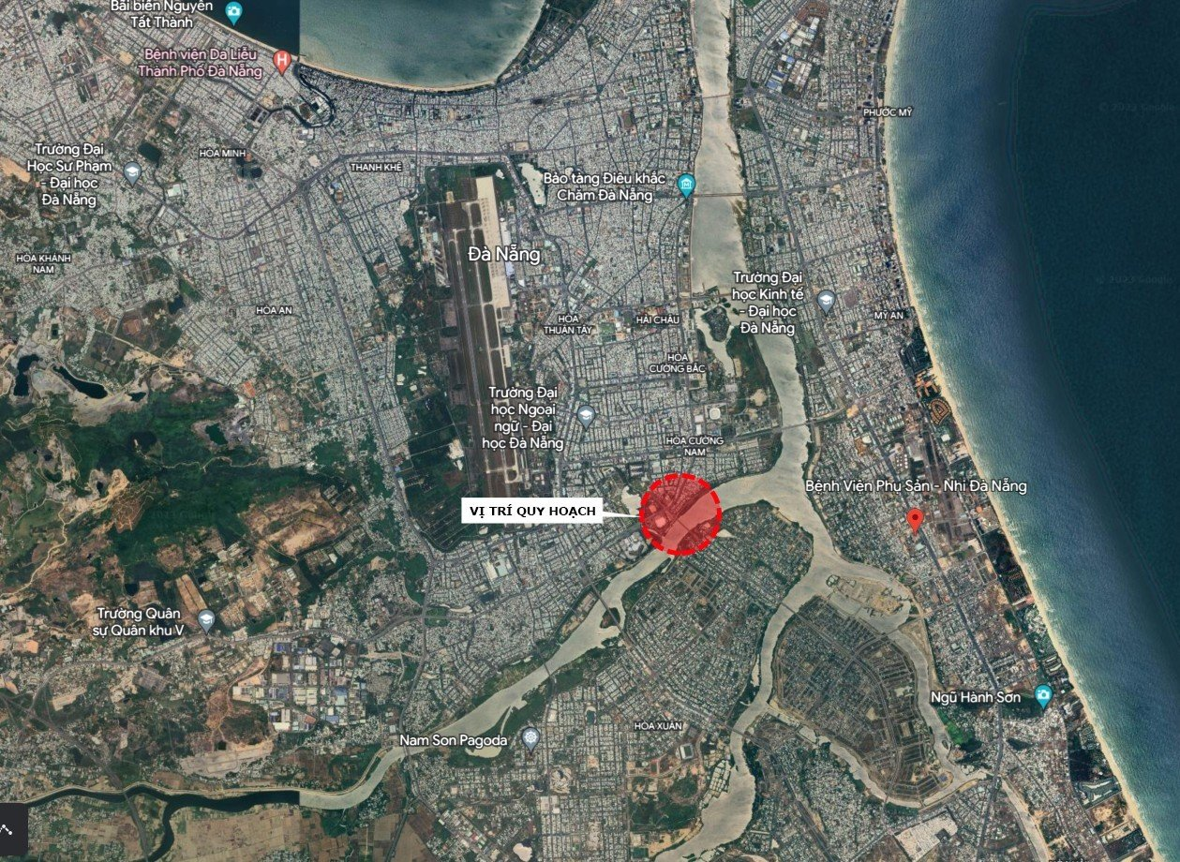

- Current Intersection Cluster Status:
The area northwest of Hoa Xuan Bridge currently consists of a cluster of adjacent intersections, with the Cach Mang Thang Tam - Le Thanh Nghi intersection at the center. Approximately 140m to the north is the Cach Mang Thang Tam - Nui Thanh intersection, 245m to the south is the Mega Road (hereinafter referred to as Mega Road) - Cach Mang Thang Tam intersection, 140m to the east is the Hoa Xuan Bridge - Thang Long intersection, and 250m south along Thang Long Street is the Thang Long - Mega intersection. 860m north of the Cach Mang Thang Tam - Le Thanh Nghi intersection is the Cach Mang Thang Tam - Xo Viet Nghe Tinh - Tien Son Bridge access road intersection.
The area southeast of Hoa Xuan Bridge, approximately 120m from the bridge abutment, is the Nguyen Phuoc Lan - Nguyen Van Thong intersection.
Existing Road Dimensions:
+ Cach Mang Thang Tam Street: Bn = 5 + 10.5 + 2 + 10.5 + 5 = 33m
+ Le Thanh Nghi Street: Bn = 5 + 15 + 5 = 25m
+ Thang Long Street: Bn = 5 + 10.5 + 5 = 20.5m
+ Mega Road: Bn = 7 + 10.5 + 7 = 24.5m
+ Nguyen Phuoc Lan Street: Bn = 10 + 10.5 + 6 + 10.5 + 10 = 47m.

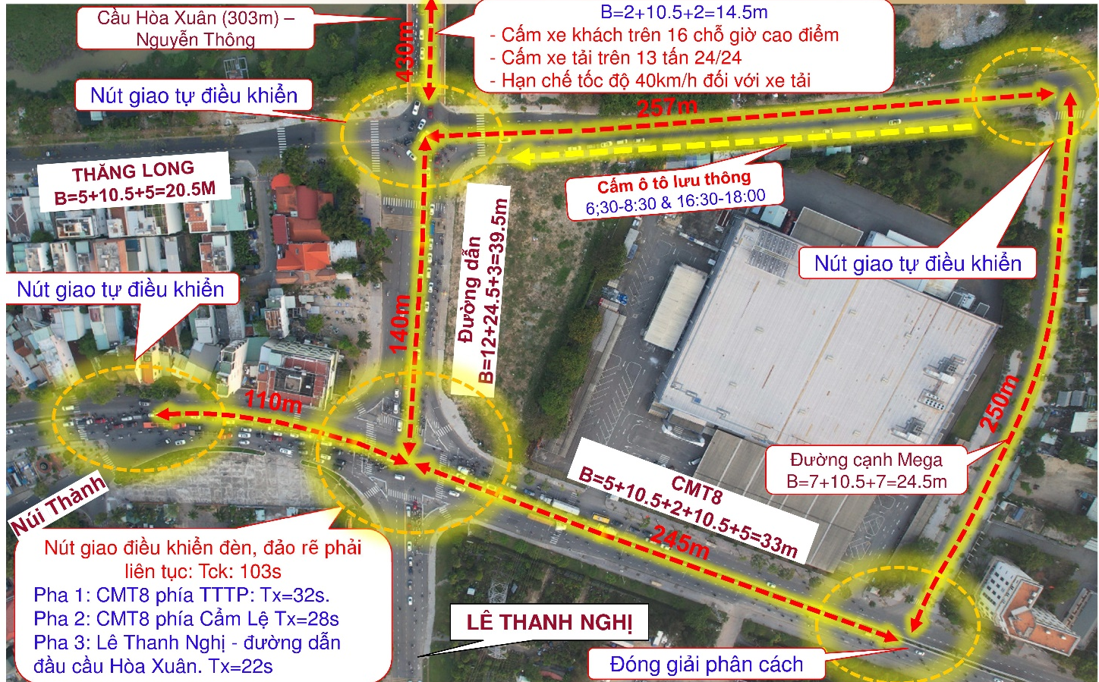

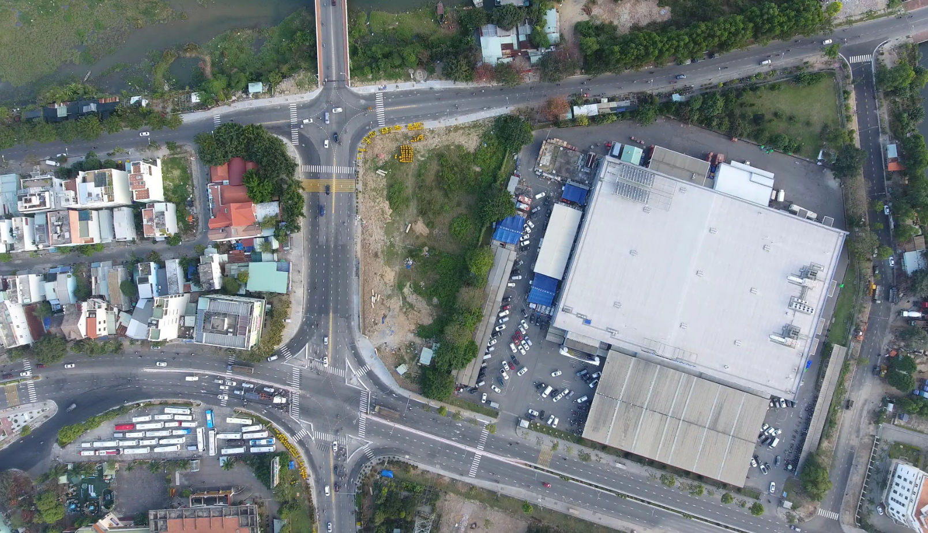
Current Situation of the Intersection Cluster Northwest of Hoa Xuan Bridge
- Current Traffic Organization:
Traffic survey data at the intersection cluster for the years 2019 and 2022 are summarized as follows.

THANG LONG - HOA XUAN BRIDGE INTERSECTION.
ROUTE | Direction | Year 2019 |  | Year 2022
ROUTE | Direction | Peak hour traffic flow (xcqd/h) | Route percentage % | Peak hour traffic flow (xcqd/h) | Route percentage %
Hoa Xuan Bridge Access Road | Go straight onto the bridge | 534 | 40,12 | 1545 | 47,84
Hoa Xuan Bridge Access Road | Turn right onto Thang Long, go to NTP Bridge | 954 | 40,12 | 618 | 47,84
Hoa Xuan Bridge Access Road | Turn left onto Thang Long, go to Tien Son Bridge | 60 | 40,12 | 60 | 47,84
Hoa Xuan Bridge | Go straight on CMT8 | 828 | 27,84 | 1107 | 30,86
Hoa Xuan Bridge | Turn right onto Thang Long, go to Tien Son Bridge | 228 | 27,84 | 261 | 30,86
Hoa Xuan Bridge | Turn left onto Thang Long, go to Nguyen Tri Phuong Bridge | 18 | 27,84 | 66 | 30,86
Thang Long Street towards Tien Son Bridge to the intersection | Go straight onto Nguyen Tri Phuong Bridge | 108 | 8,86 | 333 | 13,75
 | Turn right onto CMT8 | 138 | 8,86 | 108 | 13,75
 | Turn left onto Hoa Xuan Bridge | 96 | 8,86 | 198 | 13,75
Thang Long Street towards Nguyen Tri Phuong Bridge to the intersection | Go straight onto Tien Son Bridge | 306 | 23,17 | 120 | 7,55
 | Turn right onto Hoa Xuan Bridge | 60 | 23,17 | 75 | 7,55
 | Turn left onto CMT8 | 528 | 23,17 | 156 | 7,55
Total |  | 3858 |  | 4647

INTERSECTION OF CACH MANG THANG TAM - LE THANH NGHI - ROAD LEADING TO HOA XUAN BRIDGE
ROUTE | Direction | Year 2019 |  | Year 2022
ROUTE | Direction | Peak hour traffic flow (xcqd/h) | Route percentage % | Lưu lượng (xcqđ/h) giờ cao điểm | Tỷ lệ nhánh %
Le Thanh Nghi Street | Go straight towards Hoa Xuan Bridge | 464 | 11,88 | 696 | 16,58
Le Thanh Nghi Street | Turn right onto CMT8, go to NTP Bridge | 92 | 11,88 | 318 | 16,58
Le Thanh Nghi Street | Turn left onto CMT8, go to Tien Son Bridge | 68 | 11,88 | 9 | 16,58
Road leading to the beginning of Hoa Xuan Bridge | Go straight on Le Thanh Nghi | 392 | 21,78 | 369 | 20,86
Road leading to the beginning of Hoa Xuan Bridge | Turn right onto CMT8, go to NTP Bridge | 616 | 21,78 | 711 | 20,86
Road leading to the beginning of Hoa Xuan Bridge | Turn left onto CMT8, go to Nguyen Tri Phuong Bridge | 136 | 21,78 | 207 | 20,86
CMT8 Street towards Tien Son Bridge to the intersection | Go straight onto Nguyen Tri Phuong Bridge | 1076 | 41,58 | 942 | 38,84
CMT8 Street towards Tien Son Bridge to the intersection | Turn right onto Le Thanh Nghi | 28 | 41,58 | 96 | 38,84
CMT8 Street towards Tien Son Bridge to the intersection | Turn left onto the road leading to Hoa Xuan Bridge | 1080 | 41,58 | 1359 | 38,84
CMT8 Street towards Nguyen Tri Phuong Bridge to the intersection | Go straight onto Tien Son Bridge | 1016 | 24,75 | 1059 | 23,72
 | Turn right towards Hoa Xuan Bridge | 212 | 24,75 | 300 | 23,72
 | Turn left onto Le Thanh Nghi | 72 | 24,75 | 105 | 23,72
Total |  | 5252 |  | 6171

From the traffic survey results at the intersection, it is observed that:
+ At the Cach Mang Thang Tam intersection, traffic has increased relatively evenly, especially in the direction of Cach Mang Thang Tam (Tien Son) turning left onto Hoa Xuan Bridge and the direction of Le Thanh Nghi going straight onto Hoa Xuan Bridge.
+ Traffic on the two branches of Hoa Xuan Bridge and the connecting road between CMT8 - Le Thanh Nghi dominates the intersection (accounting for 78.7% of vehicle traffic through the intersection), while traffic on the Thang Long axis has increased but not significantly. Vehicles going straight and turning left on Thang Long Street (from Tien Son Bridge into the intersection) and cars on Thang Long (from Cam Le into the intersection - traffic violating traffic laws) are the main flows causing conflicts with vehicles on the main axis. Congestion occurs very quickly due to the large volume of traffic entering the intersection while the intersection area is narrow.
Current Traffic Organization at the Intersections: Currently, only the Cach Mang Thang Tam - Le Thanh Nghi intersection is controlled by traffic lights with a 3-phase cycle, Tck = 103s. The remaining intersections are three-way or four-way intersections of the self-regulating type. The intersection northwest of Hoa Xuan Bridge is currently self-regulating, combined with the following solutions to limit congestion: Hoa Xuan Bridge into the intersection (cross-section scale = sidewalk + roadway + sidewalk = 2.0 + 10.5 + 2.0 = 14.5m): Buses with more than 16 seats are prohibited during peak hours, trucks over 13 tons are prohibited 24/7, and a speed limit of 40 km/h is imposed on trucks. During peak hours (6:30-8:30 and 16:30-18:00), a movable barrier is placed at the northwest end of the bridge along the centerline of the access road to prohibit vehicles from going straight and turning left onto Thang Long Street. During peak hours, traffic police are often stationed at the intersections to ensure smooth traffic flow.
The survey assessment shows that during peak hours, congestion occurs along the Cach Mang Thang Tam axis. In the afternoon peak hours, the longest queue is about 230m in the direction of Nui Thanh Street - Tien Son Bridge into the intersection, with vehicles waiting for 2-3 cycles to clear the intersection, resulting in significant time loss. Similarly, in the opposite direction from Cam Le into the intersection during the morning peak hours, especially when there are heavy trucks and semi-trailers, congestion also occurs.
The placement of movable barriers during peak hours temporarily solves congestion at the Hoa Xuan Bridge - Thang Long intersection but also distributes traffic going straight and turning left on Thang Long Street onto Cach Mang Thang Tam Street, putting pressure on this route. Additionally, there is a risk of safety issues on the bridge as some vehicles deliberately violate traffic rules and make U-turns on the bridge to turn towards the city center, endangering other traffic and causing congestion for vehicles going straight across the bridge.
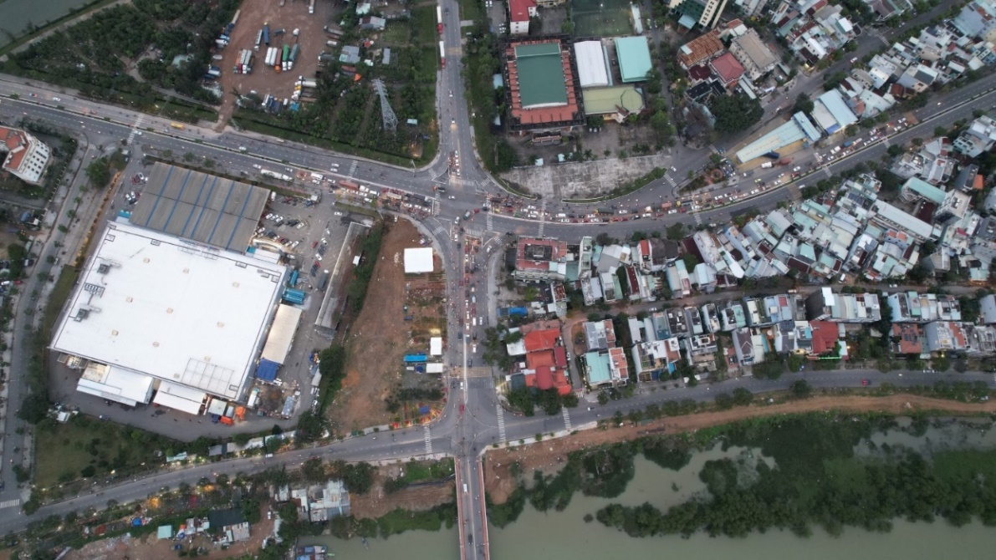
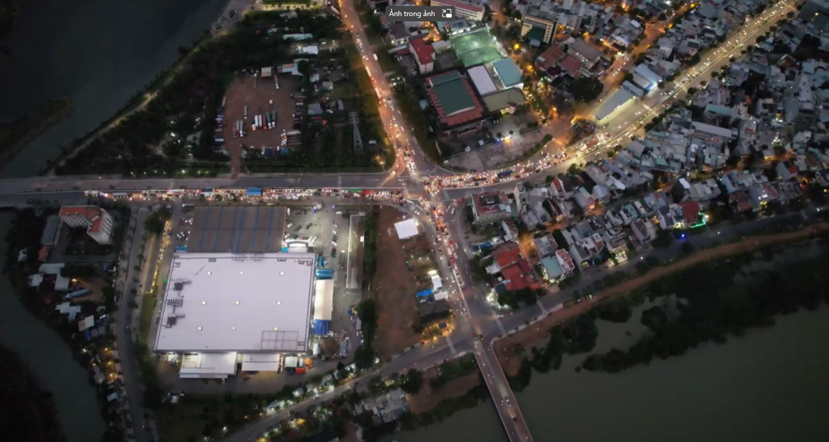
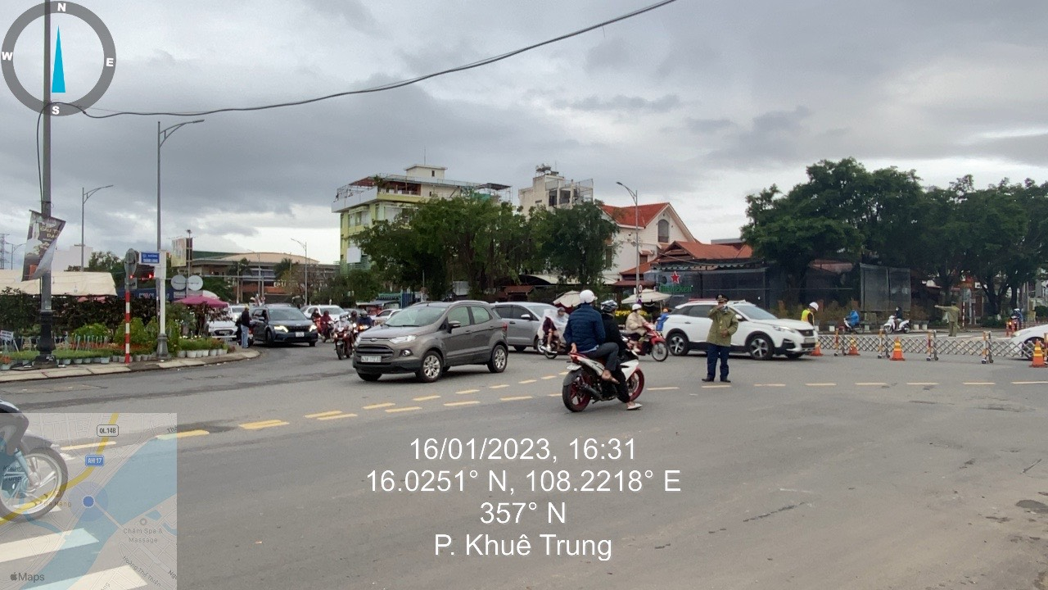
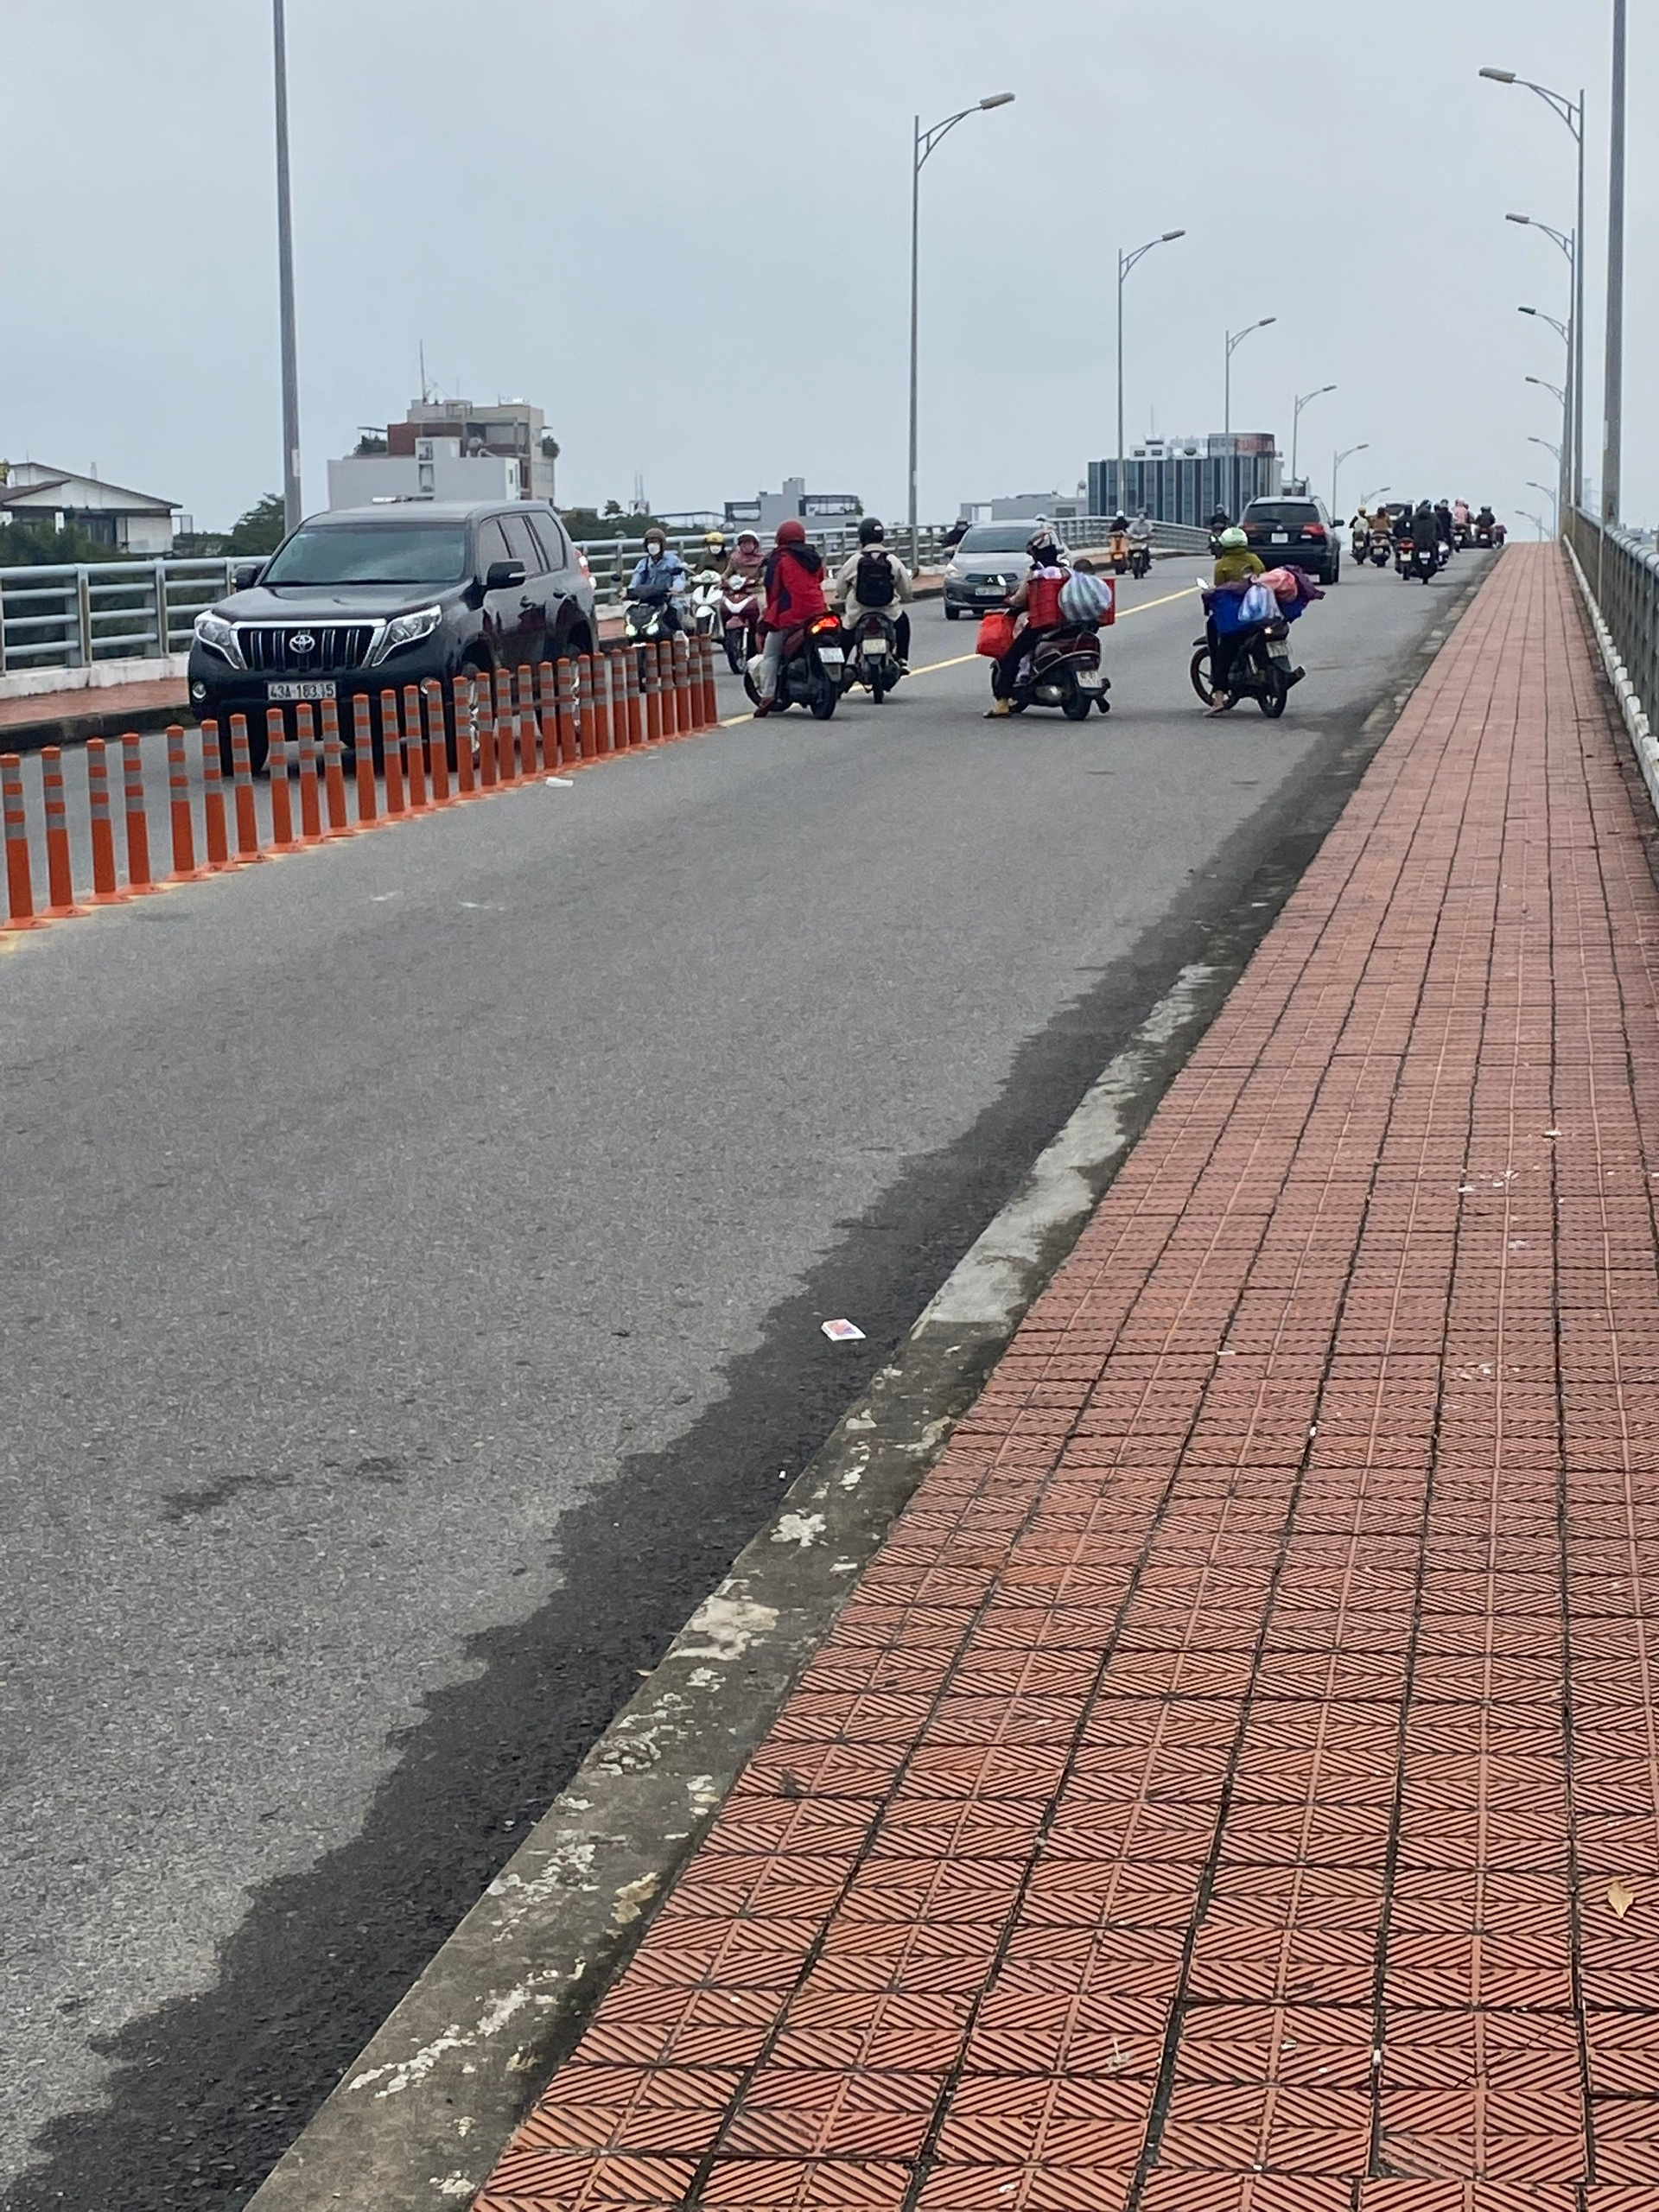 | Vehicles making illegal U-turns on the bridge create safety hazards and congestion.
Image of the current state of the intersection cluster
- Current State of Technical Infrastructure
On Thang Long Street:
- Reinforced concrete retaining wall on a pile foundation to protect the roadbed on the riverbank side.
- Rainwater drainage system with pipes of D800, B1200, and D1500 diameters, flowing into an outlet with an opening of (3x2.5)m, discharging directly into the river, located about 20m downstream from the existing bridge abutment.
- D900 water supply pipe located under the road, near the curb edge of the sidewalk on the riverbank side.
- Wastewater treatment system including a D600 wastewater discharge pipe located under the sidewalk on the riverbank side and a wastewater treatment plant about 30m upstream from the existing bridge abutment.
- According to the planning, there is also a D900 wastewater discharge pipe running outside the existing retaining wall.
On Cach Mang Thang Tam Street and the connecting road to the head of Hoa Xuan Bridge:
- Rainwater drainage system with D800 and D1000 pipes located under the sidewalk, leading to a (3x2.5)m outlet.
- Water supply system, street lighting, and other communication cables..
- The project area has already been invested in and completed with technical infrastructure works, especially on Thang Long Street, where there is a water supply system, wastewater treatment, and rainwater drainage system... arranged interchangeably. Therefore, when expanding the grade-separated intersection within this area, there must be appropriate solutions for dismantling and restoring these systems.
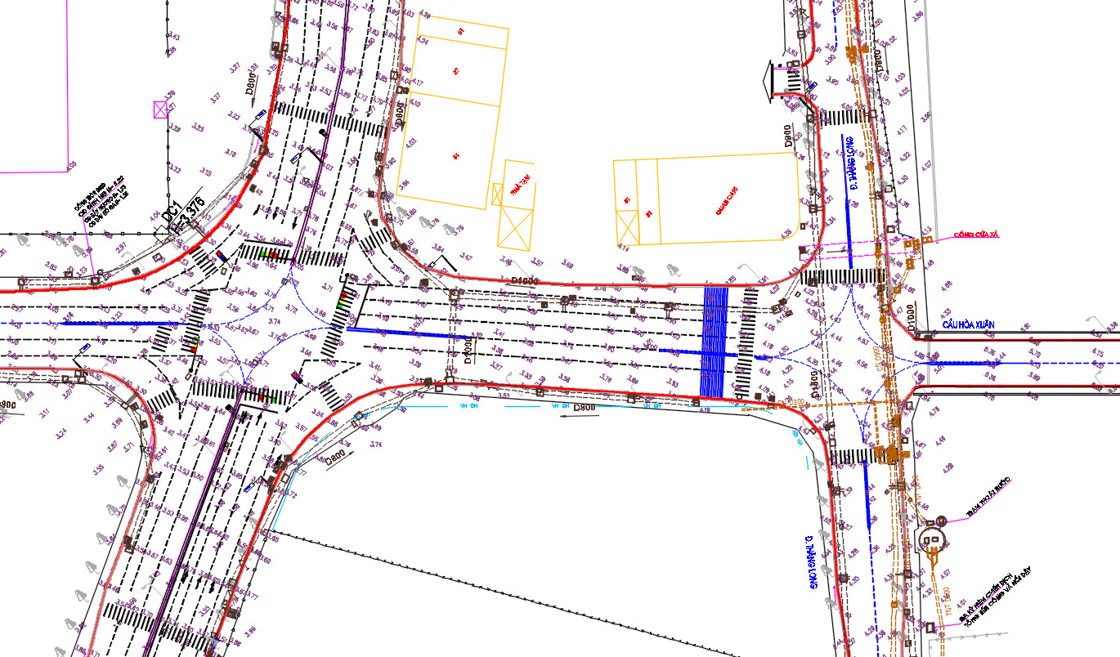
Current Situation of the Intersection Cluster
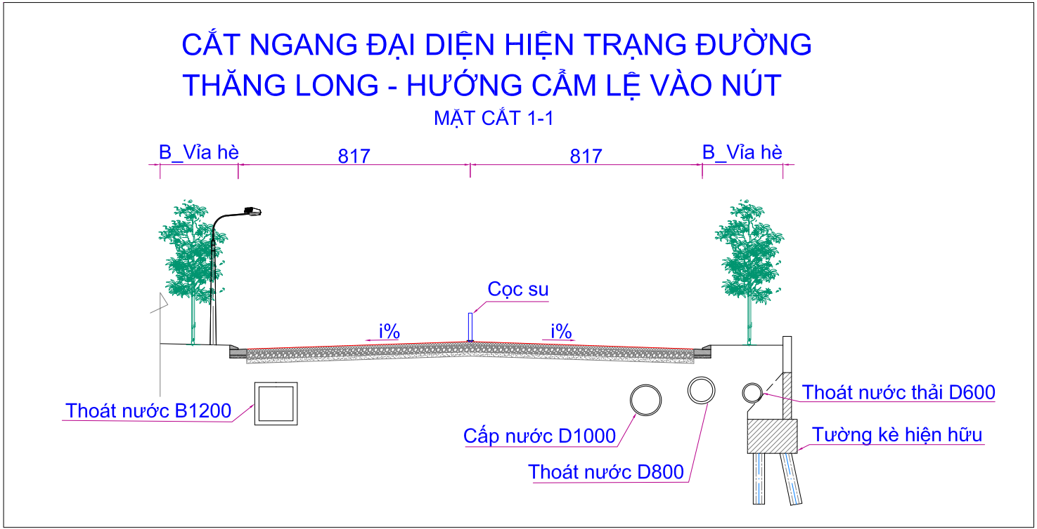
Cross-section of Thang Long Street (within the intersection area)
Additionally, within the project area, there is a 110kV power line that crosses Cach Mang Thang 8 Street and Thang Long Street before crossing the river over the Hoa Xuan area.
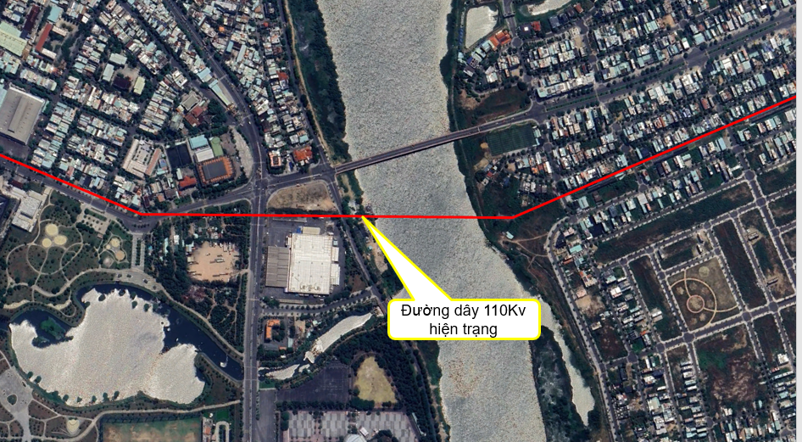
4. Design Requirements:
- Design Boundaries:
- The planning location is within Hai Chau District and Cam Le District, Da Nang City.
- The planning area (hard boundary) covers an area of approximately 11.95 hectares, including the entire existing roadway and sidewalks of the following routes: Cach Mang Thang Tam - Thang Long - Le Thanh Nghi - Hoa Xuan Bridge access road - Nguyen Phuoc Lan, a part of Thanh Nien Park, the City Labor Culture House, and other adjacent areas bordering the roads within the intersection cluster.
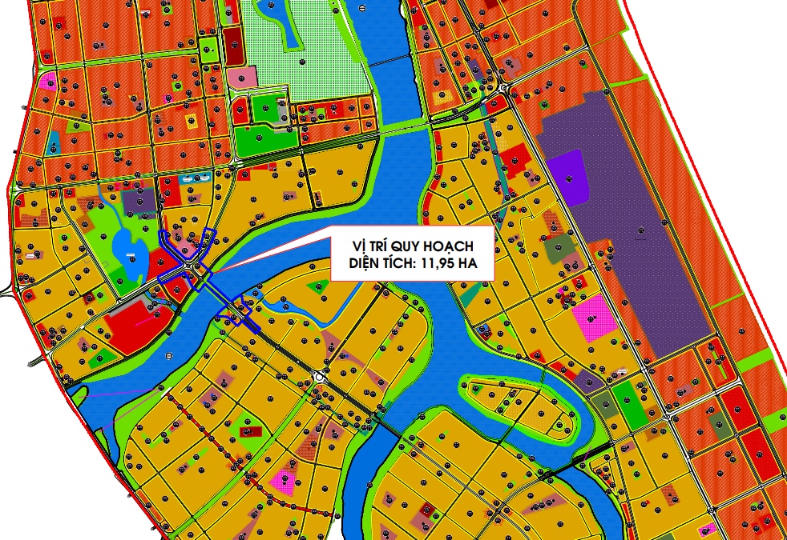
Location of the Planning Area in the Zoning Plan
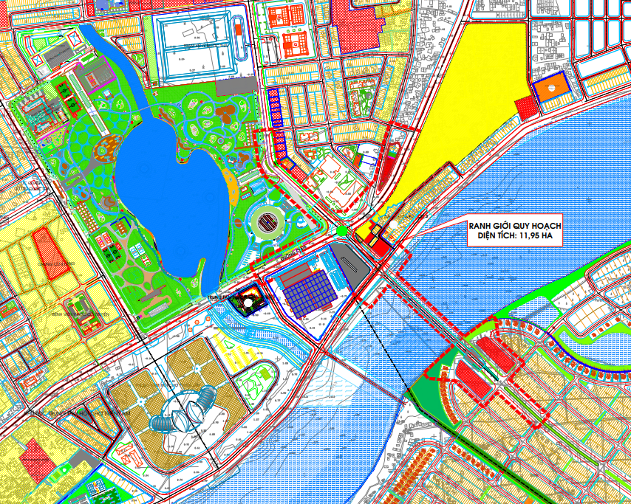
Planning Boundaries
- Expansion Beyond Boundaries: If necessary, expansion into the surrounding area may be considered when the hard boundary is insufficient. However, this expansion must be justified with a detailed explanation, noting that the design boundary expansion should be minimized to conserve land, limit site clearance, and ensure efficient project investment.
- Study Area (Soft Boundary): Extend connections to the surrounding area to organize traffic and create a harmonious spatial arrangement of architecture and landscape in the region.
- Proposed Overall Scale:
- The planning and architectural design of the Cach Mang Thang Tam - Le Thanh Nghi - Thang Long - Hoa Xuan Bridge access road intersection cluster is a comprehensive combination of the following project components.
* Hoa Xuan Bridge:
+ Hoa Xuan Bridge with a length of 303m.
+ New construction or renovation and expansion of Hoa Xuan Bridge with a minimum of 6 lanes. The bridge design should ensure aesthetics and harmony with the surrounding landscape.
* Intersection Cluster Northwest of Hoa Xuan Bridge, including the following intersections:
+ Cach Mang Thang Tam - Le Thanh Nghi Intersection: Implement a grade-separated intersection, with Cach Mang Thang Tam Street oriented as the main urban axis, incorporating an LRT (light rail transit) line in the median. Ensure the resolution of congestion on Cach Mang Thang Tam Street.
+ Thang Long - Hoa Xuan Bridge Intersection: Propose research to expand the intersection scale, reduce intersection points within the intersection, and avoid conflicting traffic flows within the intersection area. Provide a long-term solution for congestion before the bridge while ensuring smooth traffic flow in all directions.
* Intersection Cluster Southeast of Hoa Xuan Bridge:
+ Newly constructed or renovated and expanded access road to Hoa Xuan Bridge, connecting with the existing urban road system to ensure smooth and uninterrupted traffic flow, avoiding congestion.
+ Nguyen Phuoc Lan - Nguyen Van Thong Intersection: Reduce conflicts at the intersection near the bridgehead.
* Surrounding Area:
+ A portion of Thanh Nien Park and the City Labor Culture House area.
+ Adjacent areas bordering the main roads.
+ Areas along both banks of the Cam Le River.
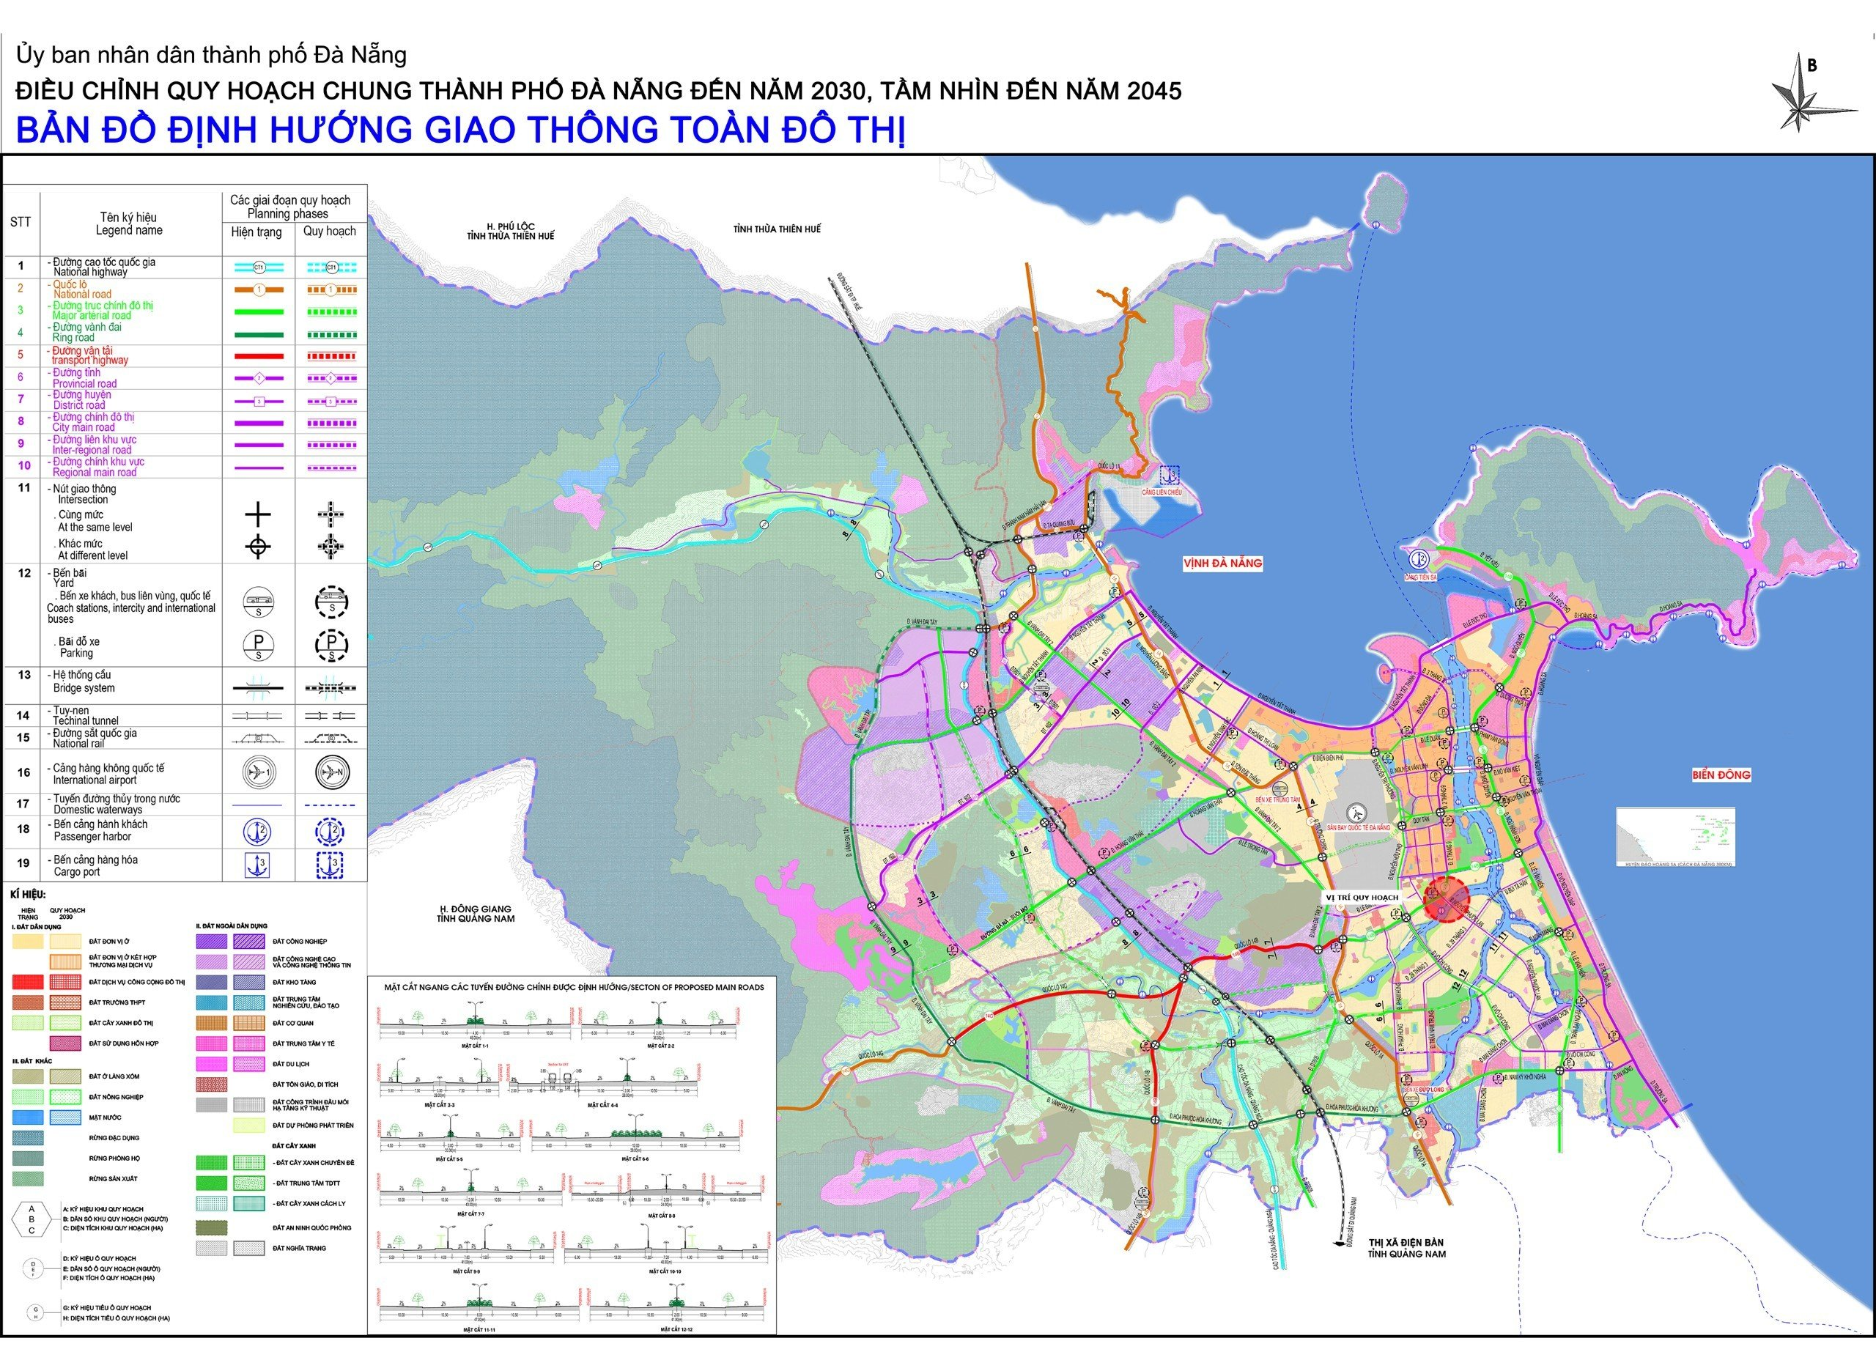
Project Location in the Transportation Planning Orientation
- Function and Characteristics:
- This is a key transportation project for the city. In the East-West direction, it serves as the Cach Mang Thang Tam axis, connecting from National Highway 1A and National Highway 14B to Tien Sa Port. In the North-South direction, it serves as the Nguyen Phuoc Lan - Le Thanh Nghi axis, connecting the new urban area in the south of the city with the city center.
- It is an iconic and modern architectural project, creating a highlight in the landscape of the area.
- Technical Requirements:
* For the Bridge Project:
- Project Scale: Permanent structure, ensuring flood clearance.
- Project Level: Class II transportation project.
- Design Frequency: Design flood frequency P = 1%.
- Design Load: HL-93 live load for roads, pedestrian load 3Kpa.
- River Navigation Clearance: Applicable for Class IV rivers, width B > 30m, H = 6m.
- Maximum Design Speed: Vtk = 60km/h.
- Underpass Clearance: H = 4.75m.
- Earthquake Level: Acceleration coefficient A = 0.1006.
- Bridge Width: Minimum of 6 lanes.
- Other Considerations:
When renovating or constructing new structures at the intersection cluster, attention must be paid to the existing technical infrastructure within the project area. Appropriate relocation must be calculated to ensure technical feasibility, especially for the 110kV high-voltage power line that crosses Cach Mang Thang 8 Street and Thang Long Street, crossing the river about 130m upstream of the existing Hoa Xuan Bridge.
For the Hoa Xuan Bridge design solution, consider the following:
+ The bridge abutment location should not be within the flood drainage corridor, and a temporary construction cofferdam should be built across the river.
+ If a cofferdam is constructed, it must be designed to withstand a flood frequency of P = 10%, paying attention to minor floods, and the completion of cofferdam removal must be before August 31st each year, i.e., before the flood season.
- Basic Technical Criteria:

No. | Criteria | Unit | Giá trị
A | Bridge Section
1 | Project Scale |  | Permanent
2 | Project Level |  | 2
3 | Design Flood Frequency | % | 1
4 | Navigation Clearance (Class IV River) | m | B>30m, H=6m
5 | Underpass Clearance | m | 4,75
6 | Earthquake Level: Acceleration Coefficient |  | A=0,1006
7 | Minimum Number of Lanes by 2045 (Aligned with Nguyen Phuoc Lan Street in the adjusted master plan - QH359) | lane | 6
8 | Design Speed | Km/h | 60
9 | Design Load | Kpa vehicular train | HL93  3
B | Road Section
1 | Design Frequency | % | 5
2 | Cach Mang Thang Tam Street
 | + Road Class |  | Main Urban Axis (Main Street)
 | + Design Speed | Km/h | 80
 | + Minimum Number of Lanes by 2045 (According to the draft urban transportation plan) | lane | 6
3 | Nguyen Phuoc Lan Street
 | + Road Class |  | Inter-regional (Secondary Main Street)
 | + Design Speed | Km/h | 60
 | Minimum Number of Lanes by 2045 (According to the adjusted master plan - QH359) | lane | 6
4 | Le Thanh Nghi Street
 | + Road Class |  | Inter-regional
 | + Design Speed | Km/h | 60
 | + Minimum Number of Lanes by 2045 (According to the draft urban transportation plan) | lane | 4
- Water Level at Cam Le Hydrological Station
+ In 2019, the average annual water level reached -2 cm. The highest water level of the year was 101 cm, and the lowest water level of the year was -76 cm. Details are as follows:
Typical | I | II | III | IV | V | VI | VII | VIII | IX | X | XI | XII | Year
Average | 19 | -1 | 1 | -3 | 3 | -8 | -8 | -4 | 13 | 20 | 34 | 15 | -2
Max | 77 | 53 | 48 | 43 | 63 | 47 | 51 | 70 | 69 | 99 | 101 | 81 | 101
Min | -46 | -62 | -51 | -57 | -76 | -71 | -74 | -76 | -46 | -44 | -39 | -57 | -76
Table: Average, Highest, and Lowest Water Levels at Cam Le Hydrological Station (2019) (Unit: cm)
+ In 2022, the flow rate at Cam Le River was 14 cm; at the monitoring station, the highest water level was 214 cm, and the lowest water level was -84 cm.
Water Levels and Flow Rates of Some Major Rivers at Da Nang Monitoring Station
 | Unit | 2018 | 2019 | 2020 | 2021 | 2022
Water Level of Cam Le River | cm | 7 | 7 | 20 | 9 | 14
Monitoring Station
Highest | “ | 118 | 101 | 215 | 133 | 214
Lowest | “ | -70 | -76 | -63 | -77 | -84

- Planning Requirements:
According to the adjusted Master Plan 359 approved by the Prime Minister, the transportation axes are oriented towards 2030 as follows:
- AH17 Road (Yet Kieu, Ngo Quyen, Ngu Hanh Son, Tien Son, Cach Mang Thang Tam, Truong Son, National Highway 14B) from Tien Sa Port to Tuy Loan intersection with a length of 24.0km is an important external transportation route of the city and a main freight route connecting to Tien Sa Port (Tien Sa Port will continue its function as a cargo and logistics hub until 2030, before Lien Chieu Port comes into operation). This route is planned along the road and National Highway 14G to provide direct connection to the Ring Road 3, Da Nang International Airport, and the National Expressway.

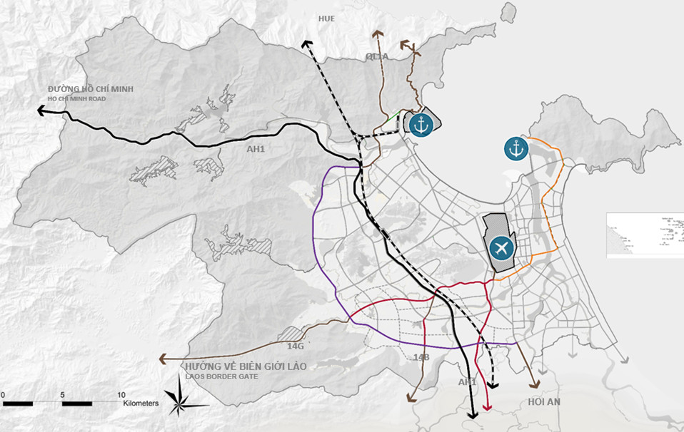
Oriented Freight Transportation Network
- Nguyen Phuoc Lan Street, with a road width of 47m, is identified as the main street of the new urban area in the south of the city, connecting to the city center.
- Le Thanh Nghi Street, with a road width of 36m, is identified as one of the main streets of the Hoa Cuong urban area.
- Traffic connections at the intersection cluster are organized in sync with the overall transportation system of the city in general and the area in particular, ensuring smooth, safe, and congestion-free traffic flow.
- According to the Master Plan orientation towards 2045, 5 LRT (Light Rail Transit) lines are planned to be built to connect urban centers and employment centers, creating a more comprehensive network. Among these, LRT line 6 passes through the project, starting at the head of Tran Thi Ly Bridge, following National Highway 14B, passing through the Hoa Vang district administrative center, and ending at the southwest bus station. Within the project area, an LRT station is planned, adhering to the prescribed distance regulations.
The plan directs the arrangement of public parking lots in the project area. The parking lots are expected to be invested in and operated under the socialization model, and they can be built underground, on the ground, or as multi-story structures adjacent to the LRT station.
The plan also directs the arrangement of passenger terminals along the inland waterway route along the Yen River - Tuy Loan River - Cam Le River (Cau Do) - Han River.

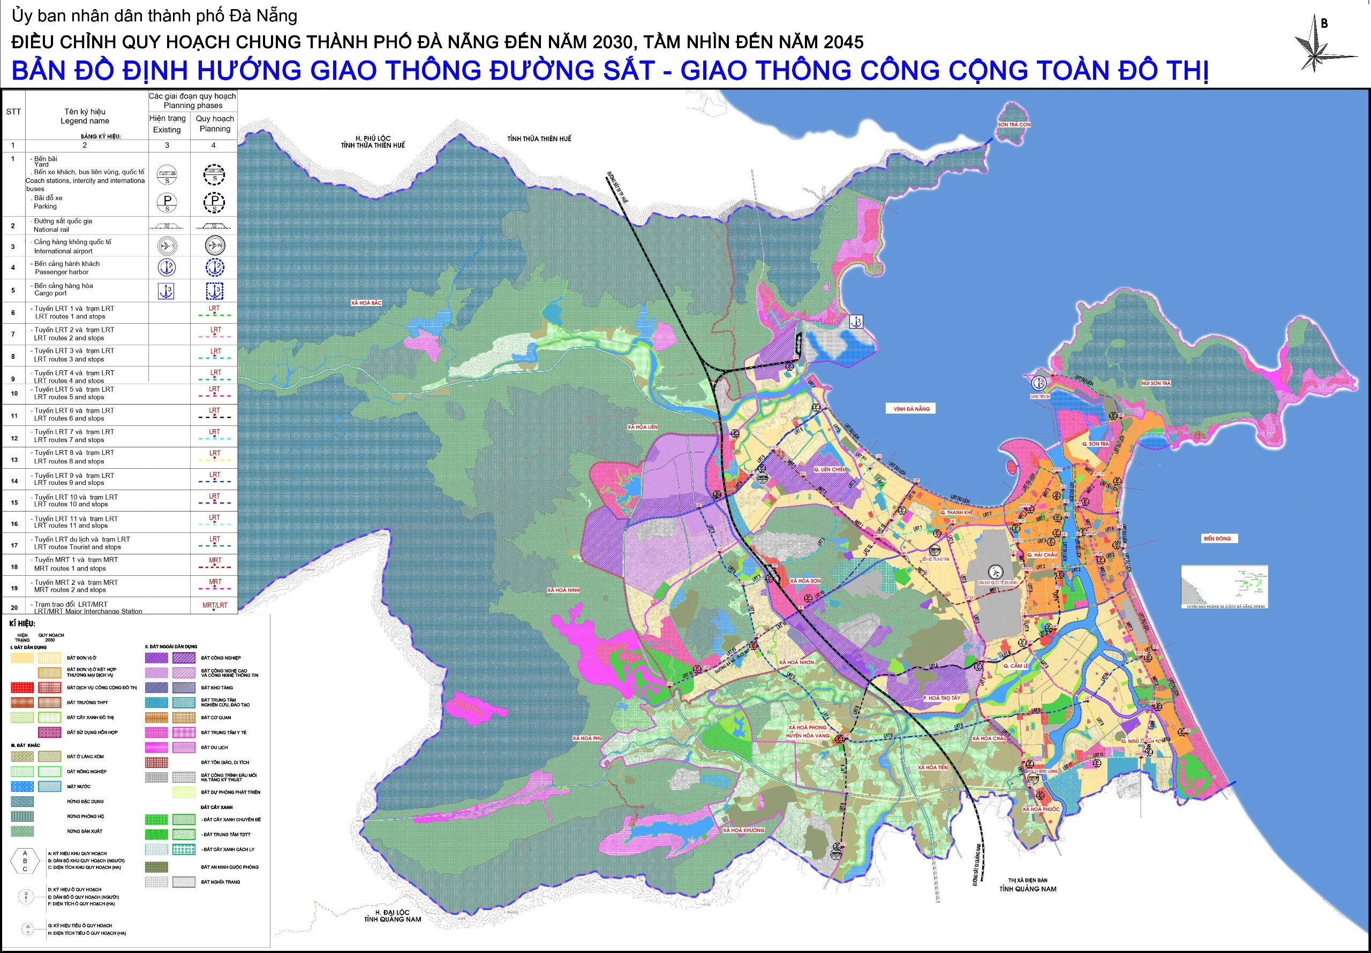

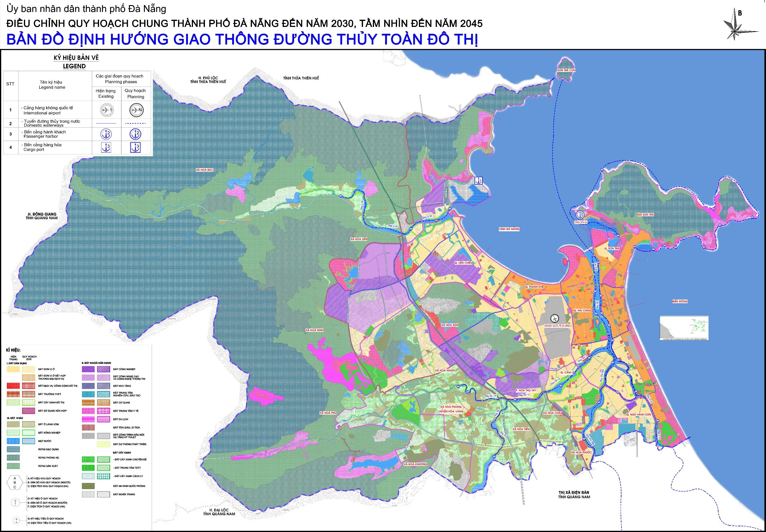
- The overall land use plan should be appropriate and comply with regulations and design standards.
- Organize the architectural and landscape space at the junction area, paying attention to the landscape of the Cam Le riverbank area, both ends of Hoa Xuan bridge, Thanh Nien Park, and the surrounding areas.
- The scale should be appropriate to the projected future traffic demand up to 2030, with a vision towards 2045.
- Ensure smooth traffic flow for various types of boats on the Cam Le River and serve tourism development.
- Limit the relocation of existing architectural structures, houses, and technical infrastructure in the area.
- Architectural requirements:
As the project is located in an important area with beautiful scenery, connecting the old city center with the newly developed areas to the south and west of the city, the architectural plan must meet the following requirements:
- The project should create an architectural and landscape highlight in the area, following the development trend of the times. The architectural style should be suitable for Vietnamese cultural identity, not hybrid, archaic, or duplicate existing architectures in Vietnam and the world.
- The design should harmoniously resolve the aesthetic and technical factors, embrace modern technology, and be suitable for the dynamic development of a developing city.
- Ensure harmony with the landscape in the area, paying attention to the factors of long-distance vision and the landscape of the Cam Le river area.
- Have a prominent decorative lighting plan, creating an architectural and landscape highlight for the area.
- Use appropriate and environmentally friendly materials.
- Other requirements:
- Technical infrastructure solutions: Ensure synchronous connection of infrastructure and technical infrastructure in the area.
- Construction technology solutions: The design plan should ensure feasibility, considering local construction conditions, the location of the project, environmental sanitation, saving construction investment costs, and reasonable construction time.
- Maintenance solutions: Facilitate management and operation, especially in the context of current climate change affecting the lifespan of the project.
- Economic efficiency: The total investment cost should be reasonable, efficient, comply with regulations on construction investment cost management, and limit compensation costs, operation management costs, and maintenance costs.
5. Economic Aspects.
The construction investment cost should be economical and suitable for local conditions, with efficient and cost-effective operation and maintenance.
The competition entry must include an estimate of the total investment cost for the project, detailing the total estimated cost including design fees and other related expenses. It should also show the investment rate for each item, the calculation basis, and a preliminary analysis of economic efficiency, land use, site clearance, and propose a suitable investment method.

C. COMPETITION PLAN
1. Objectives:
To develop a plan for the organization of a design competition for the Le Thanh Nghi - Cach Mang Thang Tam - Thang Long - Hoa Xuan Bridge access road intersection node, in order to implement the competition process in accordance with the work sequence, quality, and schedule. The content of the competition should adhere to the Terms of Reference and regulations to select the most suitable design solution.
2. Requirements:
- Fully present all the necessary content to select the architectural plan.
- Ensure compliance with the project timeline and schedule, and ensure effective coordination among participating units in the competition organization.
3. Competition Plan:

No. | CONTENT | TIMEFRAME
I | PREPARATION | 75 DAYS
1 | - Collect documents, data, and complete legal procedures related to the competition.  - Draft regulations, competition tasks, and competition plan.  - Prepare an outline and estimate the cost of consulting for the competition organization.  - Approve the competition plan, sign a contract with the consulting firm for the competition organization | 30 days
2 | - Gather feedback on the draft regulations, competition tasks, and competition plan.  - Finalize the regulations, tasks, and competition plan.  - Estimate the cost of organizing the competition.  - Submit for appraisal and approval of the regulations, tasks, plan, and estimated cost of organizing the competition.  - Sign the contract for the organization of the competition | 30 days
3 | - Send invitations to the Jury.  - Establish the Jury and Technical Team | 15 days
II | COMPETITION PHASE | 75 DAYS
4 | - Create a competition website, announce the competition information and invite entries (including the holiday break from April 30th to May 1st, 2024) | 10 days
5 | - Receive registrations from participating units.  - Conduct preliminary screening and invite units to participate | 15 days
6 | - Conduct site surveys.  - Participating units complete their competition entries | 50 days
III | REPORTING, EVALUATION, AND SELECTION OF ENTRIES | 30 DAYS
7 | Receive competition entries | 01 day
8 | Conduct preliminary evaluation of the entries | 15 days
9 | Exhibit the competition entries | 7 days
10 | - Participating units present their proposals.  - The Jury evaluates and selects the winning entries. | 15 days
IV | ANNOUNCEMENT OF RESULTS AND AWARD CEREMONY | 30 DAYS
11 | Report and Decision on the recognition of the competition results | 15 days
12 | Announce the results and award prizes | After the City People's Committee approves the competition results

D. APPENDIX
Appendix 1
SOCIALIST REPUBLIC OF VIETNAM
Independence – Freedom – Happiness

APPLICATION FOR PARTICIPATION IN THE COMPETITION
Competition for the selection of planning and architectural design for the Le Thanh Nghi - Cach Mang Thang Tam - Thang Long - Hoa Xuan Bridge access road intersection node.

To: Project Management Unit For Investment And Construction Of Transportation Works.

Unit applying for participation:
Address:
Email:
Phone:..........................................Fax:..............................................................
Representative:...................................Position:................................................
We have received information about the Competition for the selection of planning and architectural design for the Le Thanh Nghi - Cach Mang Thang Tam - Thang Long - Hoa Xuan Bridge access road intersection node through various media channels.
Considering that our unit has sufficient prestige and capacity, we hereby register to participate in the competition. We commit to complying with all the regulations of the competition.

………….., date……month……year 2024
REPRESENTATIVE OF THE UNIT APPLYING FOR PARTICIPATION
(Clearly state name, title, signature, and seal)

Appendix 2
……….., date ... month ... year 2024

JOINT VENTURE AGREEMENT
Competition for the selection of planning and architectural design for the Le Thanh Nghi - Cach Mang Thang Tam - Thang Long - Hoa Xuan Bridge access road intersection node

Pursuant to the announcement of the Competition for the selection of planning and architectural design for the Le Thanh Nghi - Cach Mang Thang Tam - Thang Long - Hoa Xuan Bridge access road intersection node.
We, the representatives of the parties signing this joint venture agreement, including:
Joint Venture Name:
Representative: Mr./Ms.
Position:
Address:
Phone:
Email:
Bank Account Number:
Tax Code:
The parties (hereinafter referred to as "members") agree to enter into this joint venture agreement with the following terms:
Article 1. General Principles
1. The members voluntarily form a joint venture to participate in the competition for the selection of planning and architectural design for the Le Thanh Nghi - Cach Mang Thang Tam - Thang Long - Hoa Xuan Bridge access road intersection node.
2. The members agree that the name of the joint venture for all transactions related to this competition shall be: ………………………………………………… (Enter the name of the joint venture as agreed).
3. In the event that the proposal is selected, no member shall have the right to refuse to perform the responsibilities and obligations specified in the Competition Regulations issued by the City People's Committee under Decision No. ………/QĐ-UBND dated ... month ... year .... In the event that a member of the joint venture refuses to fulfill their individual responsibilities as agreed, that member shall be subject to the following penalties:
- Compensation for damages to the other members of the joint venture;
- Compensation for damages to the competition organizer as specified in the Competition Regulations;
- Other forms of penalty ……………………………….. (Specify other forms of penalty).
Article 2. Division of Responsibilities
The members agree to share joint responsibility and individual responsibilities for participating in the competition for each member as follows:
1. Lead Member of the Joint Venture
The parties agree to authorize ……………………… (Enter the name of the authorized company) as the lead member of the joint venture, representing the joint venture in the following tasks:
- Signing the application for participation;
- Signing documents and materials for transactions with the Technical Team during the competition process, including presenting the competition entry report;
- Participating in the negotiation of the Contract and subsequent design steps if selected;
- Other tasks ………………………………….. (Clearly state the content of other tasks (if any)].
2. Members of the joint venture agree to divide responsibilities for the tasks as follows:
No. | Name | Tasks | Percentage %
1 | Lead Member of the Joint Venture | - ....  - .... | - .... %  - .... %
2 | Second Member | - ....  - .... | - .... %  - .... %
.... | …… | …… | ……
Total |  | All tasks | 100%
Article 3. Effectiveness of the Joint Venture Agreement
1. This joint venture agreement shall take effect from the date of signing.
2. This joint venture agreement shall terminate in the following cases:
- The parties have fulfilled their responsibilities and obligations;
- The parties mutually agree to terminate;
- The joint venture's proposal is not selected;
- The competition is canceled as announced by the Competition Organizer.
This joint venture agreement is made in …… copies, each party keeps …… copies, all copies have the same legal validity.
LEGAL REPRESENTATIVE OF THE LEAD MEMBER OF THE JOINT VENTURE
[Enter name, title, signature, and seal]

LEGAL REPRESENTATIVE OF THE JOINT VENTURE MEMBER
[Enter the name of each member, title, signature, and seal]

Appendix 3
COMPETITOR'S CAPACITY
A. Competitor's Capacity Documents:
- Capacity profile, certificate of capacity, design practice certificate (accompanied by relevant legal documents).
- Professional awards (if any).
- Number of years of experience in the field of planning and architecture.
- Financial statements of the unit for the last 3 years.
- Experience of participating individuals.
- Projects and works of similar scale and nature that the unit and individuals have implemented.
NO. | UNIT NAME | CONTACT INFORMATION | UNIT CAPACITY PROFILE (Company Operation Capacity Certificate) | PERSONNEL CAPACITY PROFILE (Design Practice Certificate) | EXPERIENCE IN SIMILAR PROJECTS | RELEVANT AWARDS AND COMMENDATIONS
B. Achievements
(Summarize the content and scale of the planning projects that the consulting unit has participated in or implemented; awards achieved in the field of planning and design, evaluated by reputable international/Vietnamese organizations - with supporting documents) ...
KEY EXPERT PROFILE
Proposed Position:
Name of Consulting Firm:
Name of Expert: …………………………Nationality:
Profession:
Date of Birth:
Professional Organization Membership:
Work Experience:
Time | Name of Agency/Unit | Reference Information | Position Held
From Month/Year to Month/Year | …… | (state the name, phone number, and email of the person to be referenced to verify the information) | ……
Similar Projects Participated In:

(List similar projects participated in)
Professional Qualifications:
(Specify relevant degrees and professional practice certificates as required in the competition conditions).

I hereby certify that the above information is true and accurate. If there are any inaccuracies, I will be held legally responsible.
………, Date … Month …Year 2024
Declarant
[Signature, Title, and Full Name]

Note:
The consulting firm should attach a copy of the employment contract; copies of diplomas and professional practice certificates of the above-mentioned consulting experts.
LIST OF SIMILAR PROJECTS IMPLEMENTED
No. | Contract Name | Project Name | Investor Name | Construction Location | Scale (planning area, project level...) | Implementation Time | Awards Achieved
1
2
3
...
Note:
- The participating unit must submit a copy of the document proving that they have completed at least 01 approved project.
- The participating unit must submit a copy of the award (if any).

Appendix 4
PARTICIPATING UNIT INFORMATION
Name of participating unit:
Participation code:
Contact address:
Phone number:
Email:
Account number:
Tax code:
Name and professional background of the project leader and design team members.
Agreement on cooperation, joint venture (if any).
………, Date…….. month…….. year 2024
Declarant
[Signature, Title, and Full Name]

INSTRUCTIONS FOR ENCODING COMPETITION ENTRIES
1. The design code of the participating design consulting firm consists of 02 random letters and 02 random numbers (for example: AB12) and must be printed in capital letters about 10mm high in a rectangular box about 15mm high and 50mm wide in the upper right corner of the drawings.
This code must also be written on the cover of the explanatory note and on a corner of the model.
2. Outside the envelope: Clearly state the name of the competition; participation code.
Content inside includes: (Appendix 3)

