SOCIALIST REPUBLIC OF VIETNAM
Independence - Freedom - Happiness
------------------

COMPETITION TASKS
ARCHITECTURAL DESIGN COMPETITION FOR KIM BONG BRIDGE
(CAM KIM LOCAL BRIDGE), HOI AN CITY

***DA NANG, 2023 ***
SOCIALIST REPUBLIC OF VIETNAM
Independence - Freedom - Happiness
---------***--------
Da Nang, …………………. 2023

COMPETITION TASKS
ARCHITECTURAL DESIGN COMPETITION FOR KIM BONG BRIDGE
(CAM KIM LOCAL BRIDGE), HOI AN CITY
(Promulgated together with Decision No ..... /QD-UBND dated ………… 2023
by the People’s Committee of Hoi An City)

Competition Name: Architectural Design Competition for Kim Bong bridge
(Cam Kim local bridge), Hoi An City
Promoter: People’s Committee of Hoi An City
Organization Board: Urban Management Department of Hoi An City
Competition Advisor: Da Nang Consultant Technical Construction Center

Competition Advisor Organization Board
Da Nang Consultant Technical Construction Center Urban Management Department of Hoi An City

PEOPLE’S COMMITTEE  OF HOI AN CITY | SOCIALIST REPUBLIC OF VIETNAM  Independence - Freedom - Happiness
COMPETITION TASKS
ARCHITECTURAL DESIGN COMPETITION FOR KIM BONG BRIDGE
(CAM KIM LOCAL BRIDGE), HOI AN CITY
(Promulgated together with Decision No ..... /QD-UBND dated …………. 2023
by the People’s Committee of Hoi An City)

Chapter I
OVERVIEW
I. Legal Bases:
- Law on Urban Planning No. 30/2009/QH12 dated 17 June 2009;
- Construction Law No. 50/2014/QH13 dated 18 June 2014; the Law No. 62/2020/QH14 dated 17 June 2020 amending and supplementing a number of articles of the Construction Law;
- Law on Architecture No. 40/2019/QH14 dated 13 June 2019;
- Government’s Decree No. 06/2021/ND-CP dated 26 January 2021 detailing a number of contents on quality management, construction and maintenance of construction works;
- Government’s Decree No. 10/2021/ND-CP dated 09 February 2021 on management of construction investment costs;
- Government’s Decree No. 15/2021/ND-CP dated 03 March 2021 detailing a number of contents on management of construction investment project;
- Government’s Decree No. 85/2020/ND-CP dated 17 July 2020 detailing a number of articles of the Law on Architecture;
- Decision No. 1013/QD-UBND dated 28 June 2012 by the People’s Committee of Hoi An City approving the dossier of new rural planning and promulgating the Regulation on construction management according to the planning of Cam Kim Commune, Hoi An City;
- Decision No. 557/QD-UBND dated 18 March 2016 by the People’s Committee of Hoi An City approving the partial adjustment of the dossier of new rural planning of Cam Kim Commune, Hoi An City;
- Announcement No. 86/TB-TU dated 08 April 2015 by the Party Committee of Hoi An City on the conclusion of the Standing Committee of the City Party Committee at the 38th meeting on 07 April 2022, in which it was agreed to hold an architectural design competition for Kim Bong bridge (Cam Kim local bridge);
- Official Letter No. 441/UBND dated 28 February 2022 by the People’s Committee of Hoi An City on unifying the policy of holding an architectural design competition for Cam Kim local bridge;
- Decision No. 744/QD-UBND dated 07 June 2022 by the People’s Committee of Hoi An City approving the plan to hold an architectural design competition for Kim Bong bridge (Cam Kim local bridge);
- Decision No. 238/QD-UBND dated 17 March 2023 by the People’s Committee of Hoi An City on approving the cost estimate and contractor awarding plan in the pre-investment stage of the project: Renovating and upgrading Kim Bong bridge (Cam Kim local bridge), item: Architectural design competition;
- Decision No. 469/QD-UBND dated 12 May 2023 by the People’s Committee of Hoi An City on establishing the Jury Board of architectural design competition for Kim Bong bridge (Cam Kim local bridge), Hoi An City.
II. Competition Brief:
1. Competition Name: Architectural design competition for Kim Bong bridge (Cam Kim local bridge), Hoi An City.
2. Promoter: People’s Committee of Hoi An City.
3. Organization Board: Urban Management Department of Hoi An City.
4. Competition Advisor: Da Nang Consultant Technical Construction Center.
5. Jury Board: Established by the People’s Committee of Hoi An City.
The Jury Board consists of representatives from state management agencies, relevant social - professional organizations, the city architectural planning advisory council and experienced experts in the fields of planning - architecture, traffic, culture and society.
6. Technical Team: Established by the Organization Board or the Competition Advisor.
The Technical Team is to assist the Organization Board and the Jury Board.
7. Organizing Committee: Established by the Urban Management Department of Hoi An City.
8. Preliminary Information About the Competition:
- Location: Hoi An City, Quang Nam Province.
- Scope and boundary: The scope of the study is oriented on the existing concrete road (starting point and end point) and a part of the current natural land area of Ngoc Thanh Block - Cam Pho Ward and Phuoc Trung Village - Cam Kim Commune, the location is according to the existing local bridge with a total length of about 615m (02 bridges and the path between 02 bridges).
- Scale and construction grade: permanent, ensuring the flood level (as per the current local bridge). Construction grade: traffic works grade III.
III. Necessity for Investment:
The old Cam Kim local bridge is currently degraded, some structural items of the bridge are damaged, the bridge deck is small with B=2.5m and thus does not meet the travel and freight needs of people in the area. Therefore, the investment in renovating and upgrading Cam Kim local bridge and the path at both ends of the bridge is very necessary in order to:
- Make good the deterioration of the old bridge, ensuring the safety of people when traveling across the bridge;
- Meet the travel and freight needs of people in the area, serving local socio-economic development;
- Gradually build and complete the transport network in the area.
- Kim Bong bridge and the surrounding area have great terrain and landscape, so it is necessary to build a bridge with beautiful architecture, ensuring aesthetics, worthy of Hoi An Ancient Town to play the role of serving the needs of the people, landscape and tourism.
IV. Design Mission.

1. Applicable design regulations and standards:
- Regulation QCVN 01:2021/BXD on construction planning.
- Regulation QCVN 02:2009/BXD on data of natural conditions used in construction.
- Regulation QCVN 03:2012/BXD on the principles of hierarchical classification of civil, industrial and urban technical infrastructure (expired from 31 May 2023); National Technical Regulation QCVN 03:2022/BXD on classification of works for construction design (effective from 01 June 2023).
- National Technical Regulation QCVN 07-4:2016/BXD on technical infrastructure works - traffic works.
- National Technical Regulation QCVN 41:2019/BGTVT on road signs.
- TCVN 5664:2009 - Technical classification of inland waterways.
- TCXDVN 104:2007 - Technical regulations on design of urban streets and squares.
- TCVN 4054-05 - Highway - specifications for design.
- TCVN 11823:2017 - Highway bridge design specification.
- International design standards (if any) (applicable standards need to ensure uniformity and compliance with regulations on application of national technical regulations and standards in construction activities according to Circular No. 18/2010/TT-BXD dated 15 October 2010 by the Ministry of Construction).
2. Project location:
- Kim Bong bridge which was designed, upgraded and renovated from the old Cam Kim local bridge, is a traffic work connecting Cam Kim Commune with Cam Pho Ward, crossing the Thu Bon River, is the main traffic route connecting the people of Cam Kim Commune with localities in Hoi An City.
- Scope and boundary: The scope of the study is oriented on the existing concrete road (starting point and end point) and a part of the current natural land area of Ngoc Thanh Block - Cam Pho Ward and Phuoc Trung Village - Cam Kim Commune, the location is according to the existing local bridge with a total length of about 615m (02 bridges and the path between 02 bridges).
Location of Cam Kim local bridge (new Kim Bong bridge)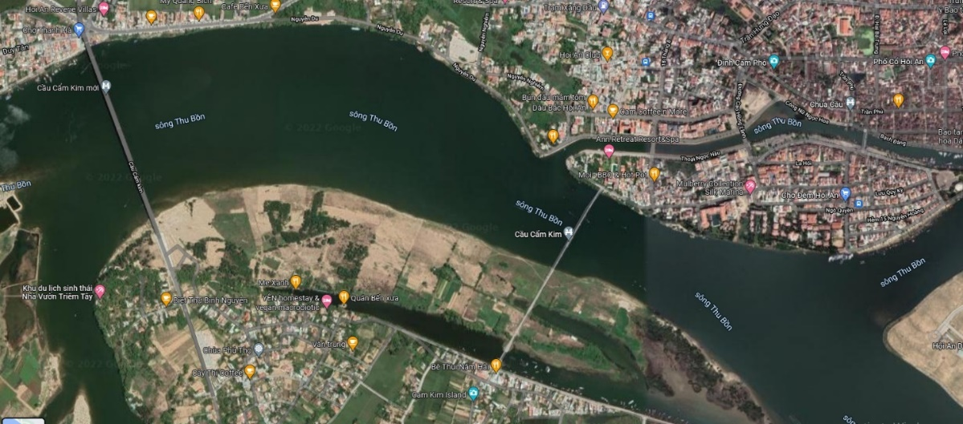
Cam Kim local bridge

3. Current status of Cam Kim bridge:
3.1. Current status of bridge structure:
- The old Cam Kim local bridge is currently degraded, with a total length of 346.53m, the bridge deck has a width of B=2.5m which is unable to meet the travel and freight needs of people in the area.
+ Bridge 1: including 09 main spans (1x27.48m+5x30.48m+42.67m+2x24.38m);
+ Bridge 2: including 01 main span (30.48m)
+ Cross section of the old bridge: B=0.3m+3.0m+0.3m=3.6m
- Span structure and deck slab are made with bailey girders, the steel structure is rusted, structural abutment is made of reinforced concrete.
- According to the inspection survey, the abutment structures and piers are in good technical condition, still ensuring load-bearing safety when calculating with a design load of 16-seat passenger cars (about 4 tons) or a group of people of 410daN/m2.
3.2. Some pictures of the current status:

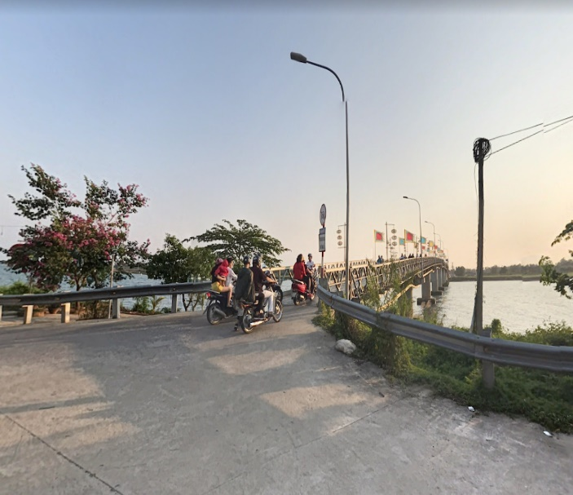  (Path to bridge made of cement concrete) | 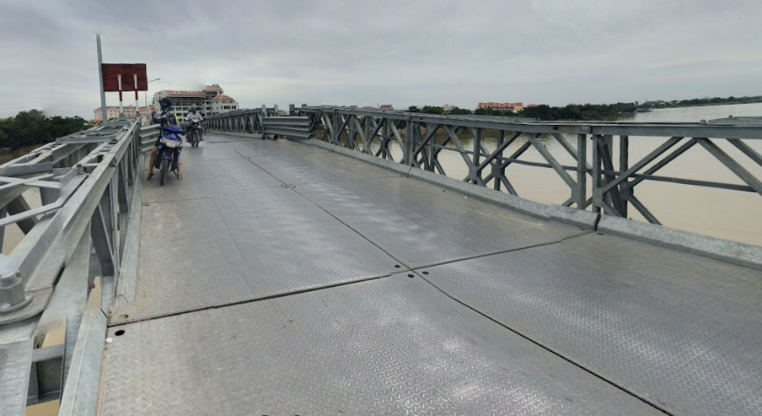  (Bridge deck, span, steel bridge railing)
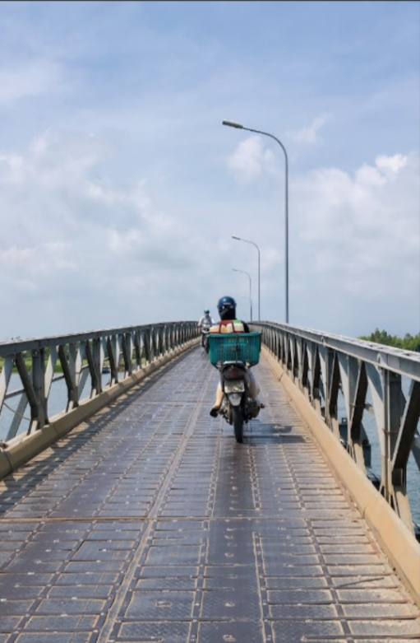  (Small width of the bridge does not ensure the transportation of goods) | 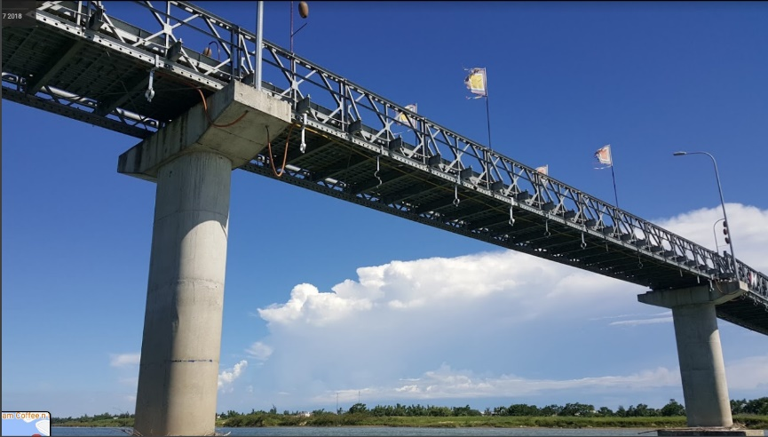  (Structure of abutment, bridge piers made of reinforced concrete)

4. Design Requirements:
4.1. Investment Scale:
- Design scale: Permanent scale, ensuring the flood level.
- Design frequency: Design flood frequency P=1%, H1%=+4.10m (as per the current Cam Kim local bridge).
- Design load: Guaranteed load for 16-seat passenger cars to travel conveniently (equivalent to 0.5HL93).
- Navigational clearance: Applied to grade III rivers (as per the current bridge).
4.2. Bridge Design Solutions:
- Bridge route map: The bridge center line can be taken as per the current bridge center or proposed to be adjusted to suit the architectural idea and regional traffic connection; however, it is necessary to ensure the specifications on the basis of considering taking advantage of the existing abutments to save costs.
- Design elevation: Minimum control as per the current bridge girder bottom elevation to ensure the hydrological conditions of the works and the navigational clearance.
- The bridge cross-section must ensure at least 2 lanes, it is possible to consider expanding at some positions according to the architectural ideas; however, the proposed plan must be based on the tested structure to have a suitable structural solution proposal.
- Bridge structure and deck slab: Based on the tested structure to have a solution to take advantage of the old bridge structure to reduce costs, encourage the use of reinforcement of old abutments, piers, landscaping... the deck slab material is selected in accordance with architectural requirements and vehicle load.
- The bridgehead road (Cam Pho and Cam Kim) and the path between the two bridges: To propose the scale of the road level, the width of the road surface, the roadbed, the pavement, the pavement structure, the accompanying technical infrastructure works, to carry out research on the location of the parking zone for tourists.
4.3. Specific Requirements:
a. General Requirements:
- As a landscape bridge serving people’s lives and connecting regional traffic.
- The bridge is a “greeting” and a symbol of Cam Kim area in general and Kim Bong carpentry village in particular.
+ Having a harmonious overall shape, a highlight for the river and 02 banks, a bridge connecting Cam Pho to Cam Kim;
+ A place to display items and models of good artisans.
- Design orientation of a bridge bearing the characteristics of Kim Bong cultural village and some other traditional craft villages of Cam Kim, as well as a connection point between the two banks of the Thu Bon River and an artistic highlight, attracting tourists to visit.
b. Planning Requirements:
- Traffic organization must ensure reasonable, clear and unambiguous traffic flow, limiting conflicts between vehicles; ensure to fully meet the travel needs of vehicles on the bridge according to the design as well as on the ground, at the intersections without adversely affecting the traffic organization at the intersections and direct traffic roads, with suitable requirements on the slope and connection between the lanes.
- Studying the synchronous connection of traffic from the road on both sides of the bridge to the roads on both sides of the river according to the planning, proposing plans and planning solutions including considering the relic of Kim Buu Pagoda - Cam Kim Commune (cannot be cleared).
- The comptetition entries can orient in the near future the way for rudimentary vehicles and pedestrians when there is a reasonable traffic flow as well as the main traffic routes are smoothly articulated because at present, there is a new Cam Kim bridge (the bridge connected to National Highway 14H).
- Organization of landscape architecture in 2 bridgehead areas.
c. Technical Requirements:
The dossier must contain a preliminary design proposal for relevant technical design subjects, in which:
- Complying with the system of Vietnamese technical regulations on construction works, traffic and environment.
- Construction structure: Maximum taking advantages of the old bridge structure, ensuring sustainability and feasibility for long-term exploitation.
- Encourage the application of new construction technologies in design and construction while ensuring technical requirements, having structural solutions suitable with typical architectural image, iconic and regional highlight.
- The bridge clearance must ensure convenient waterway traffic, navigational clearance according to regulations (as per the current bridge), minimize the impact of the work on the river’s flow.
d. Architectural Requirements:
- Texture lines need to have the core culture, be artistic, express the soul of the traditional Kim Bong carpentry village and the famous Cam Kim.
- Materials and colors used: Natural wood materials or steel frames, stay cables or new construction materials..., with colors suitable for local architecture.
- Having outstanding decorative lighting plan, standard lighting, smart lighting, suitable for traffic organization and landscape on the bridge and on both sides of the path, creating architectural highlights and regional landscapes, using appropriate materials, ensuring environmental friendliness, sustainability, attracting tourism, prioritizing the use of lighting forms currently used in Hoi An.
- Harmoniously adhere to the common criteria that are rural areas, cultural, ecological, and tourist craft villages.
- The architectural plan is feasible in terms of structure, associated with economic efficiency and has high aesthetic and artistic value.
e. Other Requirements:
- Construction technology solutions:
+ The construction plan must be suitable to the construction location and actual local conditions.
+ Ensuring environmental sanitation and saving costs, short construction time.
- Construction cost - economic efficiency:
+ Construction investment cost should be economical and suitable to local conditions, comformable and economical operation and maintenance.

